**CHAPTER ONE “INTRODUCTION”**

1. **INTRODUCTION**

##### ORGANIZATION PROFILE

* 1. **INTRODUCTION TO THE SYSTEM**

1. **INTRODUCTION**
   1. **Organization Profile**

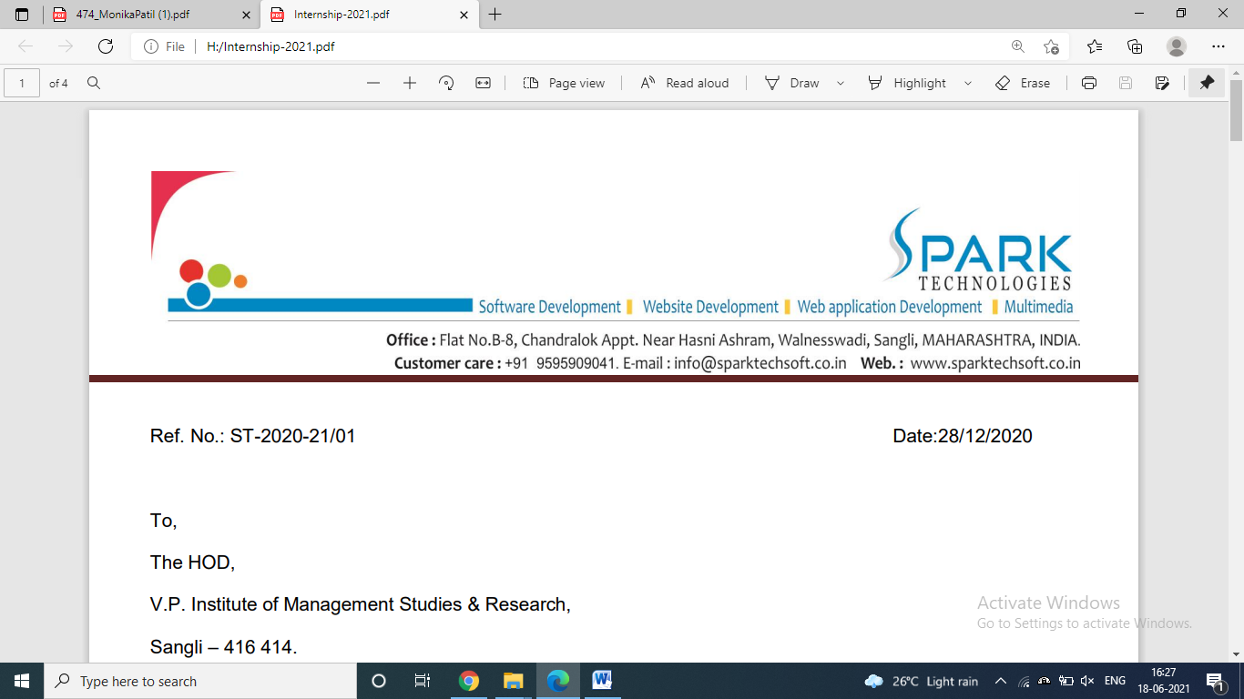

**Company Name:- Spark Technologies**

**Location:** Kamal Heights, Flat No. 6, Vishrambag, Sangli- 416410 Maharashtra. Contact :- +91-9595909041. E-mail :- support@sparktechsoft.co.in

#### About Company:-

We Spark Technologies are complete Software Solution Provider, creating rich and Custom Based also in concept development. Our team of versatile experts have unmatched skills in research, Analysis, and Implementation etc. The result is production of stunning, realistic animations. We offering high-end Web services & also Windows Offline Application Services.

We differentiate ourselves by our holistic approach in the creative and innovative process, adding new facets and learning to our portfolio each day. We provide services and solutions right from concept development phase to final Project for your Requirement & Also Provide a Guidance For your Project.

Our commitment to a culture, based on a set of strong core values is the heart of our organization. The Value Code reflects this commitment, which emphasizes placing our Clients'''' interest first, Integrity, Quality, Creativity and Teamwork. The Value Code reflects this commitment, which emphasizes placing our Clients'''' interest first, Integrity, Quality, Creativity and Teamwork.

#### Our Services:-

### Website Designing

Website is smart way to spread your business throughout world. reach your client within seconds and provide your information through just one link.

### Software Development

It includes Hotel management, School Management, Petrol pump. Also we are making customise soft wares according to your needs.

### CMS Website Development

Its most popular thing now a days. Manage your website without any technical knowledge. Can simply manage your content, create your own pages, blogs, within your websites.

### Web App Development

This includes different types of applications use for booking like hotel/restaurant, ticket booking, user registrations.

### Social Media Marketing

Its most popular thing now a days. Manage your website without any technical knowledge. Can simply manage your content, create your own pages, blogs, within your websites.

### Animation

Animation is not the art of drawings that move but the art of movements that are drawn.

#### 

#### Introduction to the System:-

ReshimGathi is a Matrimonial App/Site to find prefect life partner. To find match through this site, one has to register and also provide his expectations about his/her life partner. This helps user to find compatibility check. Also if user believes in astrology then he/she can check astrological match immediately from the given link. To check whether the user is a robot or human the site provides Captcha facility.

This site also helps its member to view information about various matches and also send messages but for this user has to buy package. We also provide facility to upload images and create album to find a better match.

If the user finds match through this application or not interested in marriage then can delete his profile by sharing reason for deletion. If he/she finds match through the application then can share their story which may help others for reference. This story may be displayed on site by admin’s choice.

However if the user finds some match inappropriate (or any) then he/she can avoid the person by blocking him/her. Also he can send like/dislike as per his choice. He/she can complain to admin of the site through message so that admin can take appropriate action towards it.

Thus, it is accessible either by an administrator (business user), customers/members (client user). Member can easily find desired match. This project is an attempt to provide the advantages of finding a perfect partner as per requirement. It helps selecting best person as life partner sitting home in the form anywhere through internet. The interface is very user-friendly. The data is well protected. E.g. all the personal details like phone number, aadhar card details will not be displayed on site which makes the user feel free and focus mainly on the finding desired match.

##### Modules of System:-

* + 1. **Admin Module (Business User):-**

In admin module admin can browse the website, then admin can create various packages like gold, silver, platinum and so on. Each package has its own advantage. He can set duration period, number of messages viz. chat limit, price of package and even discount. Admin can also view newly registered members as well as packages that are to be renewed by this month leading to help improve customer satisfaction. Admin has his own choice to display successful marriage stories on site who found their partner through ReshimGathi.

##### Member Module (Client User):-

In member module, the client also known as customer can find match as per his/her expectations, send messages, send interest, send like/dislike and many more. However, he/she can also block/unblock a person.

# CHAPTER TWO “SYSTEM ANALYSIS”

## SYSTEM ANALYSIS

##### OBJECTIVES OF THE SYSTEM

* 1. **SYSTEM SCOPE**
  2. **REQUIREMENT ANALYSIS**
  3. **SYSTEM FLOWCHART**
  4. **DATA FLOW DIAGRAM**

1. **SYSTEM ANALYSIS:**
   1. **Objectives of the System:**
      * + To find partner as per expectation like city, qualification, country, etc.
        + To provide qualitative information to user.
        + To provide a wide variety of choices for marriage.
        + To collect feedback form client.
        + To provide a user-friendly environment and user interactions.
        + To provide facility of buying package.
        + To provide astrological details for those who believe in astrology.
        + To find perfect partner in comfort from home, without having to step out of the door.
        + To provide a facility to check the functionalities of site without having to purchase package initially i.e. new members are by default using free packages. Where user can use access free trial for some days.
        + To provide independence to the administrator to display successful stories on site.
        + To provide a smooth communication with two individuals without having to exchange numbers by providing the ability to chat.
        + To make it more reliable by providing captcha which indicates user is not a machine.
        + To provide independence to block user.

##### System Scope:

* + - This project is about “website” of Matrimony. This website contains two modules i.e. Member Module (client) and Admin Module (business). In member module customer can browse website and find match. In admin module admin can create packages and display stories on site.
    - It manages and fulfill as much as it can satisfy user in finding a perfect partner.
    - The whole system is secured by giving login, password and captcha.
    - If user forgets password then he/she can generate new password.
    - Makes user feel free by allowing him/her the facility to block or unblock user.
    - It makes communication faster by sending interest if interested and also by sending messages.
    - Also helps its member to communicate with administrator using the same facility of sending message.
    - Helps to find out the people who you like and people who like you in the favorites menu.
  1. **Requirement Analysis:**

The requirements for a system are the descriptions of what the system should do the services that it provides and the constraints on its operation. These requirements reflect the needs of client for a system that serves a certain purpose such as controlling a device, finding information. The process of finding out, analyzing, documenting and checking these services and constraints is called requirements engineering (RE).

Some of the problems that arise during the requirements engineering process area result of failing to make a clear separation between these different levels of description. I distinguish between them by using the term ‘user requirements’ to mean the high-level abstract requirements and ‘system requirements’ to mean the detailed description of what the system should do. User requirements and system requirements may be defined as follows:

**User requirements** are statements, in a natural language plus diagrams, of what services the system is expected to provide to system users and the constraints under which it must operate.

**System requirements** are more detailed descriptions of the software system’s functions, services, and operational constraints. The system requirements document (sometimes called a functional specification) should define exactly what is to be implemented.

* + - The web application should be Responsive.
    - The required information should be on a central location. This will facilitate the availability of the data anywhere and anytime.
    - User manual is guide for using this system following or the steps for user to excess the site.
    - The business user must be allowing the multiple number of slots to select client.

##### System Flowchart:

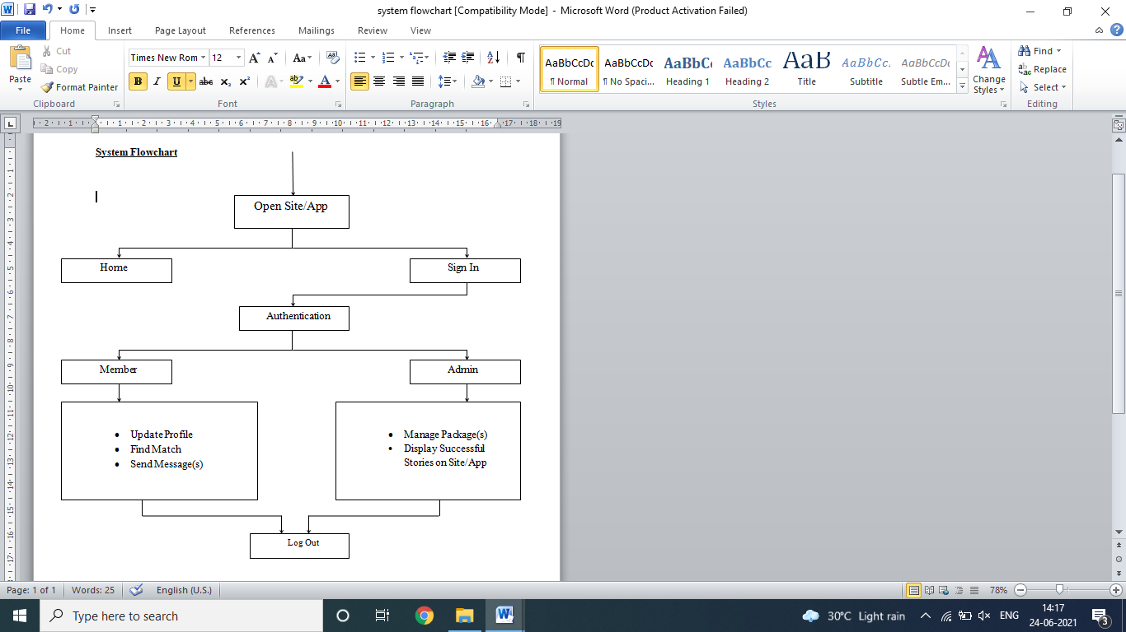

Fig. :- System Flow Chart

* 1. **Data Flow Diagram:-**

**Description:-**

Data Flow Diagrams are composed of the four basic symbols shown below.

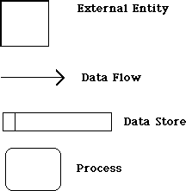

The External Entity symbol represents sources of data to the system or destinations of data from the system.

The Data Flow symbol represents movement of data.

The Data Store symbol represents data that is not moving (delayed data at rest).

The Process symbol represents an activity that transforms or manipulates the data (combines, reorders, converts, etc.)

Any system can be represented at any level of detail by these four symbols.

#### External Entities:

* + 1. Are named with appropriate name.
    2. Can be duplicated, one or more times, on the diagram to avoid line crossing.
    3. Determine the system boundary. They are external to the system being studied.
    4. Can represent another system or subsystem.
    5. Go on margins/edges of data flow diagram.

#### Data Flows:

1. Are represented with a line with an arrowhead on one end. A fork in a data flow means that the same data goes to two separate destinations. The same data coming from several locations can also be joined.
2. Should only represent data, not control.
3. Are ALWAYS named. Name is not to include the word "data".
4. Are referenced by a combination of the identifiers of the constructs that the data flow connects. (14-A references a data flow from process 14 to external entity A)

#### Data Stores:

1. Are generic for physical files (index cards, desk drawers, magnetic disk, magnetic tape, shirt pocket, human memory, etc.)
2. are named with an appropriate name, not to include the word "file", and numbered with a number preceded with a capital letter D
3. Can be duplicated, one or more times, to avoid line crossing.
4. Can show two or more systems that share a data store. This is done by adding a solid stripe on the left boundary. This can occur in the case of one system updating the data store, while the other system only accesses the data. For ex ample, the data store could be a freight rate book that one system builds and maintains, but is used by the represented system.

#### Context Level Diagram:-

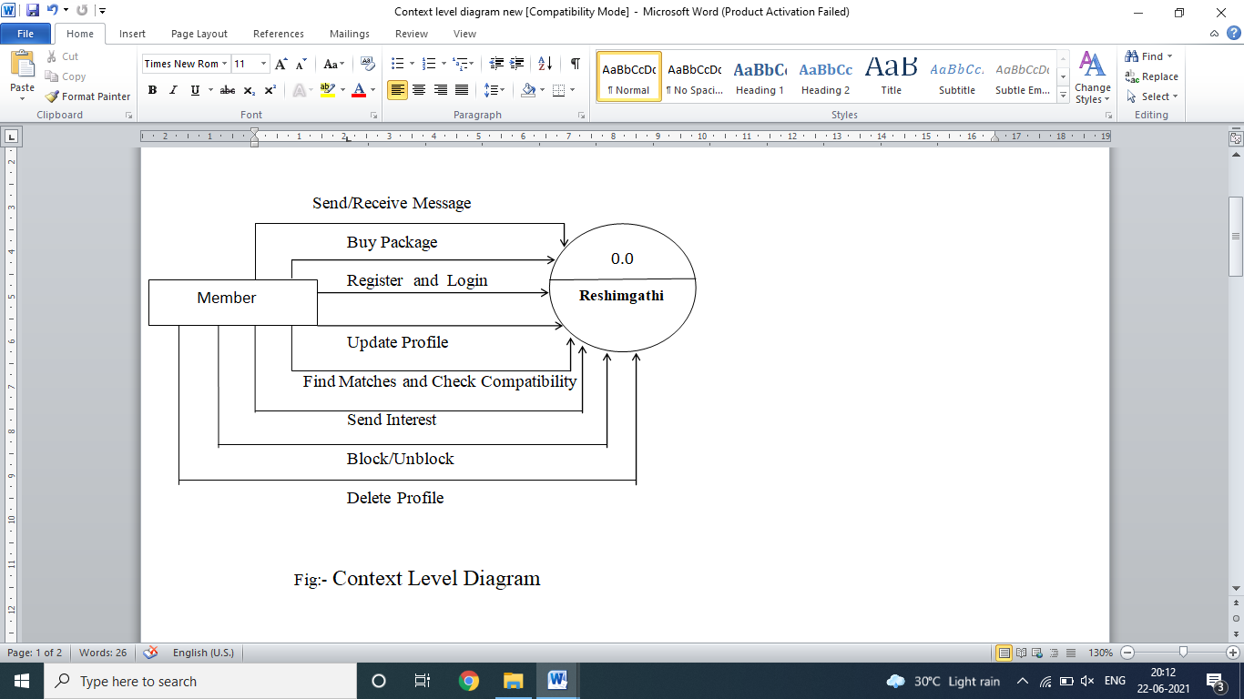

##### First Level Data Flow Diagram: -

##### Member

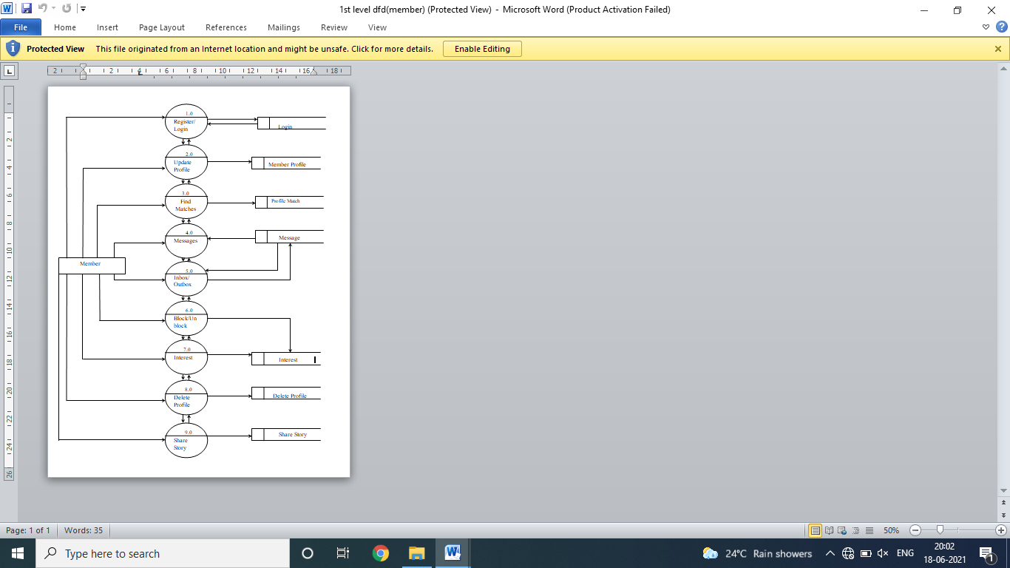

Admin

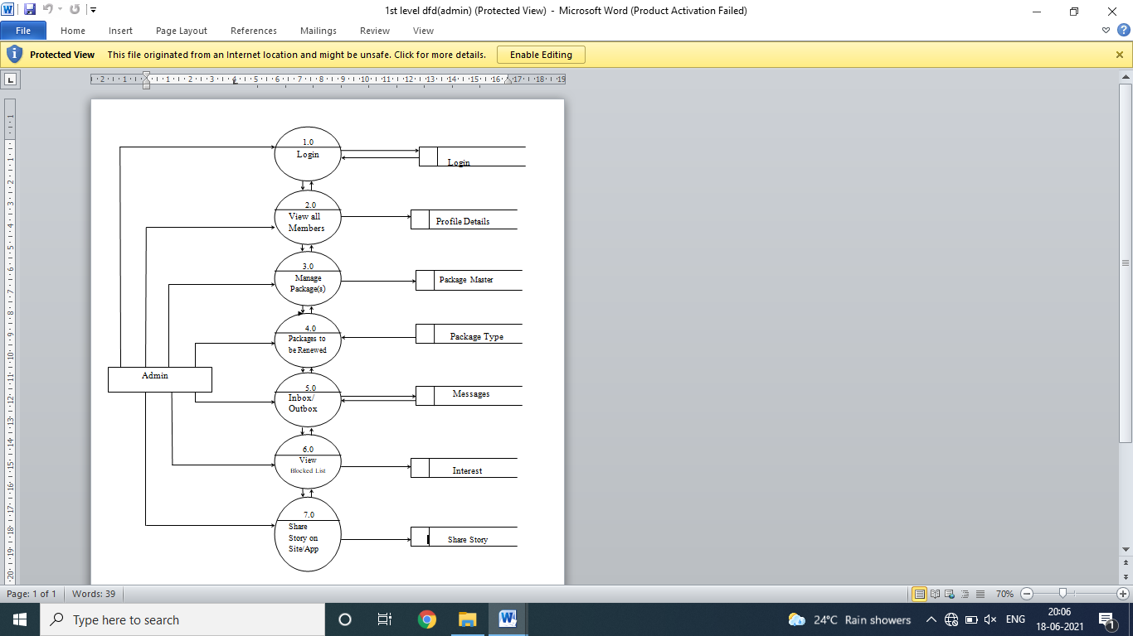

**CHAPTER THREE “SYSTEM DESIGN”**

* 1. **SYSTEM DESIGN**
     1. **UML DIAGRAMS**
     2. **ER DIAGRAMS**
     3. **FILE STRUCTURE/DATABASE DESIGN**
     4. **ABOUT ENVIRONMENT/PLATFORM USED**

**3. System Design:-**

3**.**1. UML Diagram

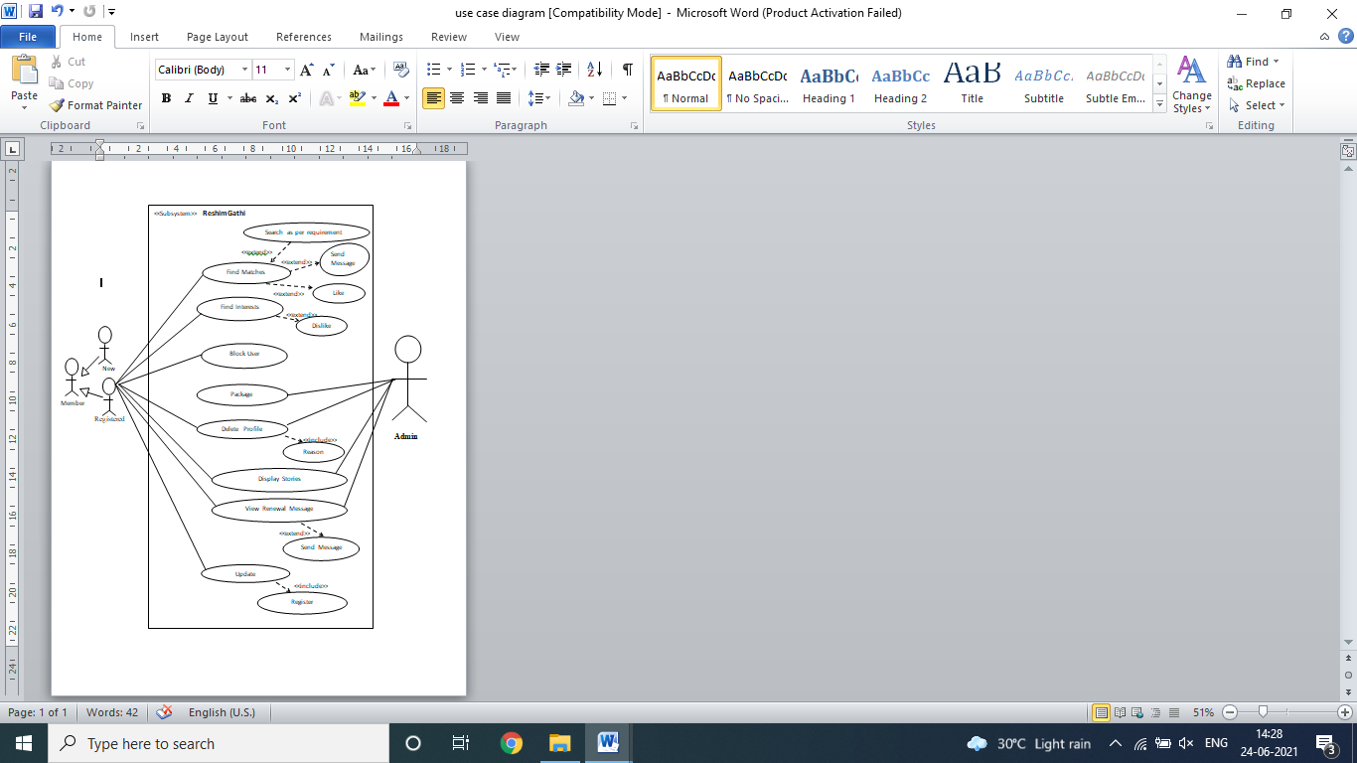

Fig. :- Use Case Diagram

##### Class Diagram:-

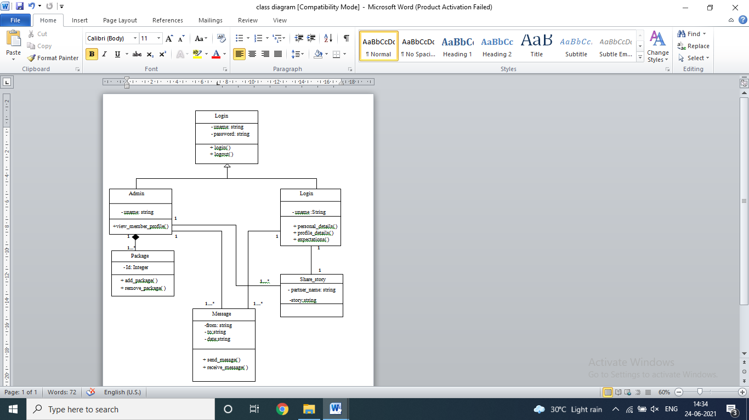

Fig. :- Class Diagram

**Sequence Diagram:-**

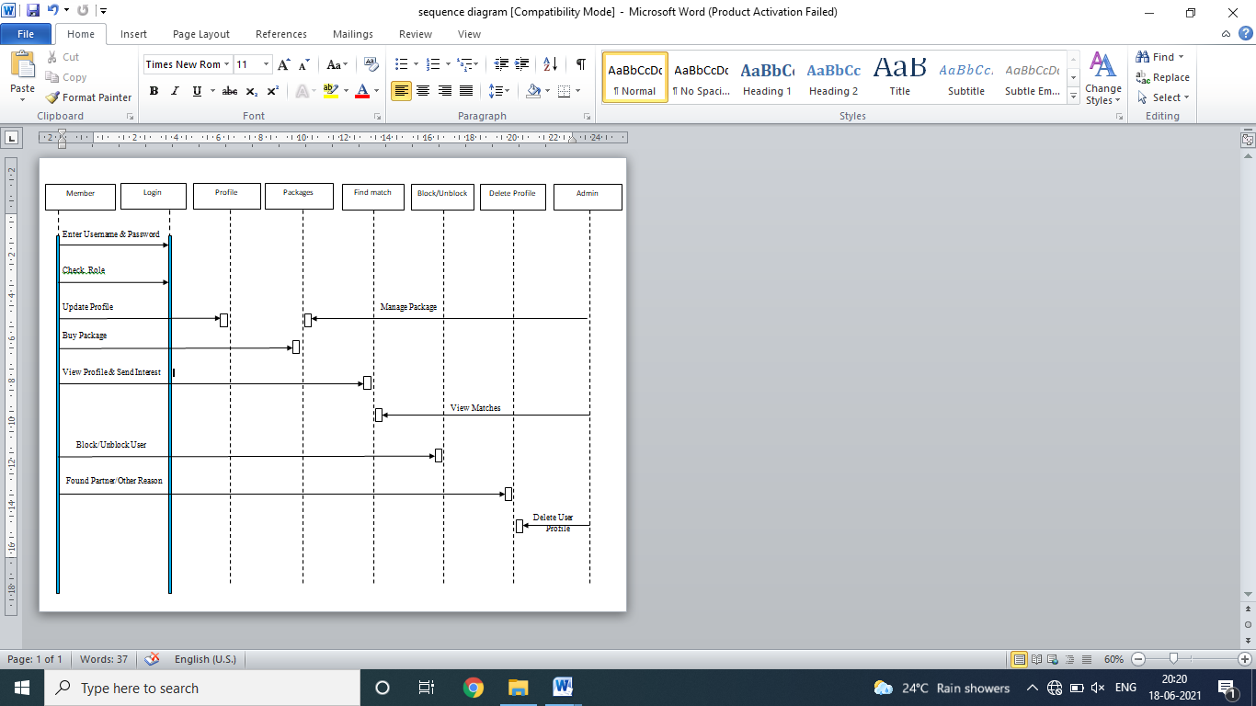

Fig. :- Sequence Diagram

**Deployment Diagram:-**

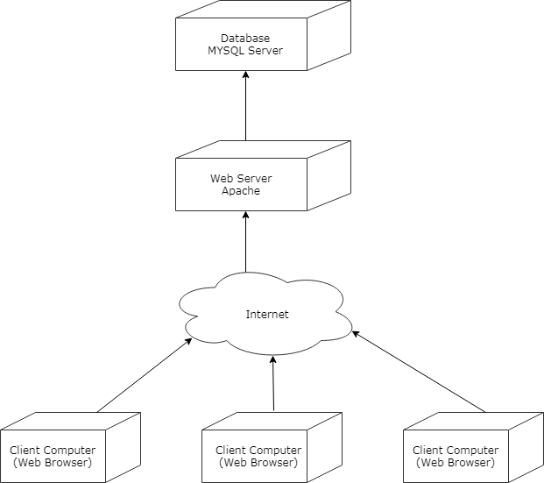Fig. :- Deployment Diagram

**Activity Diagram:-**

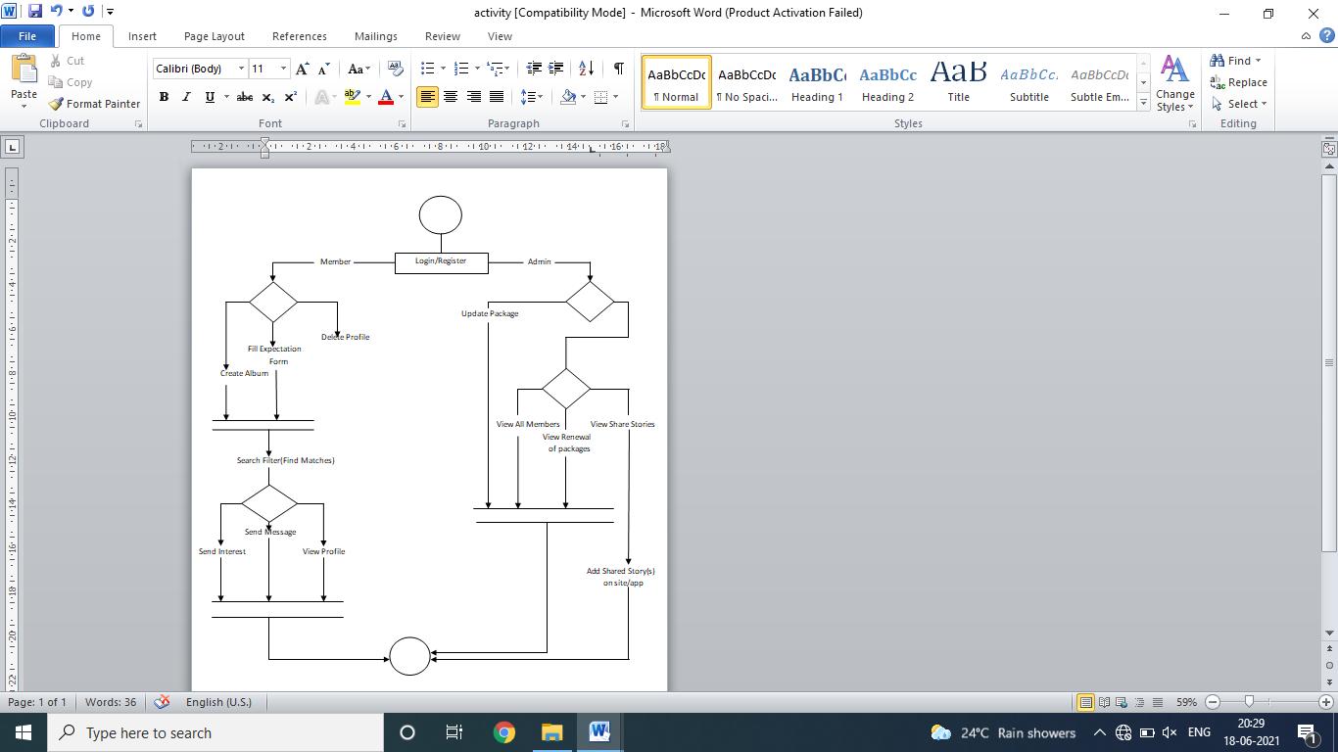

Fig.:- Activity Diagram

* 1. **ER Diagram:-**

An Entity-Relationship diagram (ERD) typically serves as the main deliverable of a conceptual data model. While newer approaches to E-R modeling have developed, the E-R approach is still cited by some professionals as “the premier model for conceptual database design” . An ERD is a logical representation of an organization’s data, and consists of three primary components:

* + - **Entities –** Major categories of data and are represented by rectangles
    - **Attributes –** Characteristics of entities and are listed within entity rectangles
    - **Relationships –** Business relationships between entities and are represented by lines

An **Entity** is a person, place, object, event, or concept that an organization wants to maintain data on. Each entity has a unique identity that differentiates it from other entities. A point of distinction must be made between entity *types* and entity *instances*. An **entity type** is a collection of entities that share common properties. Entity types are also known as entity *classes*. An **entity instance** is an individual occurrence of an entity type. A data model describes an entity type only once; however there may be numerous instances of that type within a database.

Entity type definition is important to requirements determination and structuring. Type definitions should (1) include the unique characteristics for the type, (2) clarify what instances are included and excluded in the type, (3) identify when an instance is created, deleted, or change into another entity type, and (4) specify what history needs to be kept about entity instances. A sound understanding of business should help the conceptual data modeler when defining entity types.

An **Attribute** is a characteristic of an entity that is relevant to the organization. When defining an attribute, an analyst should state why the attribute is important, what is included in the attribute’s value, the source of the value, and whether or not that value can change. Again, a sound understanding of an organization’s business should assist the analyst in compiling relevant attributes.

**Candidate keys are attributes** that uniquely identify each instance of an entity type. An analyst must select one candidate key as an entity type’s identifier. This identifier will then be used to uniquely identify each instance of that entity type. It is critical that the identifier’s value remain permanent over time, and never contain a null value.

Other types of attributes that analysts should be aware of when creating E-R diagrams include:

* + - Multivalued Attributes – attributes that may contain multiple values
    - Required Attributes – attributes that must contain a value for each instance
    - Optional Attributes – attributes that do not need a value for each instance
    - Composite Attributes – attributes that contains meaningful component parts
    - Derived Attributes – attributes whose values are computed from other data in the database

**Relationships** link the various components in an E-R diagram together. It is usually best to think of relationships as verbs and entities as nouns, which together comprise a complete sentence. For example, "an **Invoice** *Was_Sent_To* a **Customer**". Relationships depict either some kind of event occurring or a natural link between entity instances. A relationship’s **degree** indicates the number of entity types that participate in a given relationship. The three most common relationship degrees are: *Unary* (between instances of one entity type), *Binary* (between instances of two entity types), and *Ternary* (between three entity types). Below, illustrations are listed for each of the relationship degree types

##### ER Diagram:-

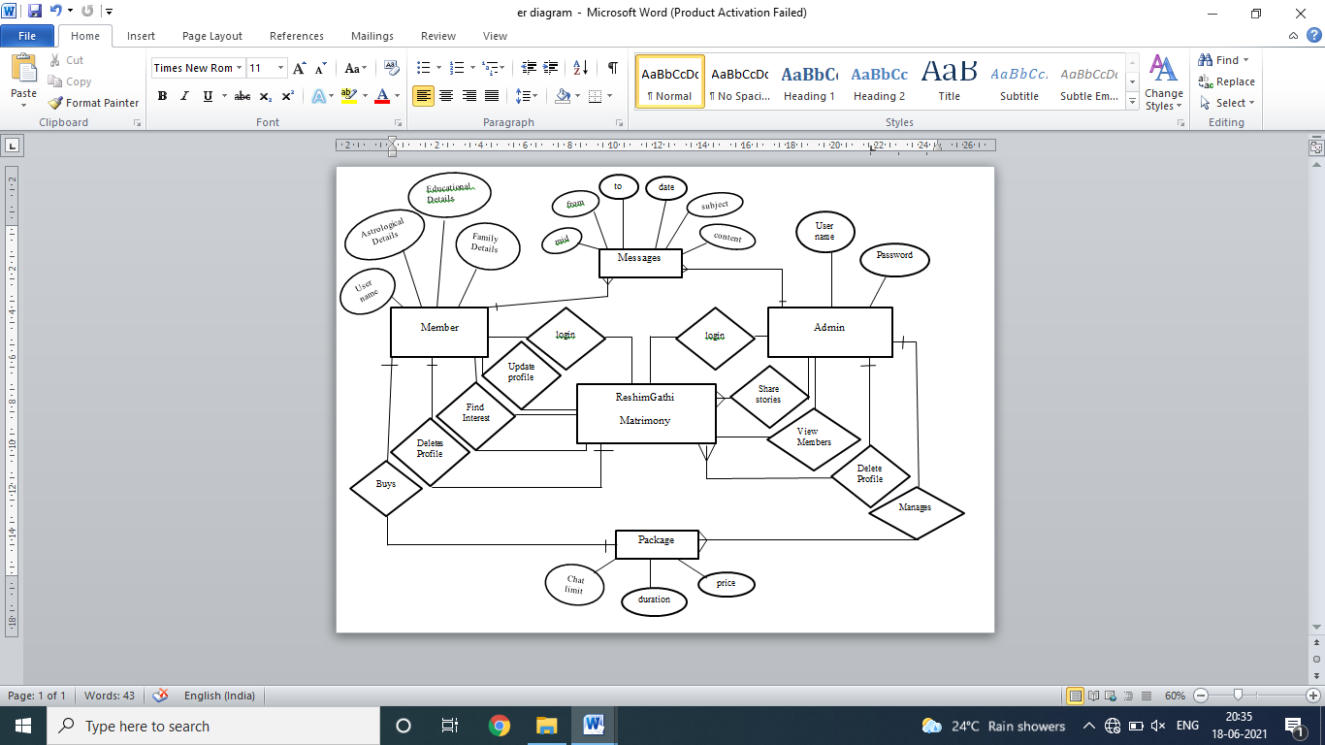

Fig. :- Entity Relationship Diagram

* 1. **File Structure/Database Design:**

1. **Table Name**:- login

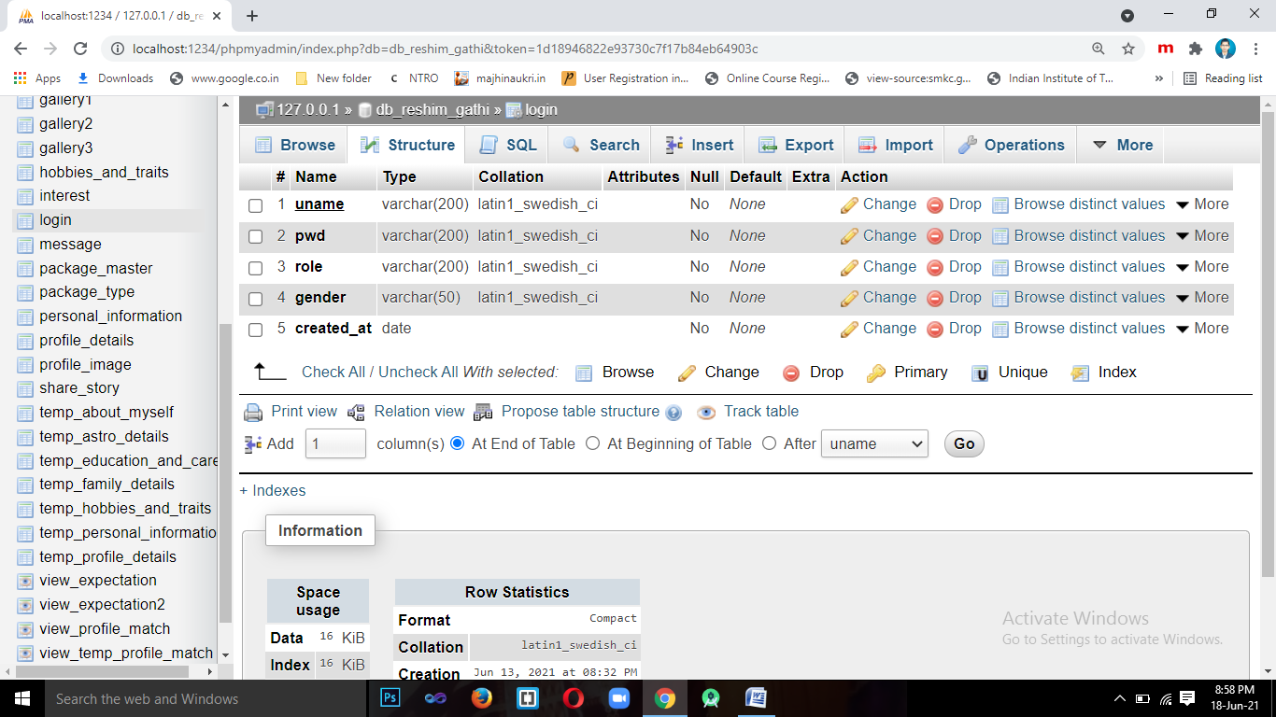

1. **Table Name**:- personal_information

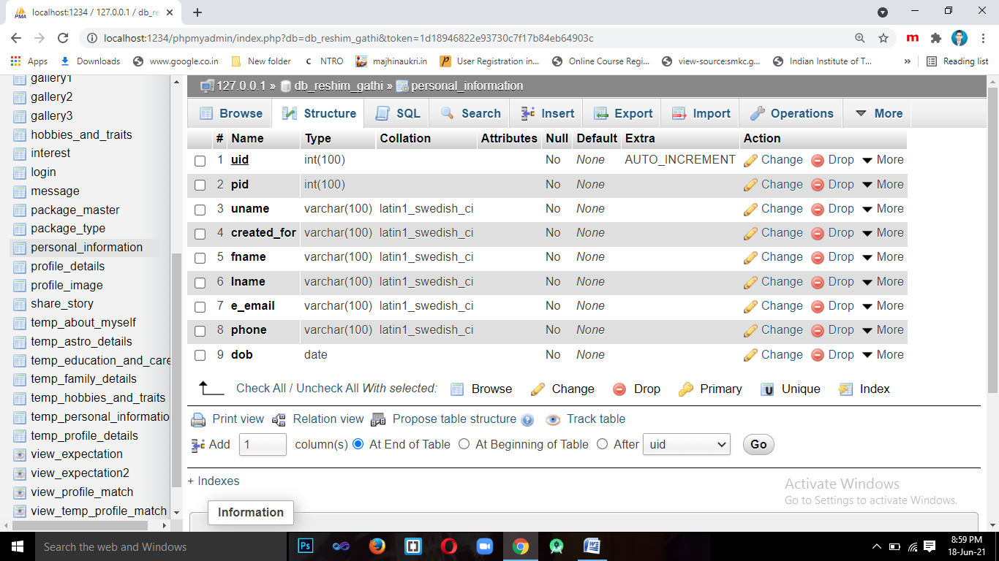

1. **Table Name**:- [profile_details](http://localhost/phpmyadmin/sql.php?db=db_reshim_gathi&table=profile_details&token=c497b6bb3edb95bd0af6b15b392a7a19)

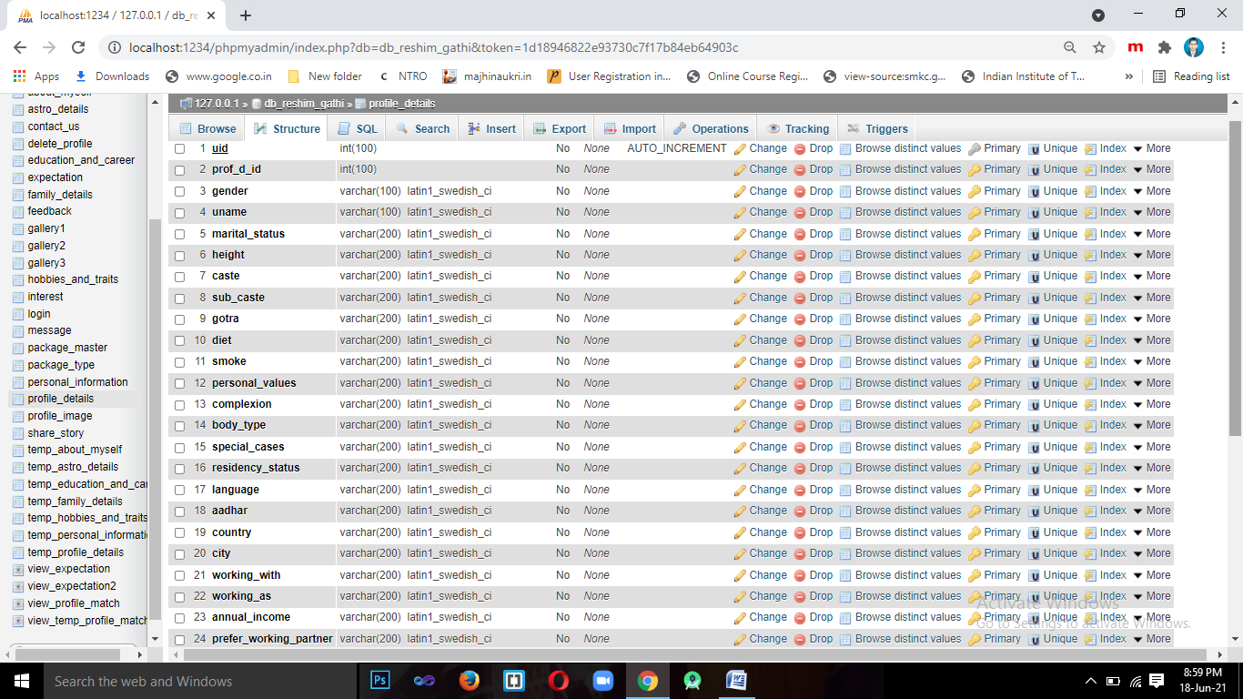

1. **Table Name**:- family_details

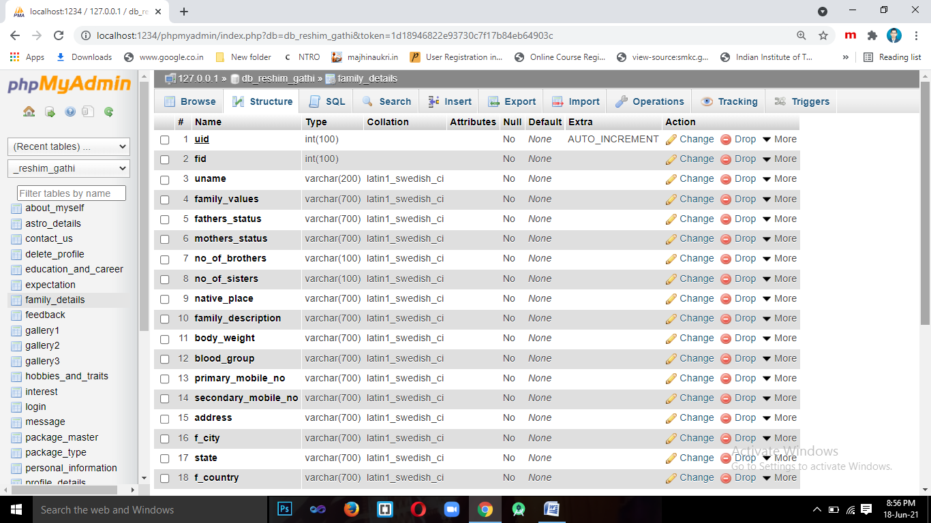

1. **Table Name**:- astro_details

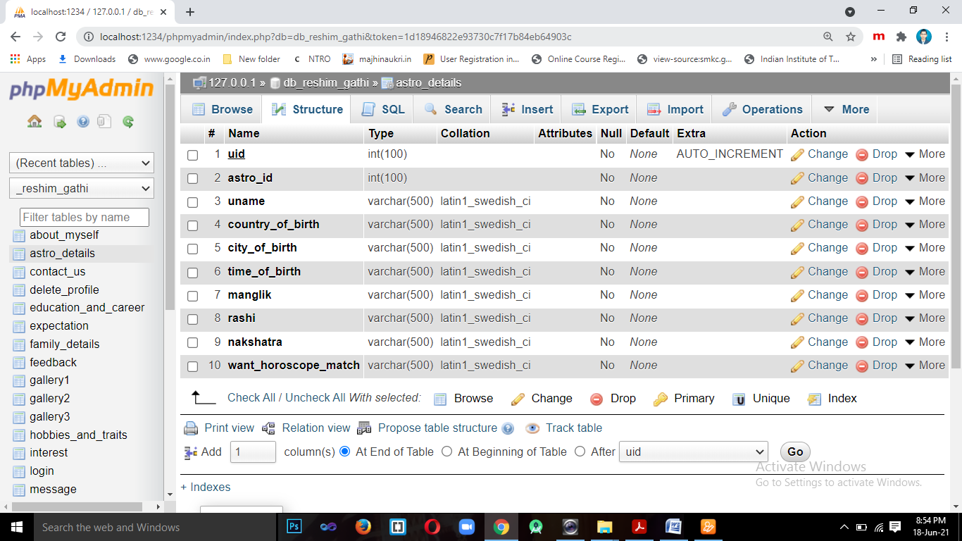

1. **Table Name**:- education_and_career

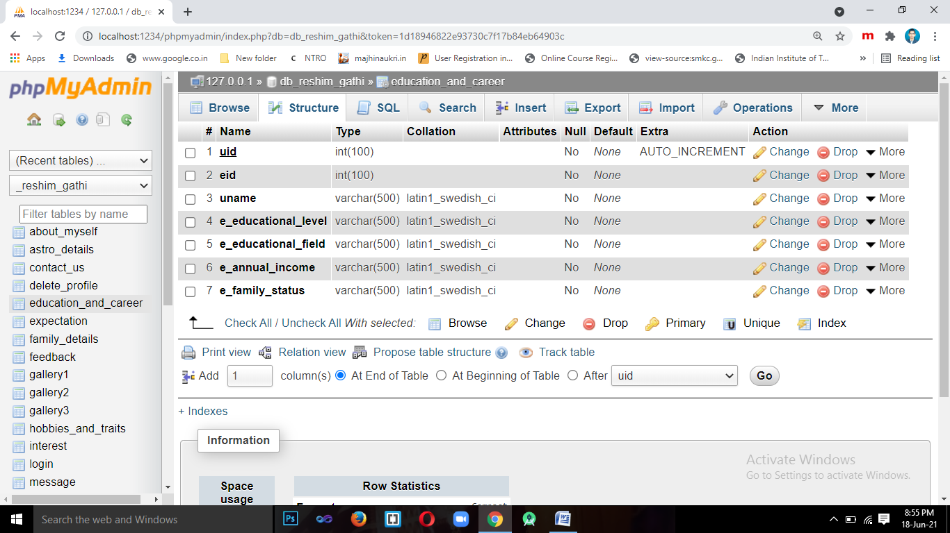

1. **Table Name**:- hobbies_and_traits

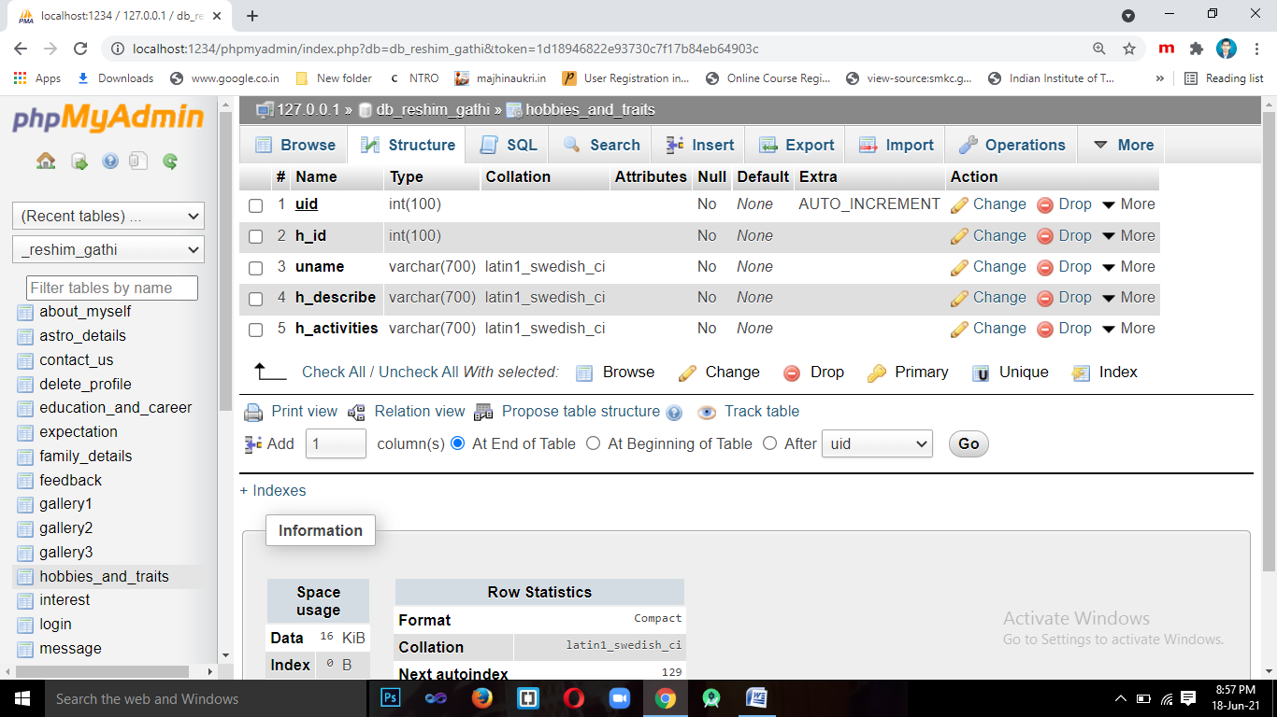

1. **Table Name**:- about_myself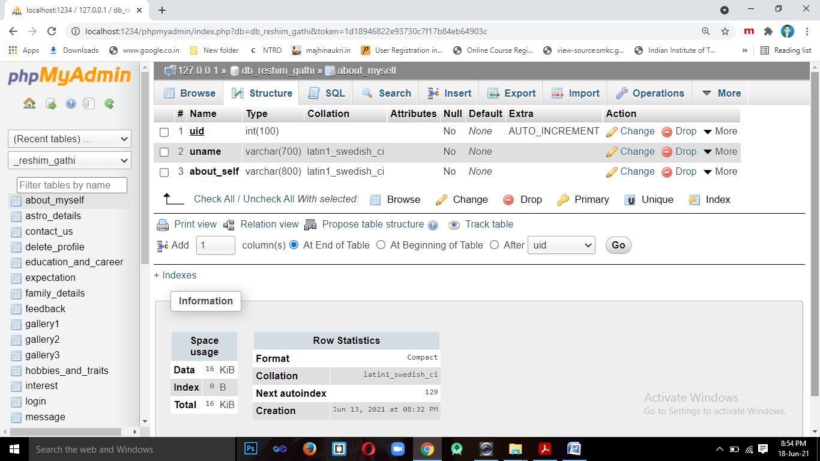
2. **Table Name**:- expectation

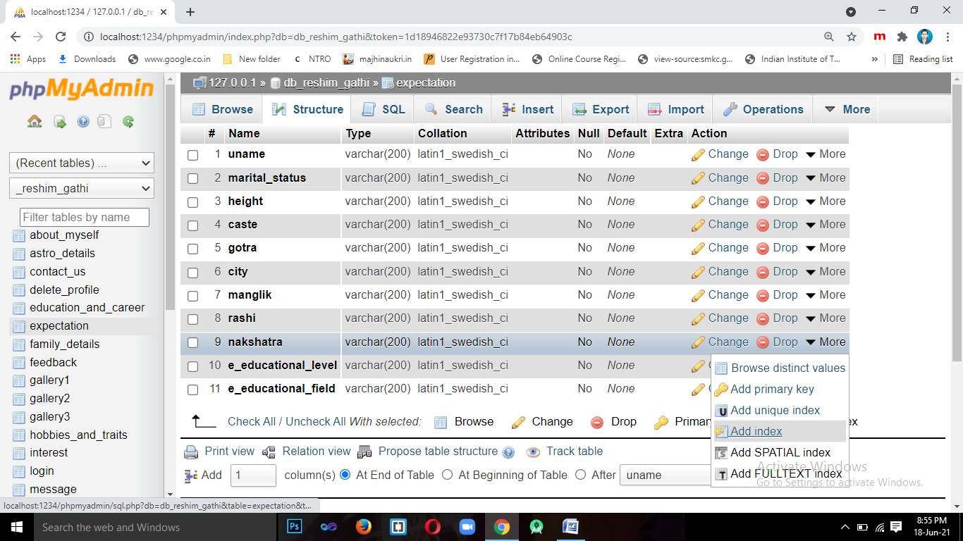

1. **Table Name**:- profile_image

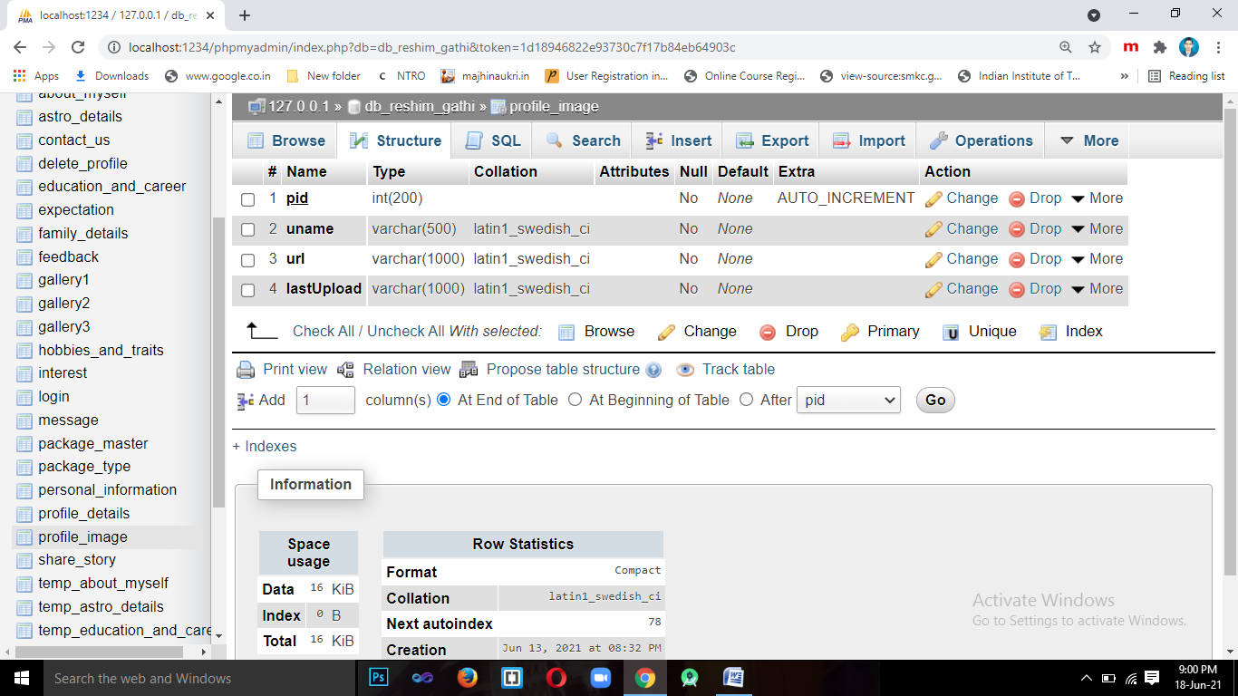

1. **Table Name**:- message

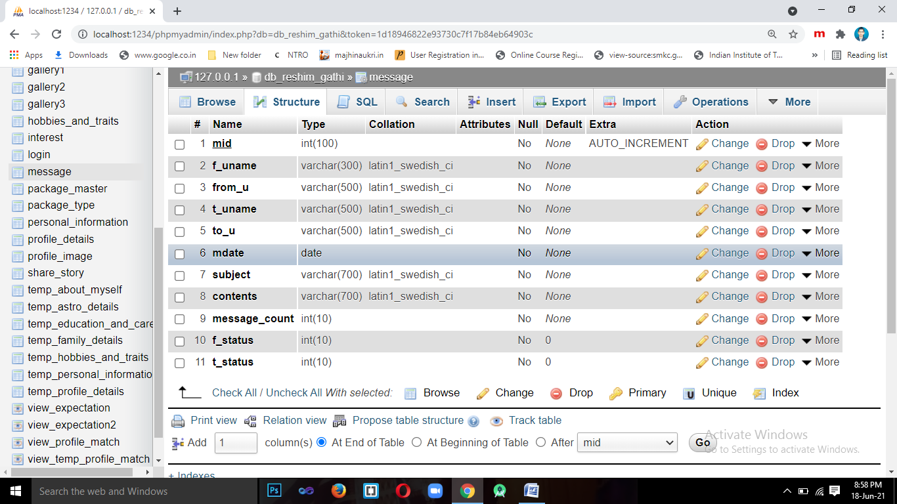

1. **Table Name**:- interest

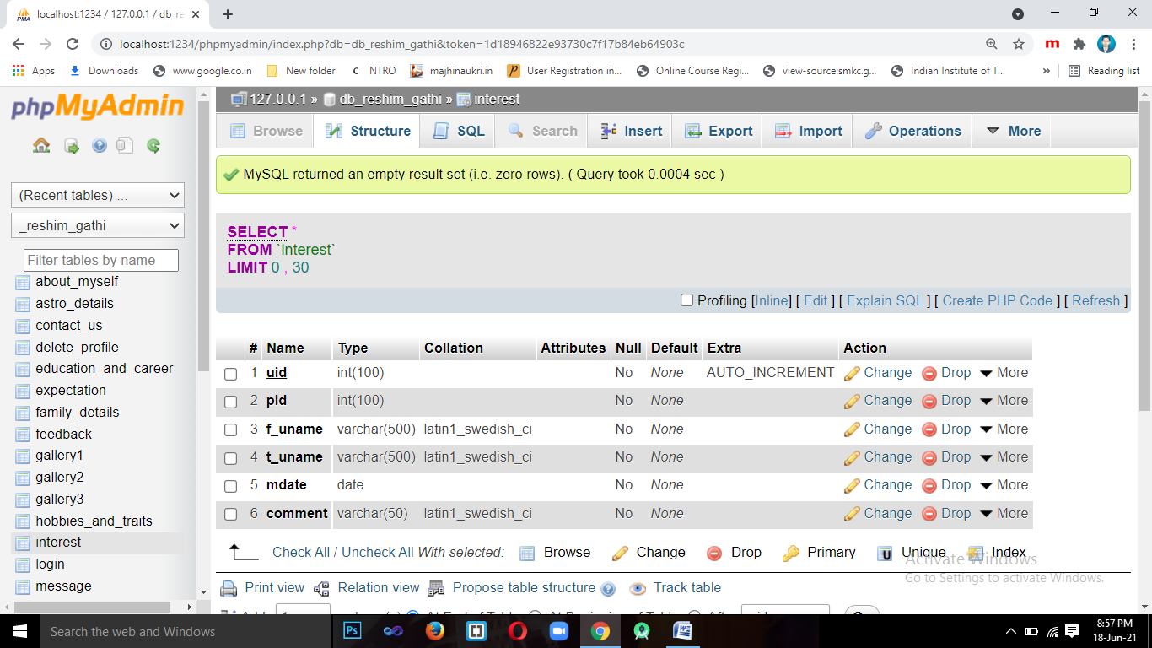

1. **Table Name**:- package_master

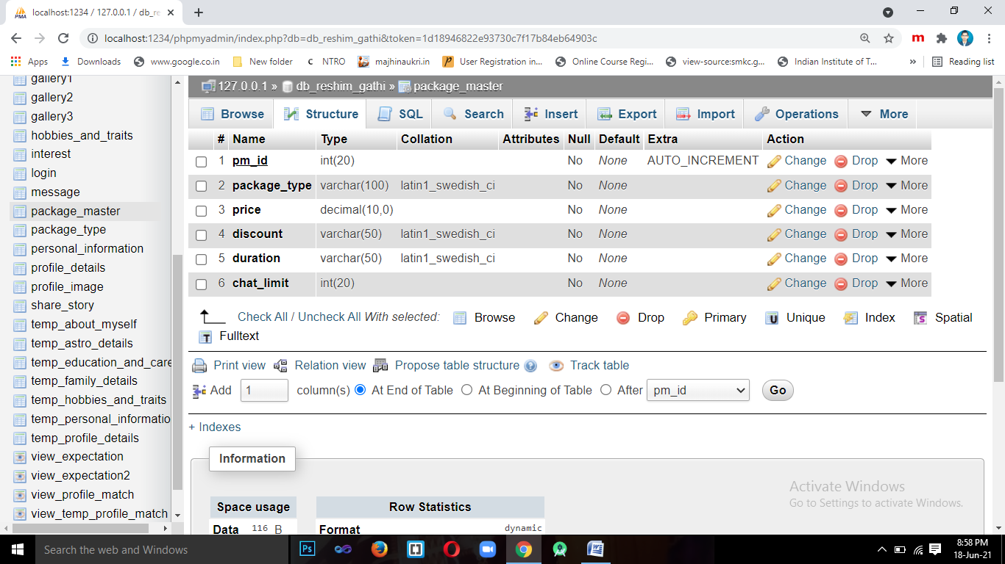

1. **Table Name**:- package_type

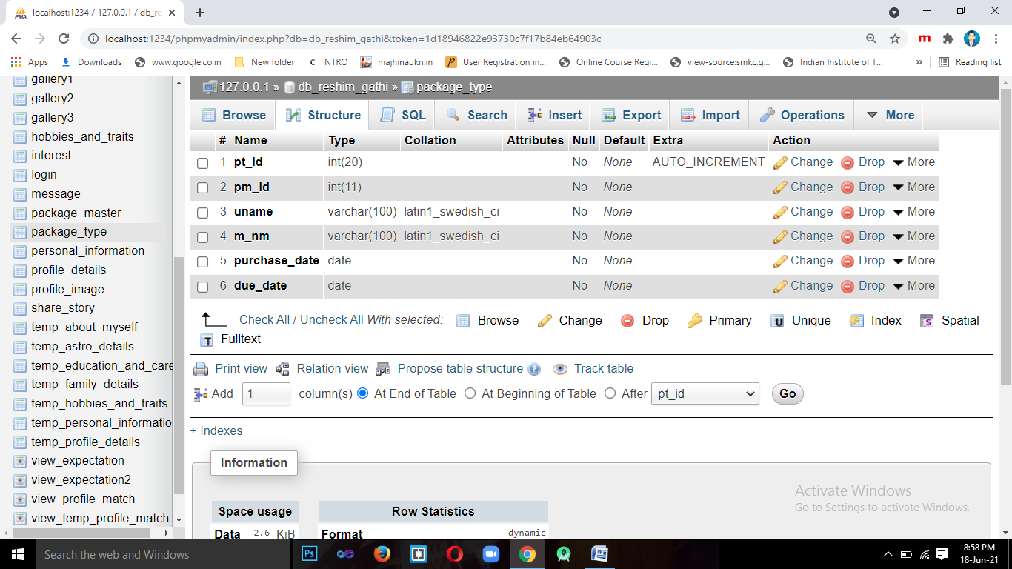

1. **Table Name**:- gallery

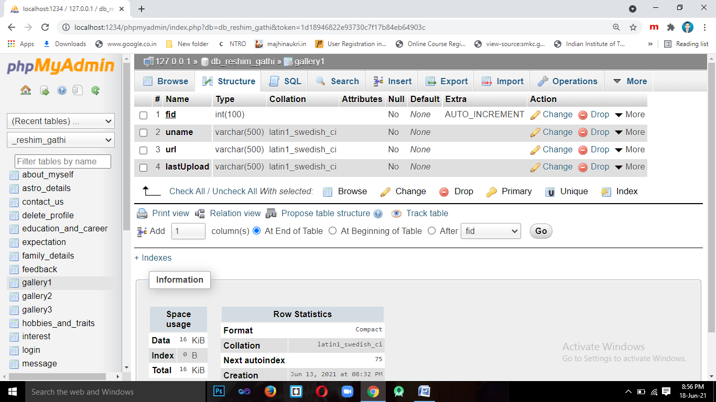

1. **Table Name**:- view_profile_match

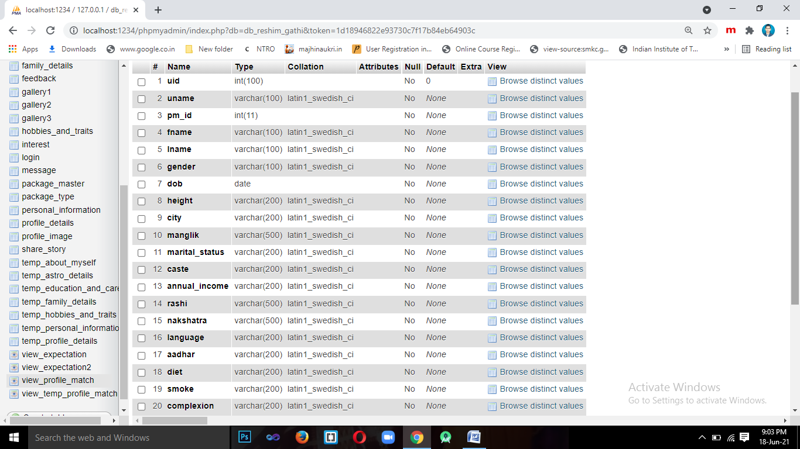

1. **Table Name**:- view_expectation

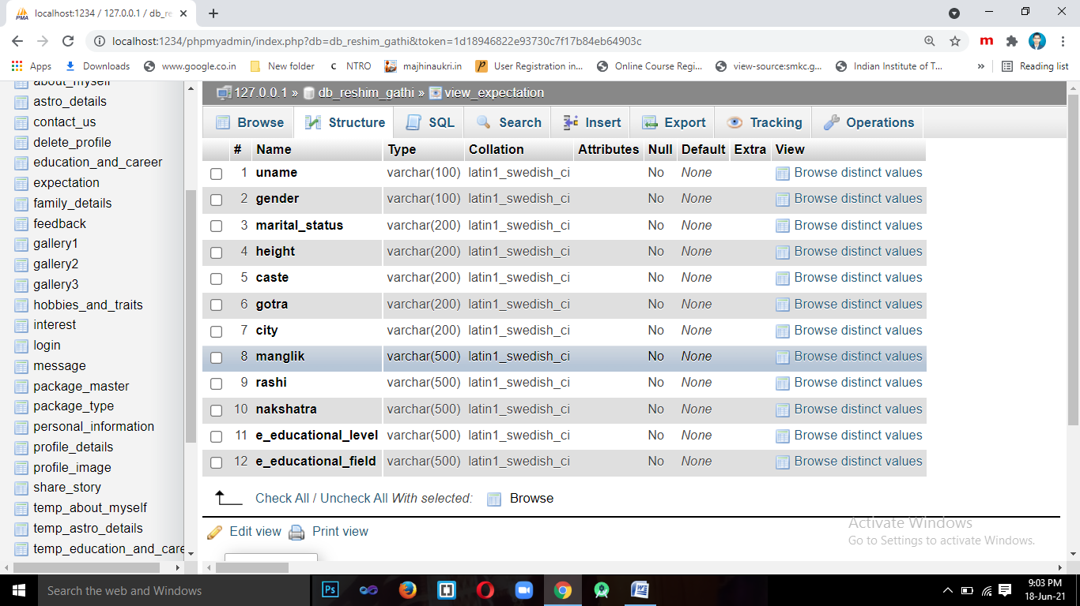

1. **Table Name**:- delete_profile

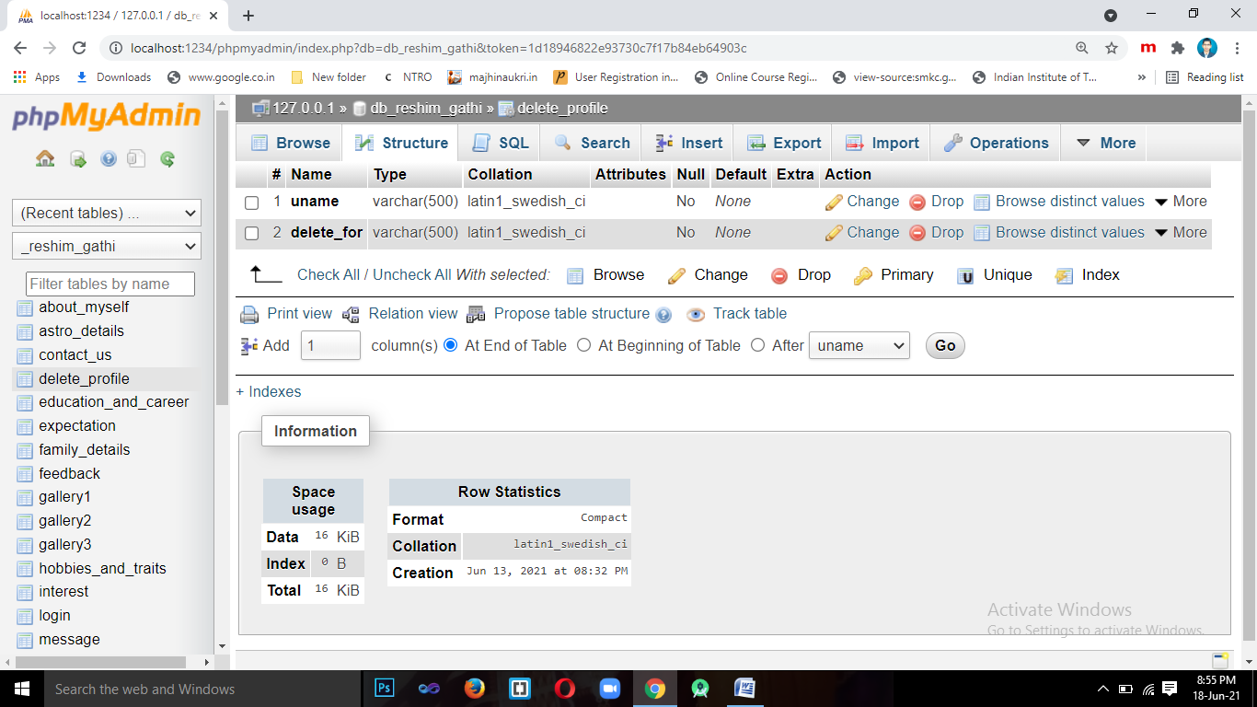

1. **Table Name**:- share_story

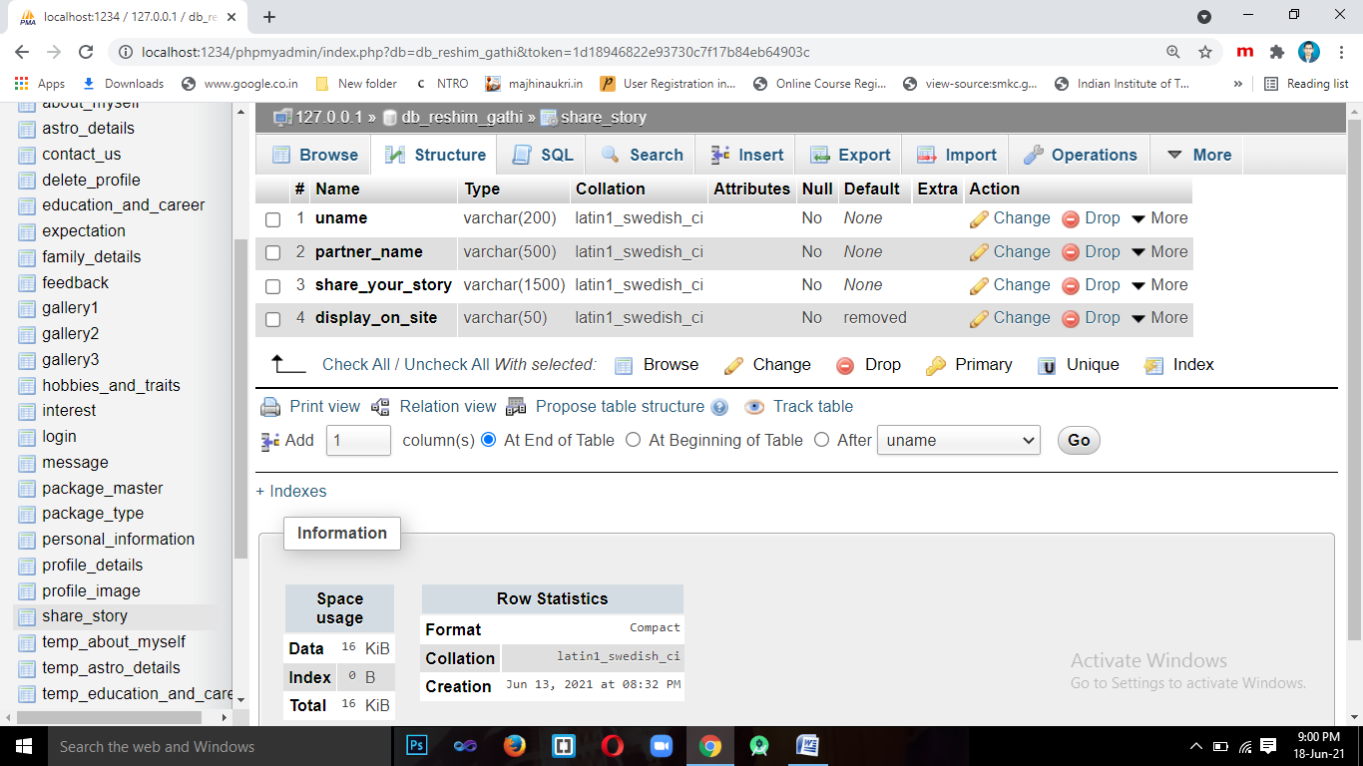

1. **Table Name**:- temp_personal_information

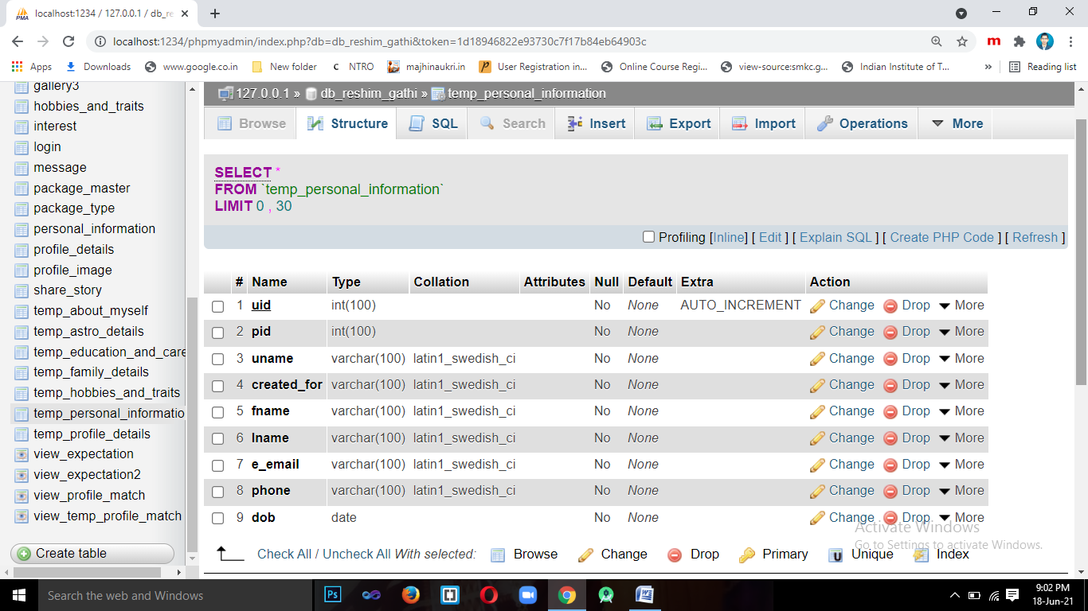

1. **Table Name**:- temp_profile_details

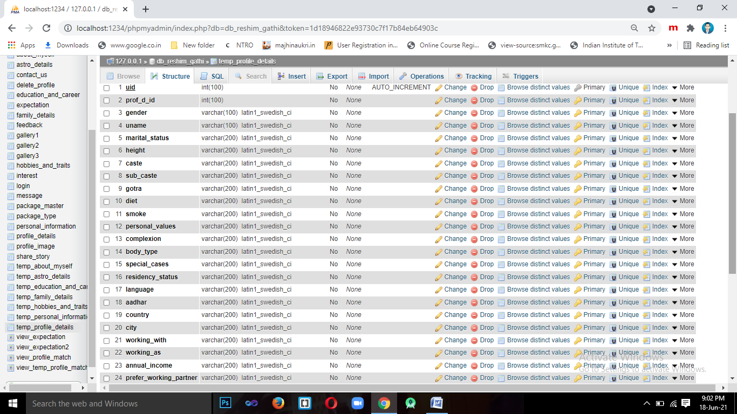

1. **Table Name**:- temp_family_details

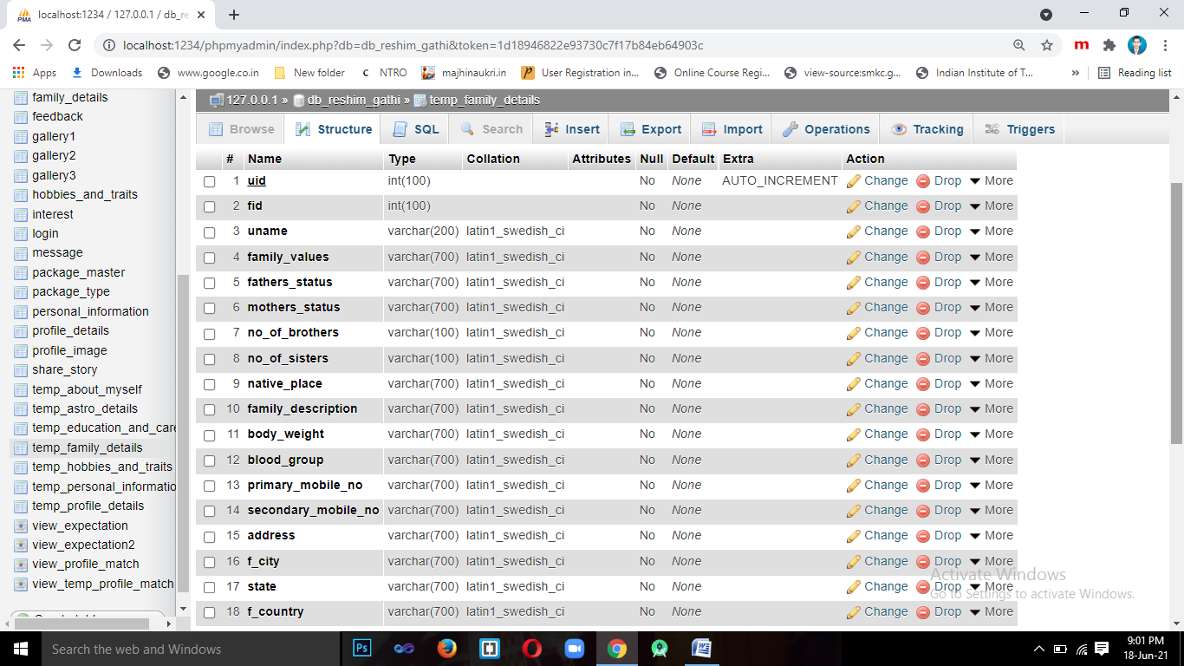

1. **Table Name**:- temp_astro_details

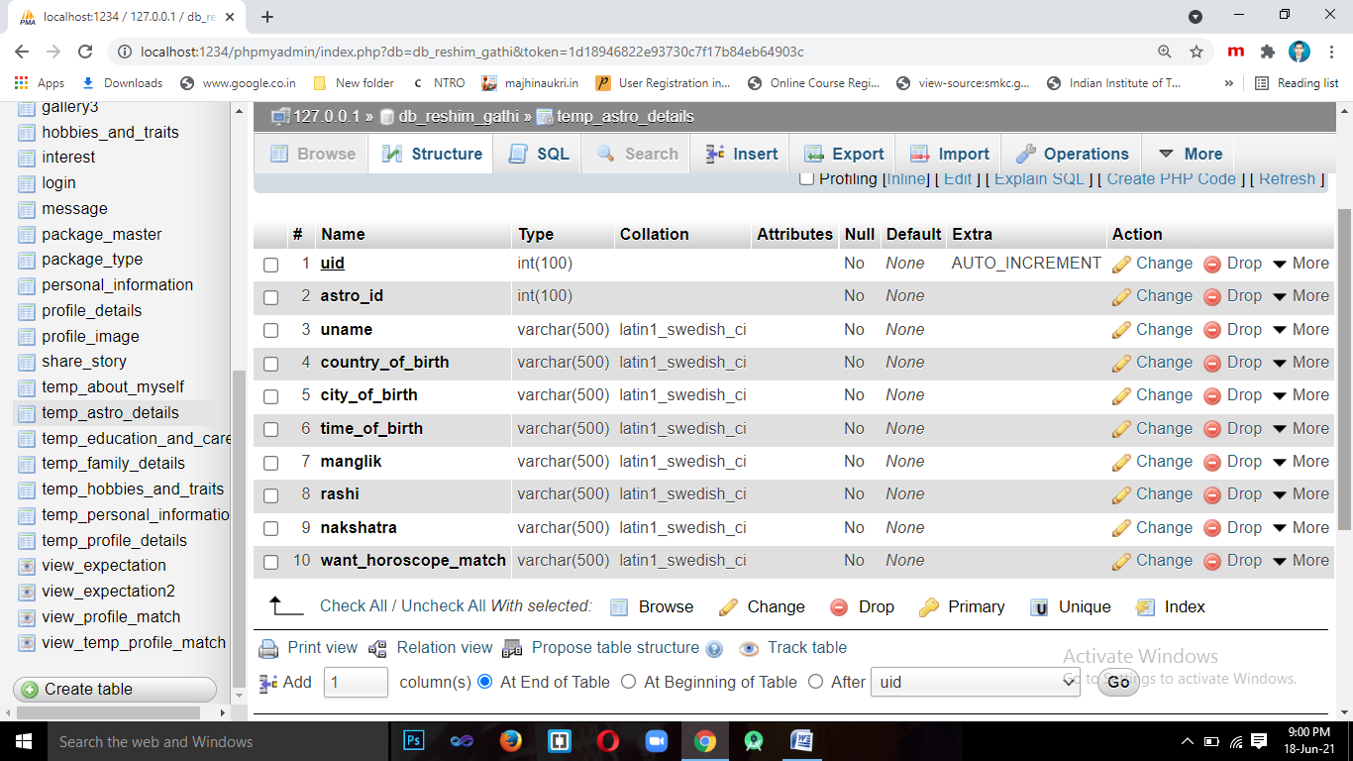

1. **Table Name**:- temp_education_And_career

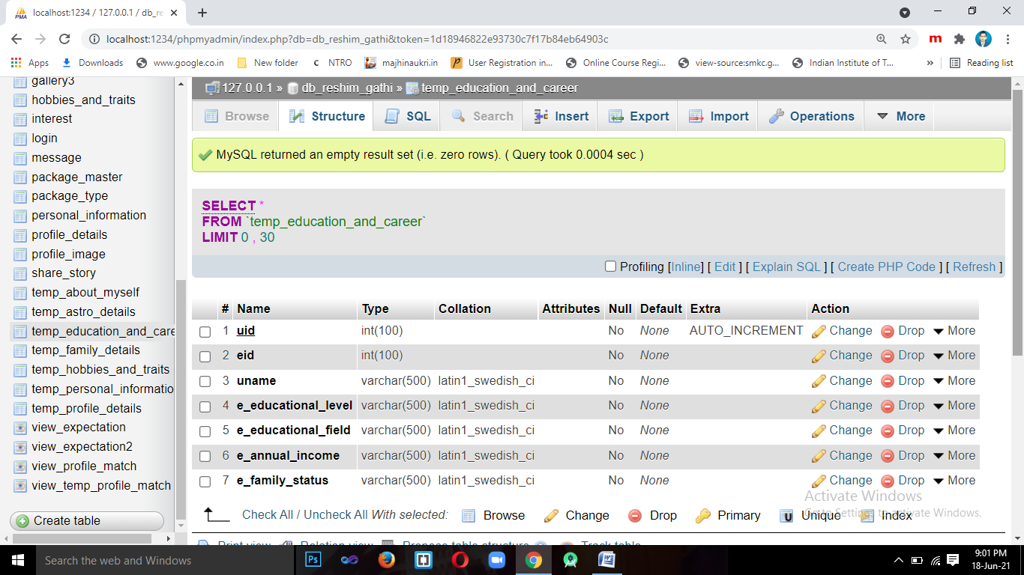

1. **Table Name**:- temp_hobbies_and_traits

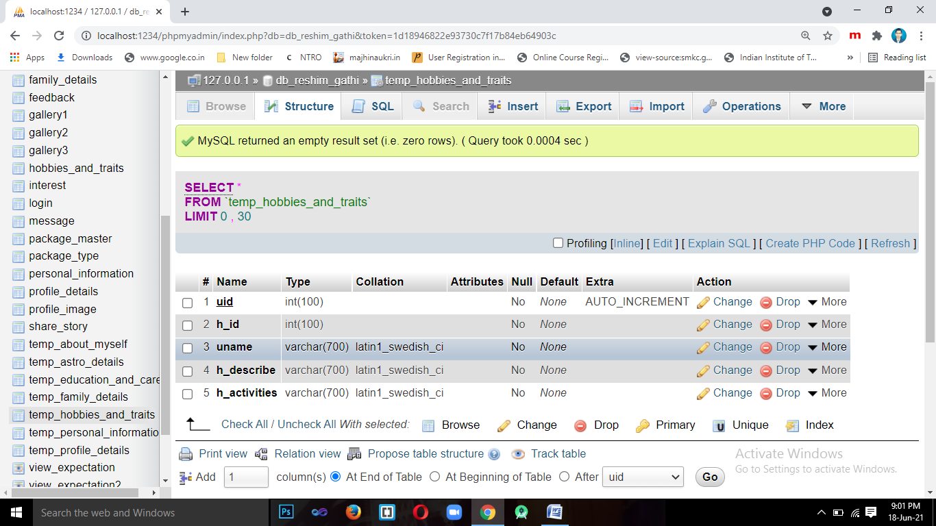

1. **Table Name**:- temp_about_myself

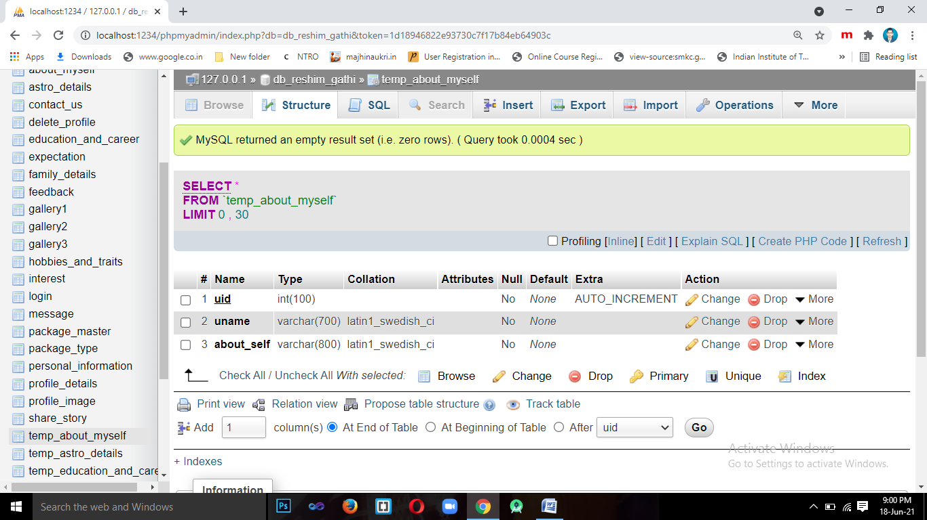

1. **Table Name**:- view_temp_profile_match

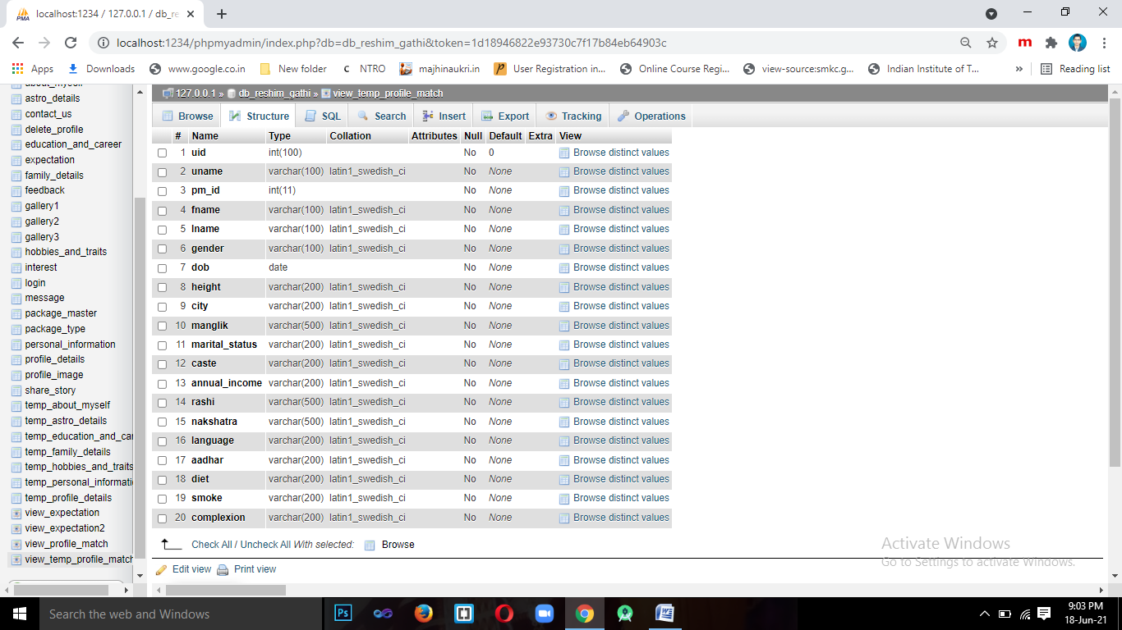

1. **Table Name**:- contact_us

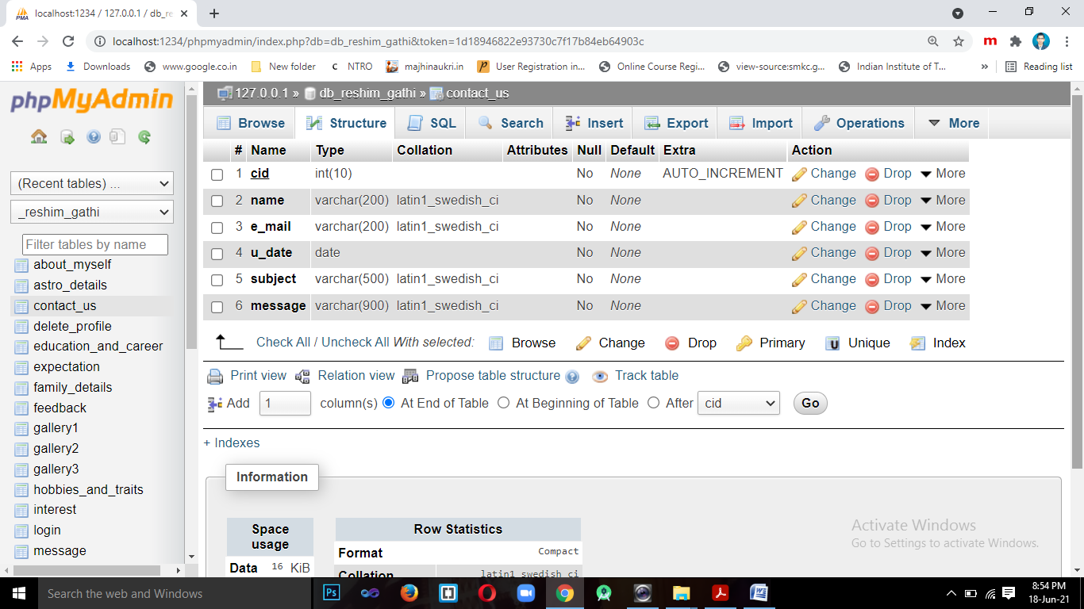

1. **Table Name**:- feedback

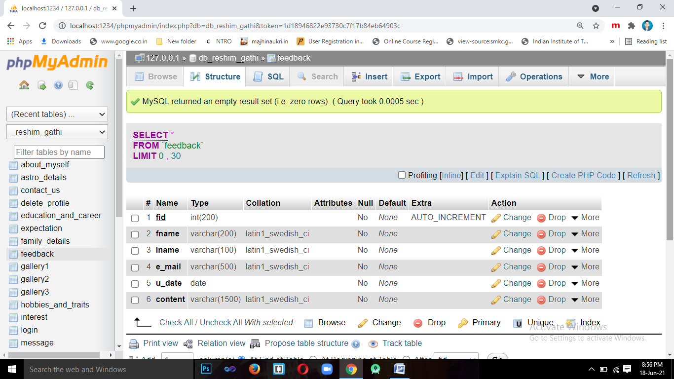

* 1. **About Environment/Platform Used: 1. Introduction to Android-**

The **Android operating system** is the largest installed base among various mobile platforms across the globe. Hundreds of millions of mobile devices are powered by **Android** in more than 190 countries of the world. It conquered around **75%**of the global market share by the end of 2020, and this trend is growing bigger every other day.

The company named **Open Handset Alliance** developed Android for the first time that is based on the modified version of the Linux kernel and other open-source software. **Google** sponsored the project at initial stages and in the year 2005, it acquired the whole company. In September 2008, the first Android-powered device launched in the market.

Android dominates the mobile OS industry because of the long list of features it provides. It’s user-friendly, has huge community support, provides a greater extent of customization, and a large number of companies build Android-compatible smartphones. As a result, the market observes a sharp increase in the demand for developing Android mobile applications, and with that companies need smart developers with the right skill set.

At first, the purpose of Android was thought of as a mobile operating system. However, with the advancement of code libraries and its popularity among developers of the divergent domain, Android becomes an absolute set of software for all devices like tablets, wearable’s, set-top boxes, smart TVs, notebooks, etc.

### Features of Android

Android is a powerful open-source operating system that open-source provides immense features and some of these are listed below.

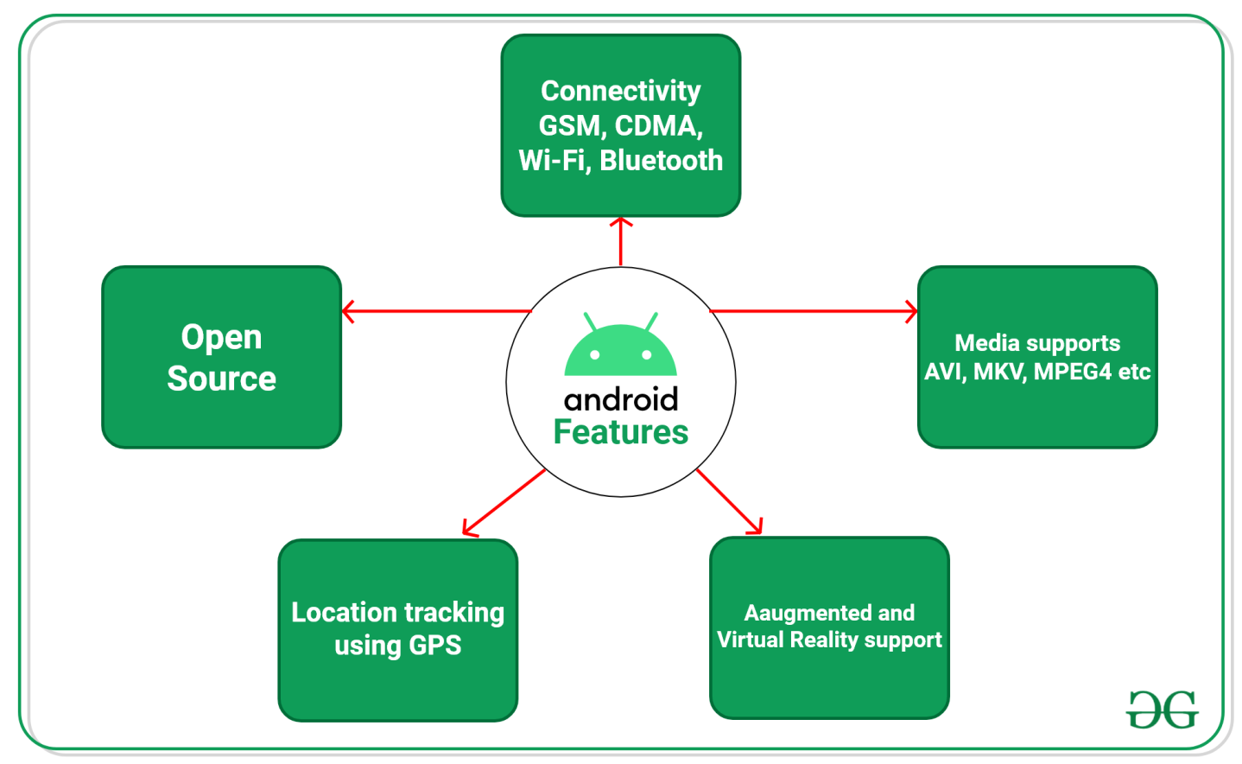

* Android Open Source Project so we can customize the OS based on our requirements.
* Android supports different types of connectivity for GSM, CDMA, Wi-Fi, Bluetooth, etc. for telephonic conversation or data transfer.
* Using wifi technology we can pair with other devices while playing games or using other applications.
* It contains multiple APIs to support location-tracking services such as GPS.
* We can manage all data storage related activities by using the file manager.
* It contains a wide range of media supports like AVI, MKV, FLV, MPEG4, etc. to play or record a variety of audio/video.
* It also supports different image formats like JPEG, PNG, GIF, BMP, MP3, etc.
* It supports multimedia hardware control to perform playback or recording using a camera and microphone.
* Android has an integrated open-source WebKit layout based web browser to support User Interface like HTML5, CSS3.
* Android supports multi-tasking means we can run multiple applications at a time and can switch in between them.
* It provides support for virtual reality or 2D/3D Graphics

### Android Versions

Google launched the first version of the Android platform on Nov 5, 2007. Since then, Google released a lot of android versions such as Apple Pie, Banana Bread, Cupcake, Donut, Éclair, Froyo, Gingerbread, Jellybeans, Kitkat, Lollipop, marshmallow, Nougat, Oreo, etc. with extra functionalities and new features.

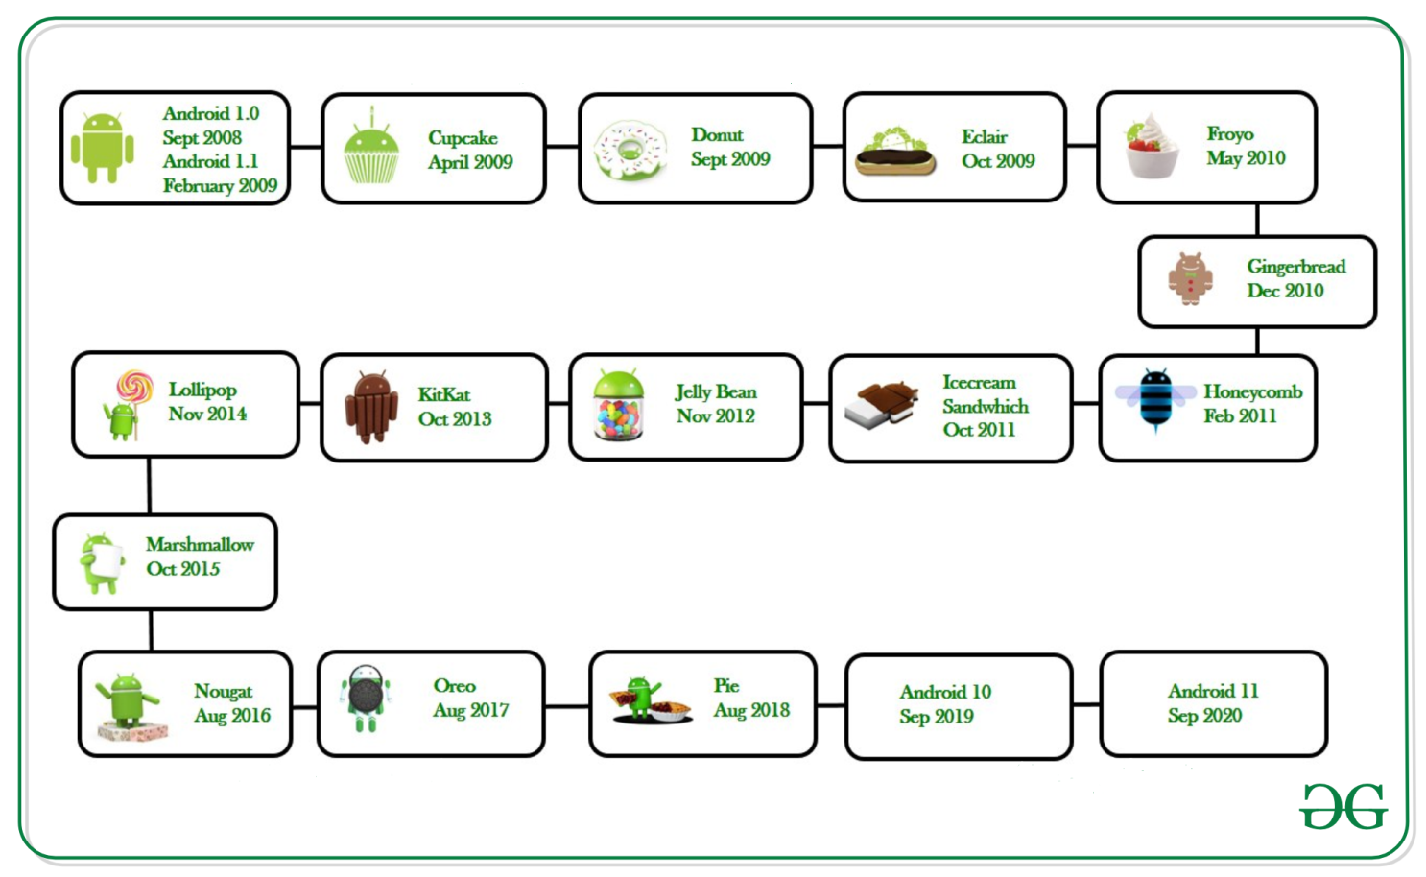

### **Programming Languages used in Developing Android Applications**

1. **Java**
2. **Kotlin**

Developing the Android Application using Kotlin is preferred by Google, as Kotlin is made an official language for Android Development, which is developed and maintained by JetBrains. Previously before the Java is considered the official language for Android Development. Kotlin is made official for Android Development in Google I/O 2017.

### ****Advantages of Android Development****

* The Android is an open-source Operating system and hence possesses a vast community for support.
* The design of the Android Application has guidelines from Google, which becomes easier for developers to produce more intuitive user applications.
* Fragmentation gives more power to Android Applications. This means the application can run two activities on a single screen.
* Releasing the Android application in the Google play store is easier when it is compared to other platforms.

### ****Disadvantages of Android Development****

* Fragmentation provides a very intuitive approach for user experience but it has some drawbacks, where the development team needs time to adjust with the various screen sizes of mobile smartphones that are now available in the market and invoke the particular features in the application.
* The Android devices might vary broadly. So the testing of the application becomes more difficult.
* As the development and testing consume more time, the cost of the application may increase, depending on the application’s complexity and features.

1. **INTRODUCTION TO HTML:-**

**HTML** stands for Hyper Text Markup Language. It is used to design web pages using a markup language. HTML is the combination of Hypertext and Markup language. Hypertext defines the link between the web pages. A markup language is used to define the text document within tag which defines the structure of web pages. This language is used to annotate (make notes for the computer) text so that a machine can understand it and manipulate text accordingly. Most markup languages (e.g. HTML) are human-readable. The language uses tags to define what manipulation has to be done on the text.

**Features of HTML:-**

* It is easy to learn and easy to use.
* It is platform-independent.
* Images, videos, and audio can be added to a web page.
* Hypertext can be added to text.
* It is a markup language.

**Advantages:-**

* HTML is used to build websites.
* It is supported by all browsers.
* It can be integrated with other languages like CSS, JavaScript, etc.

##### Limitations of HTML: -

* HTML can only create static webpages. For dynamic webpages, other languages have to be used.
* A large amount of code has to be written to create a simple web page.
* The security feature is not good.

1. **Introduction to CASCADING STYLE SHEET (CSS):**

DHTML is a new emerging technology. DHTML combines HTML with Cascading Style Sheet (CSS) and Scripting Languages. HTML specifies a web page’s elements like table, frame, paragraph, bulleted list etc. Cascading Style Sheets can be used to determine an element’s size, color, position and a number of other features. Scripting languages (JavaScript) can be used to manipulate the web page’s elements so that styles assigned to them can change in response to a user’s input.

##### Cascading Style Sheet (CSS):

Style Sheets are powerful mechanism for adding styles (e.g., fonts, colors, spacing) to Web Documents. They enforce standards and uniformity throughout a web site and provide numerous attributes to create dynamic effects. With Style Sheets, text and image formatting properties can be predefined in a single list. HTML elements on a web page can then be bound to the style sheet. The advantages of a Style Sheet include the ability to make global changes to all documents from a single location. Style Sheets are said to Cascade when they combine to specify the appearance of a page.

The Style assignment process is accomplished with the <STYLE>…</STYLE> tags. The syntax for making the assignment is simple. Between the <STYLE>…</STYLE> HTML tags, specific style attributes are listed. The <STYLE>…</STYLE>tags are written within the

<HEAD>…</HEAD> tags.

##### Advantages of CSS :-

* 1. Complete changes the appearance of the Webpage without actually changing the webpage itself.
  2. It is useful for Specifying different styles to the HTML elements. E.g. using CSS you can set background images horizontally or vertically or without repletion.

1. **Introduction to PHP-**

The PHP Hypertext Preprocessor (PHP) is a programming language that allows web developers to create dynamic content that interacts with databases. PHP is basically used for developing web based software applications. PHP is a recursive acronym for "PHP: Hypertext Preprocessor".

PHP is a server side scripting language that is embedded in HTML. It is used to manage dynamic content, databases, session tracking, even build entire e-commerce sites.

It is integrated with a number of popular databases, including MySQL, PostgreSQL, Oracle, Sybase, Informix, and Microsoft SQL Server.

PHP is pleasingly zippy in its execution, especially when compiled as an Apache module on the Unix side. The MySQL server, once started, executes even very complex queries with huge result sets in record-setting time.

PHP supports a large number of major protocols such as POP3, IMAP, and LDAP. PHP4 added support for Java and distributed object architectures (COM and CORBA), making n-tier development a possibility for the first time.

PHP is forgiving: PHP language tries to be as forgiving as possible. PHP Syntax is C-Like.

##### Common uses of PHP:

* 1. PHP performs system functions, i.e. from files on a system it can create, open, read, write, and close them.
  2. PHP can handle forms, i.e. gather data from files, save data to a file, thru email you can send data, return data to the user.
  3. You add, delete, modify elements within your database thru PHP.
  4. Access cookies variables and set cookies.
  5. Using PHP, you can restrict users to access some pages of your website.
  6. It can encrypt data.

1. **Introduction to MYSQL:**

##### What is database?

A database is a collection of information related to a particular subject or purpose, such as customer order or maintaining billing details. If your database is not stored on computer or only part of it is stored, you may be tracking information from a variety of source that are required to co-ordination and organize yourself.

So nowadays, we use relational database management systems (RDBMS) to store and manage huge volume of data. This is called relational database because all the data is stored into different tables and relations are established using primary keys or other keys known as foreign keys.

##### MySQL Database:

MySQL is a fast, easy-to-use RDBMS being used for many small and big businesses. MySQL is developed, marketed, and supported by MySQL AB, which is a Swedish company. MySQL is becoming so popular because of many good reasons:

* 1. MySQL is released under an open-source license. So you have nothing to pay to use it.
  2. MySQL is a very powerful program in its own right. It handles a large subset of the functionality of the most expensive and powerful database packages.
  3. MySQL uses a standard form of the well-known SQL data language.
  4. MySQL works on many operating systems and with many languages including PHP, PERL, C, C++, JAVA, etc.
  5. MySQL works very quickly and works well even with large data sets.
  6. MySQL is very friendly to PHP, the most appreciated language for web development.
  7. MySQL supports large databases, up to 50 million rows or more in a table. The default file size limit for a table is 4GB, but you can increase this (if your operating system can handle it) to a theoretical limit of 8 million terabytes (TB).

1. **Introduction to XAMPP:**

XAMPP is a [free and open source](https://en.wikipedia.org/wiki/Free_software) [cross-platform](https://en.wikipedia.org/wiki/Cross-platform) [web server](https://en.wikipedia.org/wiki/Web_server) [solution stack](https://en.wikipedia.org/wiki/Solution_stack) package developed by Apache Friends, consisting mainly of the [Apache HTTP Server](https://en.wikipedia.org/wiki/Apache_HTTP_Server), [MariaDB](https://en.wikipedia.org/wiki/MariaDB) [database,](https://en.wikipedia.org/wiki/Database) and [interpreters](https://en.wikipedia.org/wiki/Interpreter_(computing)) for scripts written in the [PHP](https://en.wikipedia.org/wiki/PHP) and [Perl](https://en.wikipedia.org/wiki/Perl) [programming languages.](https://en.wikipedia.org/wiki/Programming_language) XAMPP stands for Cross-Platform (X), Apache (A), MariaDB (M), PHP (P) and Perl (P). It is a simple, lightweight Apache distribution that makes it extremely easy for developers to create a local web server for testing and deployment purposes. Everything needed to set up a web server – server application (Apache), database (MariaDB), and scripting language (PHP) – is included in an extractable file. XAMPP is also cross-platform, which means it works equally well on Linux, Mac and Windows. Since most actual web server deployments use the same components as XAMPP, it makes transitioning from a local test server to a live server extremely easy as well.

##### Features:

XAMPP is regularly updated to the latest releases of [Apache,](https://en.wikipedia.org/wiki/Apache_HTTP_Server) [MariaDB,](https://en.wikipedia.org/wiki/MariaDB) [PHP](https://en.wikipedia.org/wiki/PHP) and [Perl.](https://en.wikipedia.org/wiki/Perl) It also comes with a number of other modules including [OpenSSL,](https://en.wikipedia.org/wiki/OpenSSL) [phpMyAdmin,](https://en.wikipedia.org/wiki/PhpMyAdmin) [MediaWiki,](https://en.wikipedia.org/wiki/MediaWiki) [Joomla,](https://en.wikipedia.org/wiki/Joomla) [WordPress](https://en.wikipedia.org/wiki/WordPress) and more. Self-contained, multiple instances of XAMPP can exist on a single computer, and any given instance can be copied from one computer to another. XAMPP is offered in both a full and a standard version (Smaller version).

1. **Introduction to Bootstrap:**

Bootstrap is a powerful front-end framework for faster and easier web development. It includes HTML and CSS based design templates for common user interface components like Typography, Forms, Buttons, Tables, Navigations, Dropdowns, Alerts, Modals, Tabs, Accordion, Carousel and many other as well as optional JavaScript extensions. Bootstrap also gives you ability to create responsive layout with much less efforts.

##### Advantages of Bootstrap:

The biggest advantage of using Bootstrap is that it comes with free set of tools for creating flexible and responsive web layouts as well as common interface components.

Additionally, using the Bootstrap data APIs you can create advanced interface components like Scroll spy and Type heads without writing a single line of JavaScript.

Here are some more advantages, why one should opt for Bootstrap:Save lots of time — You can save lots of time and efforts using the Bootstrap predefined design templates and classes and concentrate on other development work.

* 1. Responsive features — Using Bootstrap you can easily create responsive designs. Bootstrap responsive features make your web pages to appear more appropriately on different devices and screen resolutions without any change in markup.
  2. Consistent design — All Bootstrap components share the same design templates and styles through a central library, so that the designs and layouts of your web pages are consistent throughout your development.
  3. Easy to use — Bootstrap is very easy to use. Anybody with the basic working knowledge of HTML and CSS can start development with Bootstrap.
  4. Compatible with browsers — Bootstrap is created with modern browsers in mind and it is compatible with all modern browsers such as Mozilla Firefox, Google Chrome, Safari, Internet Explorer, and Opera.
  5. Open Source — And the best part is, it is completely free to download and use.

# CHAPTER FOUR “USER INTERFACE AND

**REPORTS”**

## USER INTERFACE AND REPORTS

##### USER INTERFACE (INPUT SCREEN)

* 1. **REPORTS (OUTPUT SCREEN)**
  2. **HARDWARE AND SOFTWARE REQUIREMENT**
  3. **USER MANUAL**

1. **USER INTERFACE AND REPORTS:**
   1. **User interface/Input Design :-**
2. **Member Interface**

**Home Page**

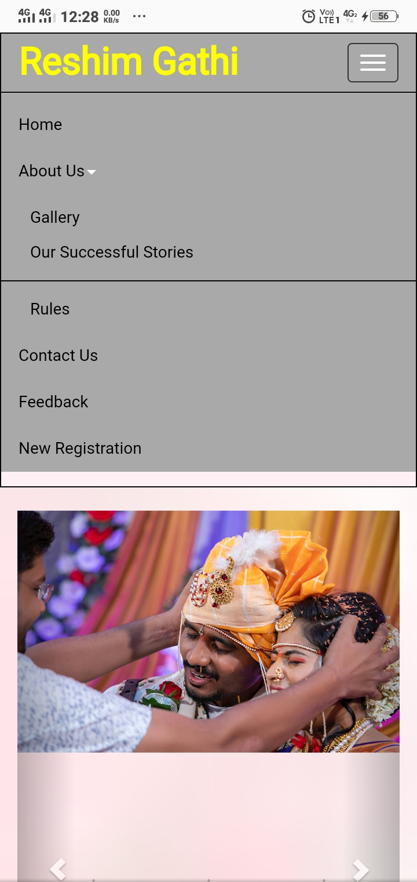

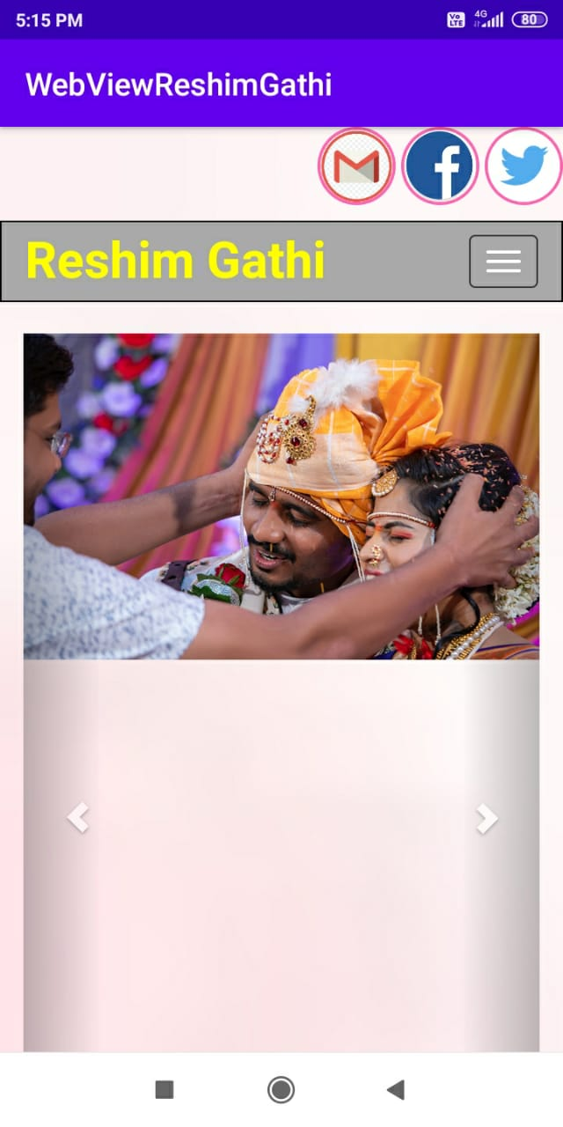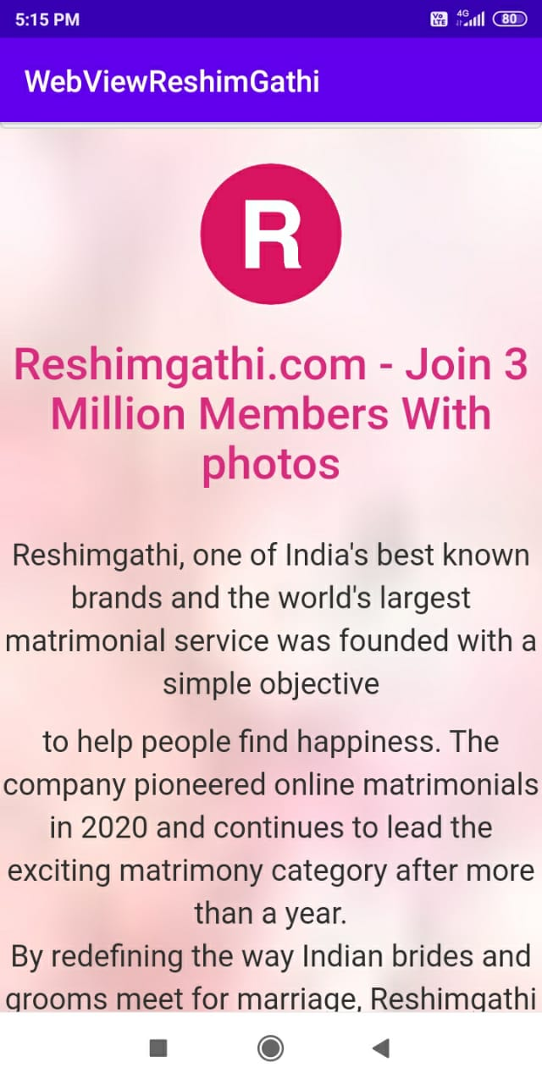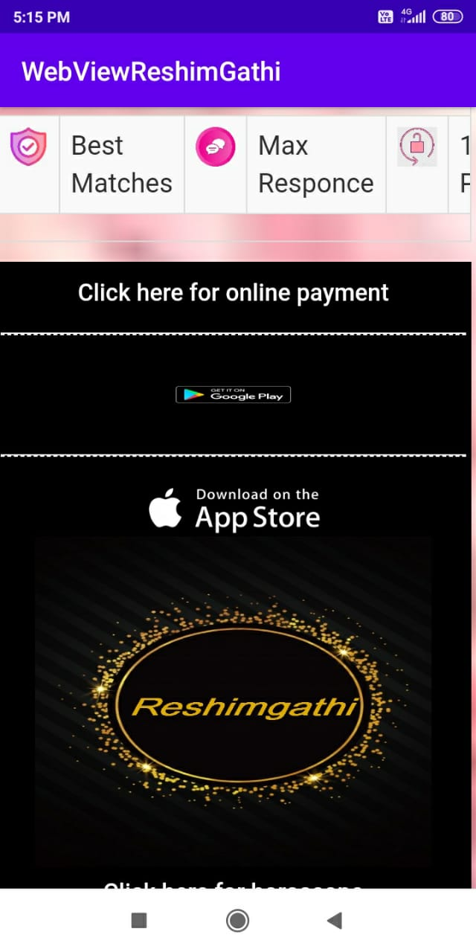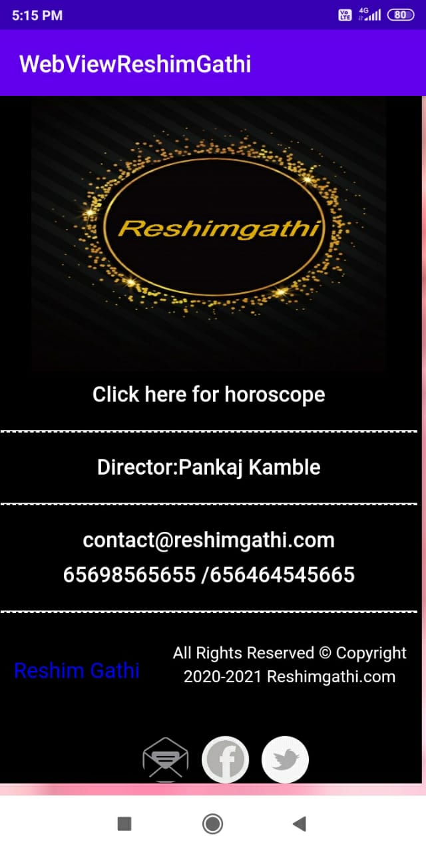

**About Us**

**Description:- This page shows information about ReshimGathi**

* 1. **Gallery**

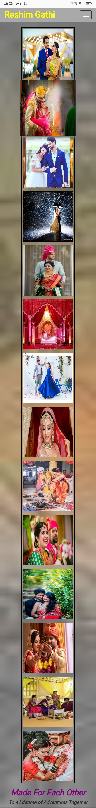

* 1. **Our Successful Stories**

**Description:- Here you can view stories of people who found their partner through ReshimGathi**

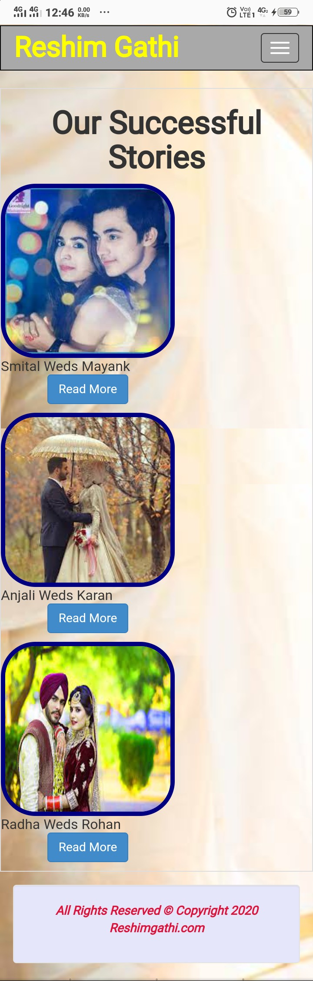

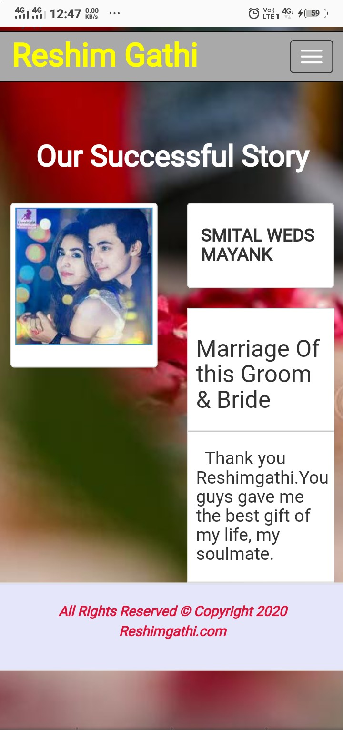

**Contact Us**

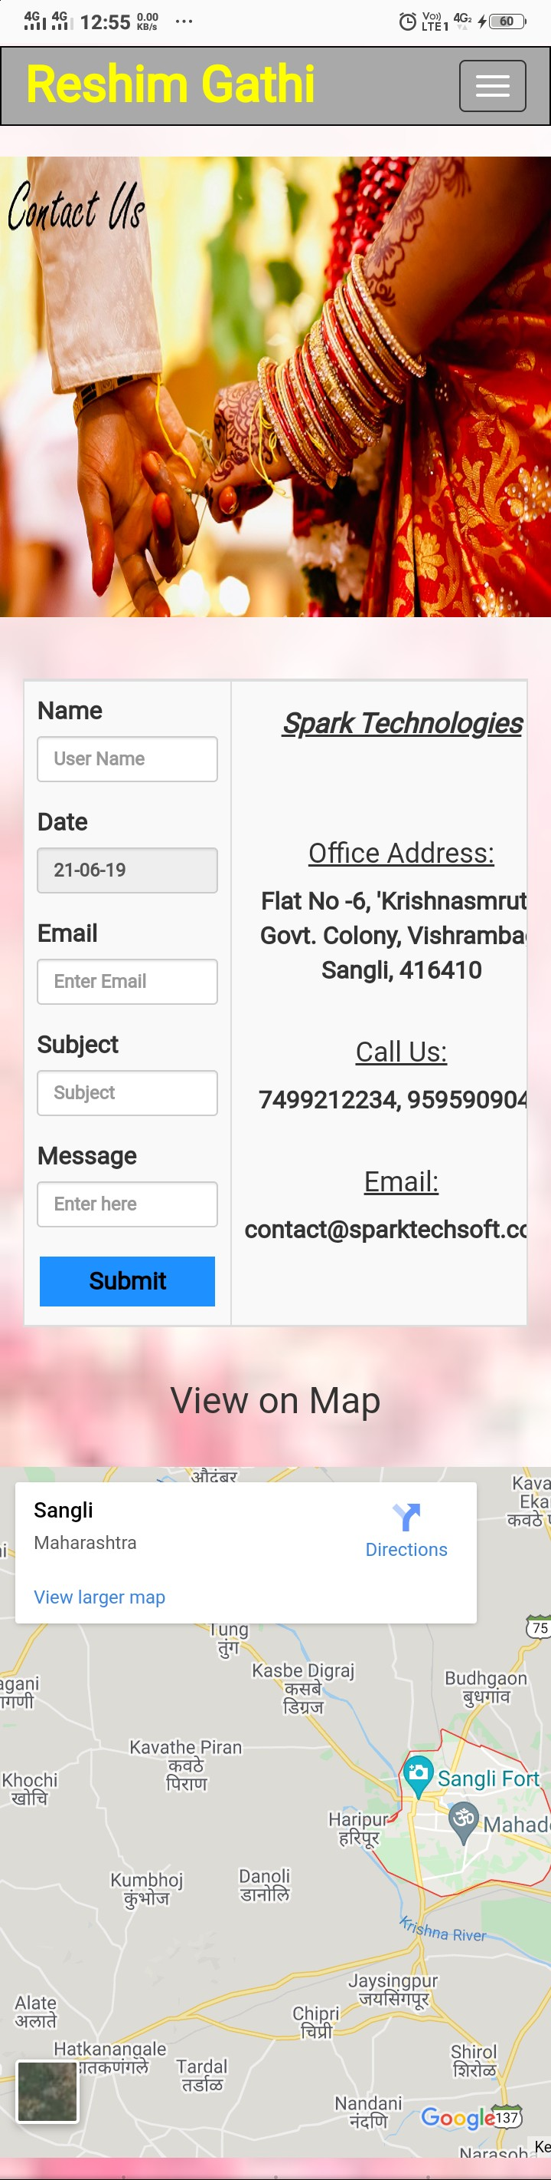

**Feedback**

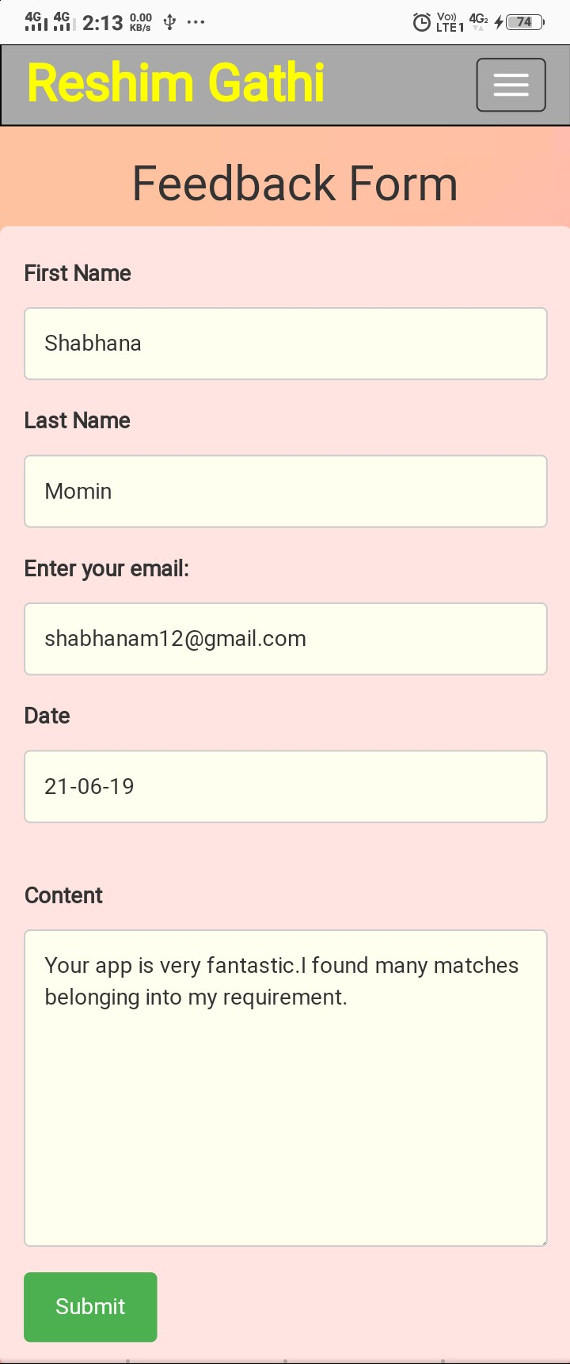

**Register**

**Description:- New user can register here.**

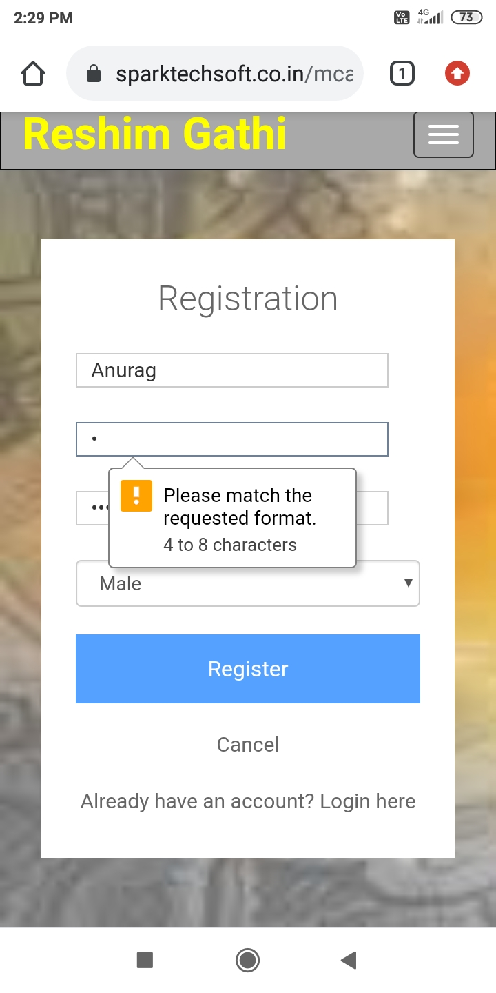

**Login**

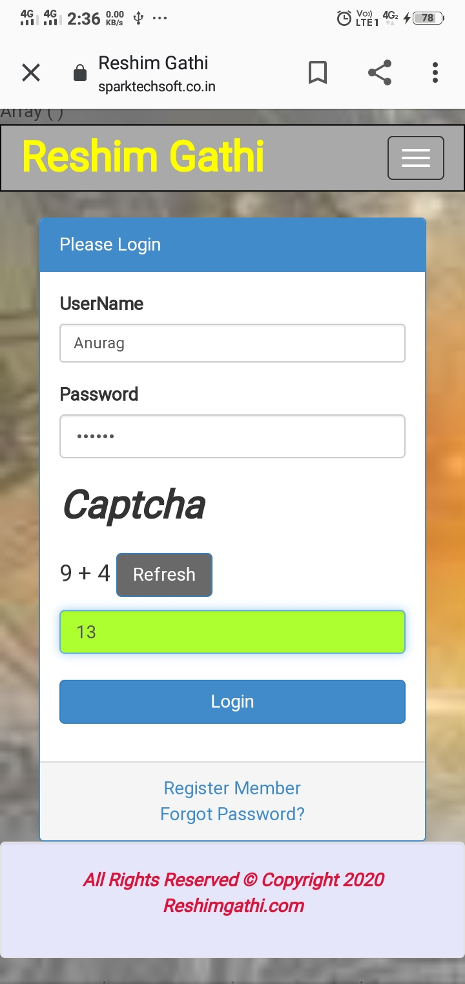

**Forgot Password**

**Description:- You can recover password here.**

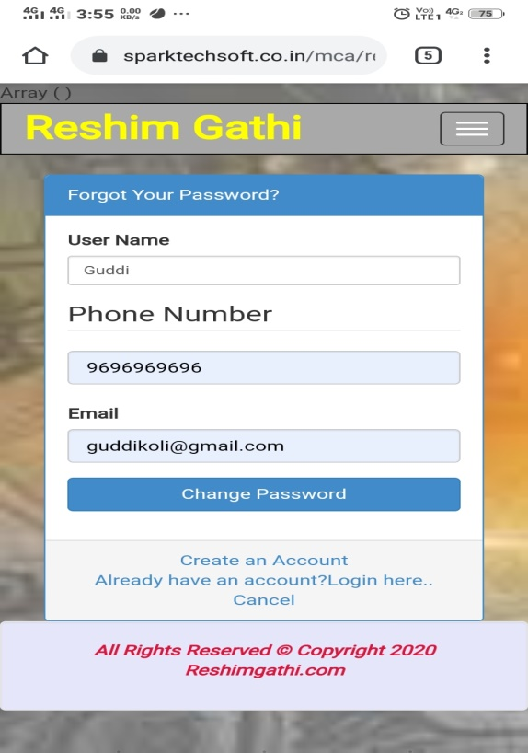

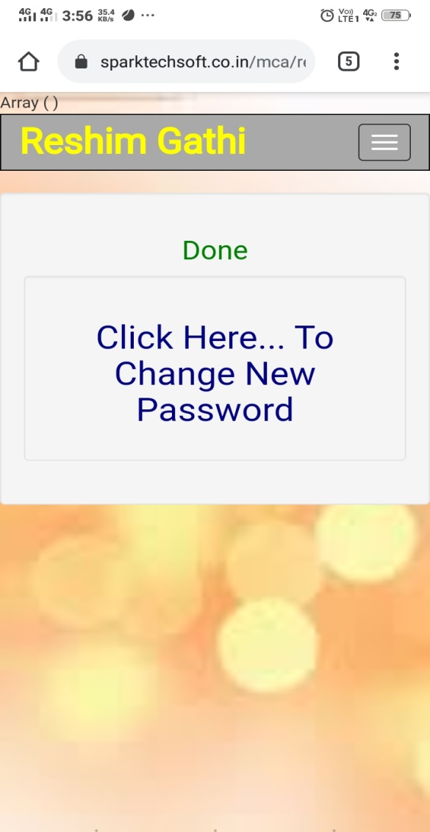

**Change Password**

**Description:- Here you can generate new password.**

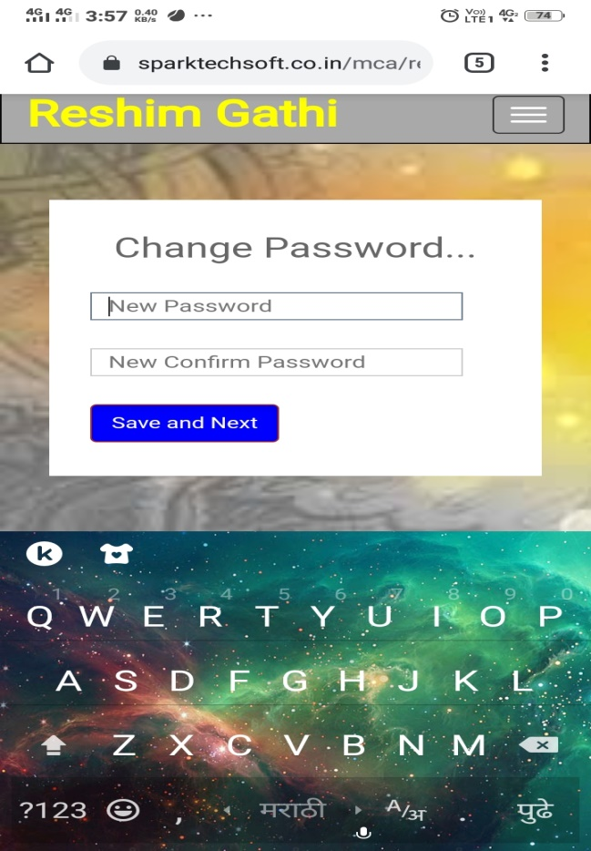

**Member Panel**

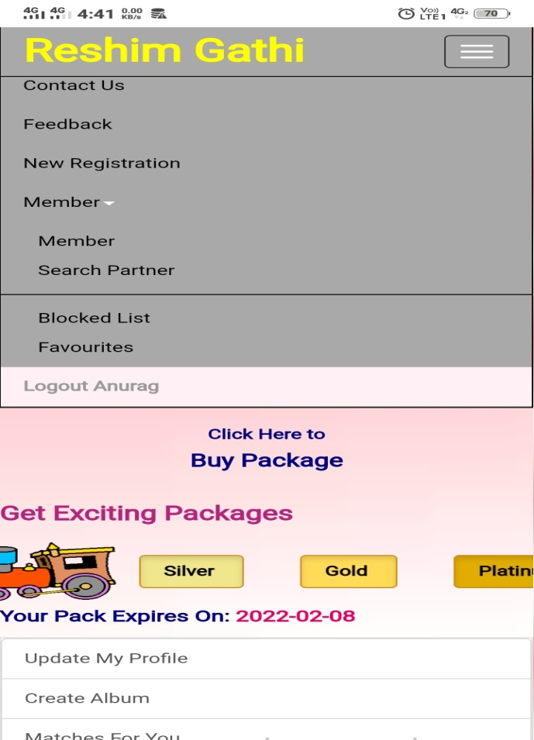

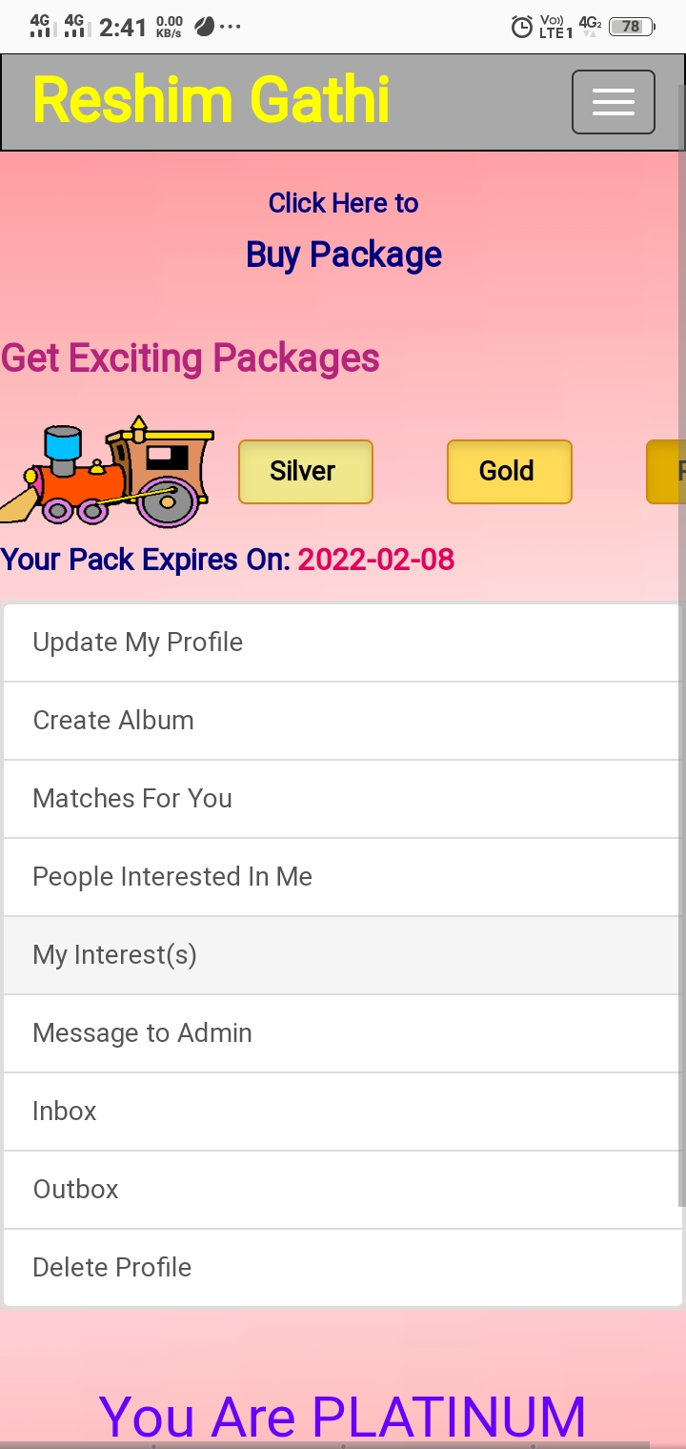

**Create Profile**

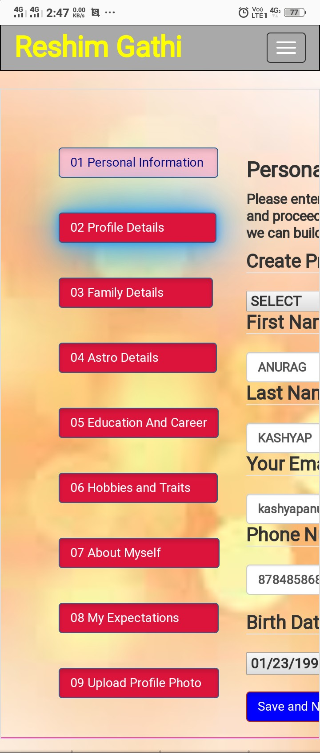

* 1. **Personal Information:-**

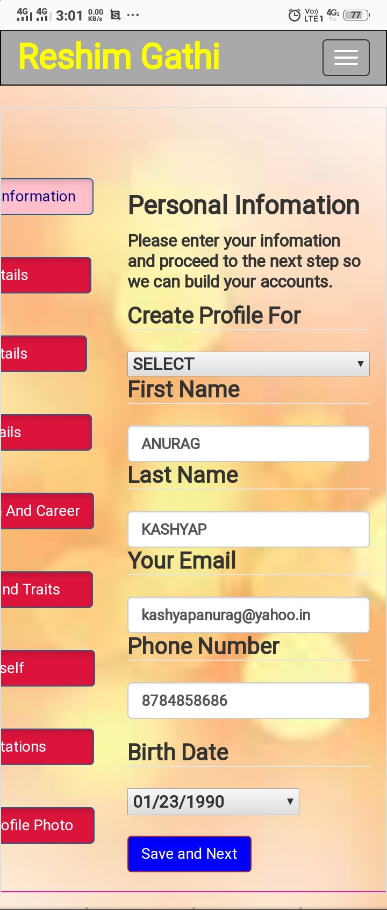

* 1. **Profile Details:-**

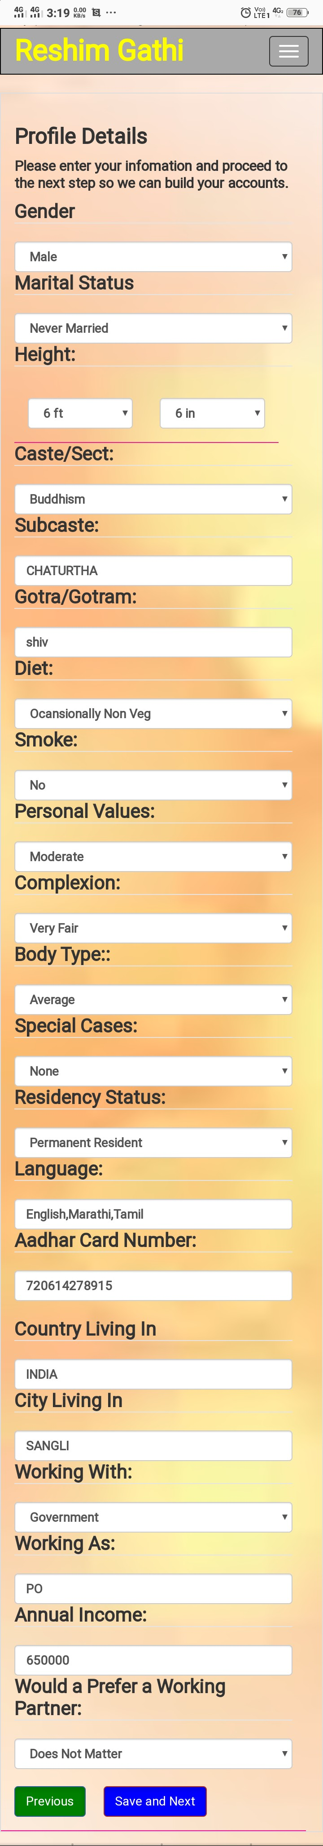

* 1. **Family Details:-**

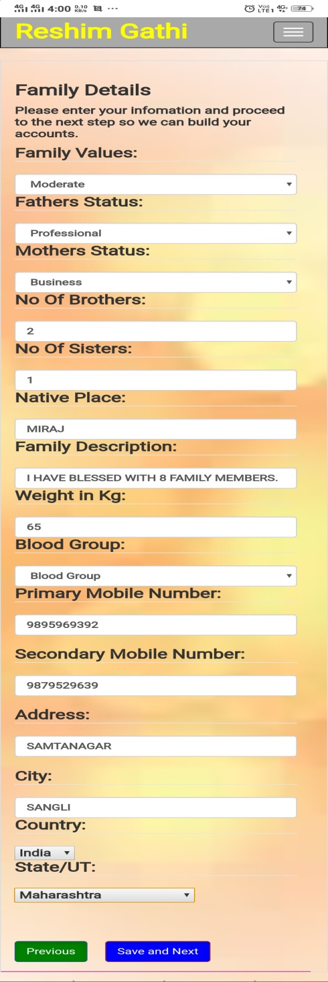

* 1. **Astrological Details:-**

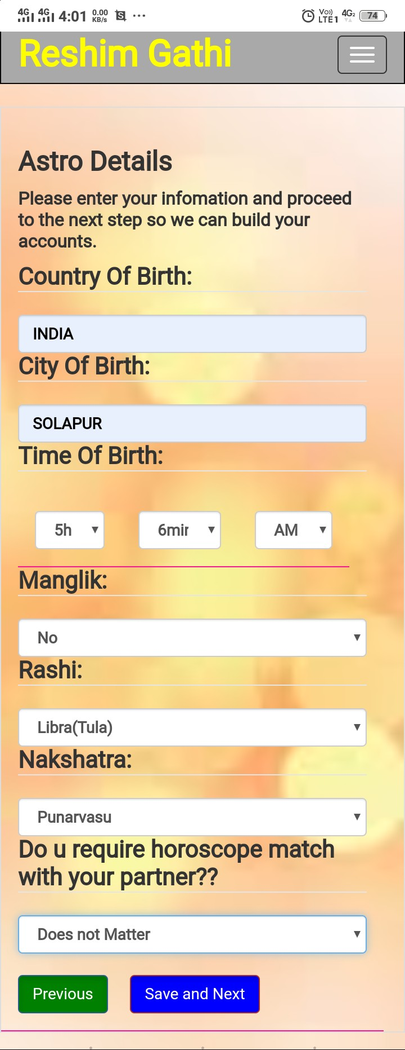

* 1. **Education and Career:-**

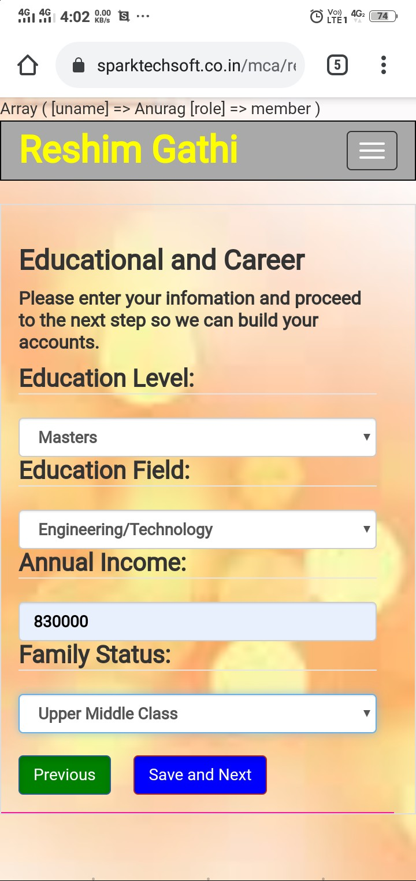

* 1. **Hobbies and Traits:-**

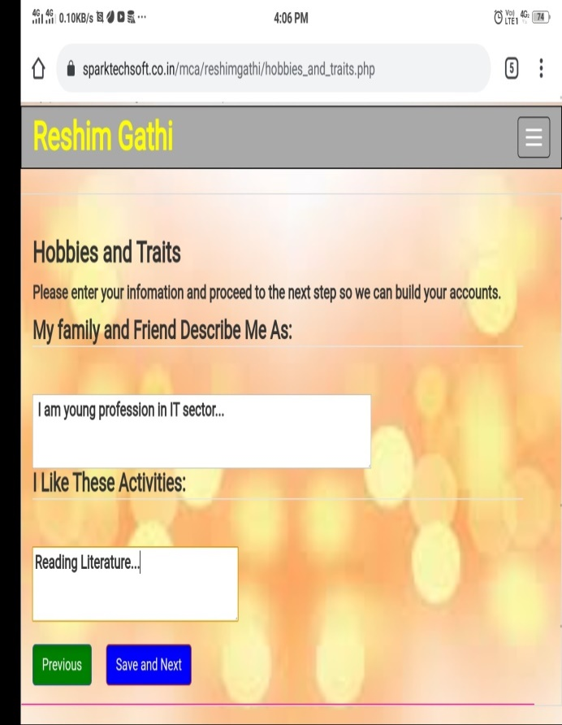

* 1. **About Myself:-**

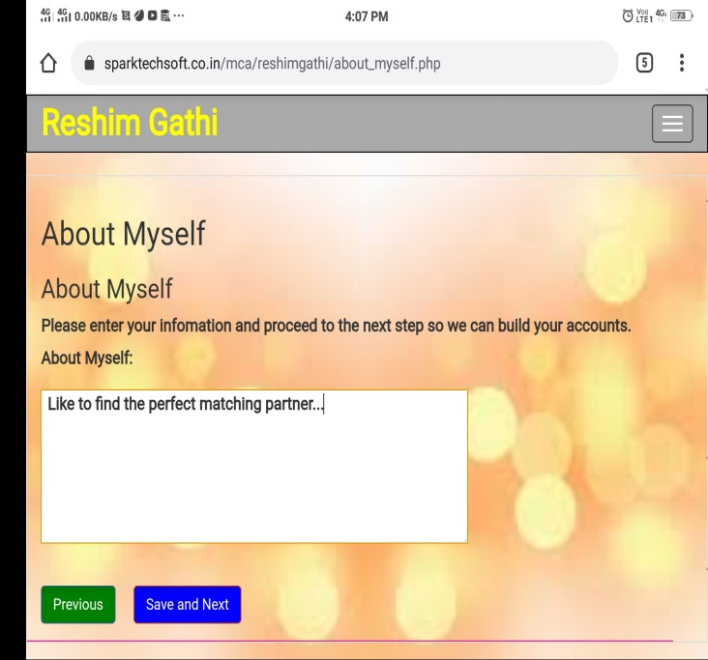

* 1. **My Expectations:-**

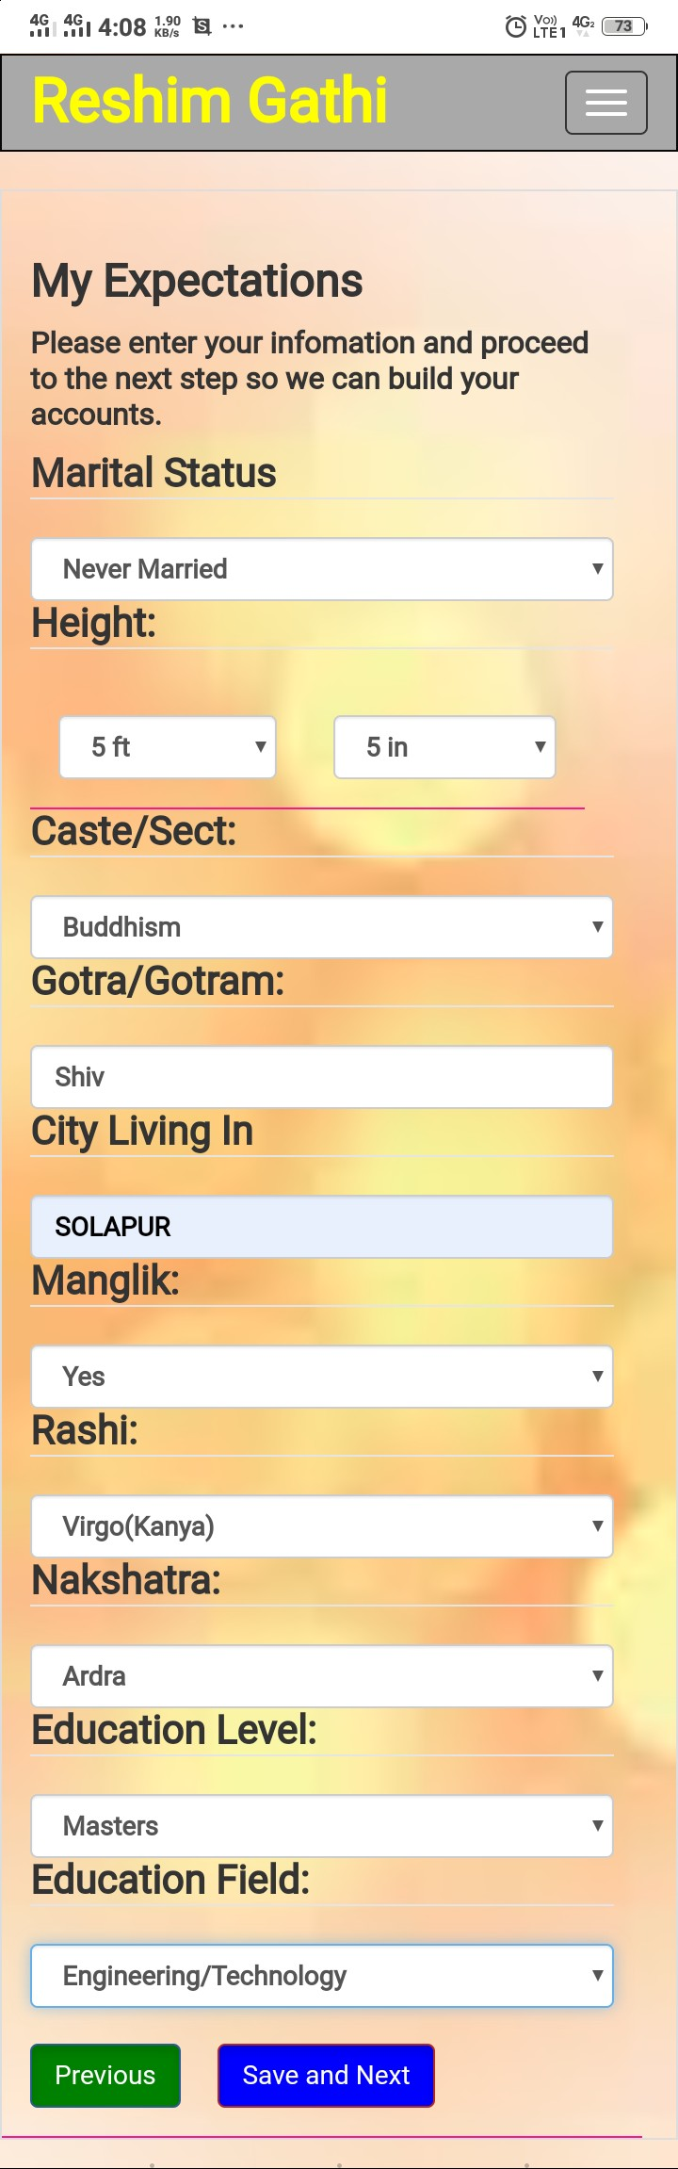

* 1. **Upload Profile Photo**

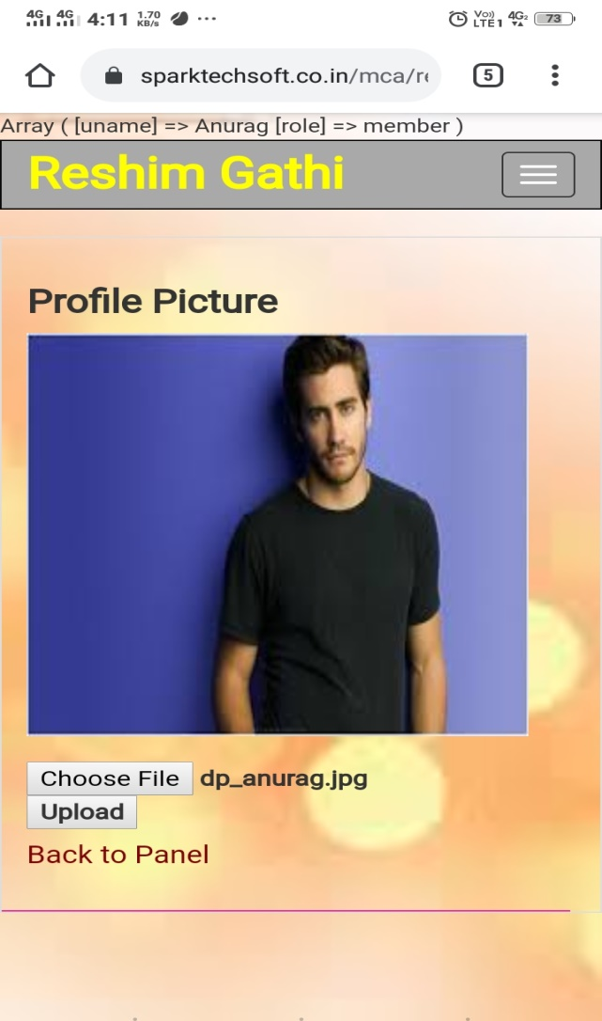

**Create Album**

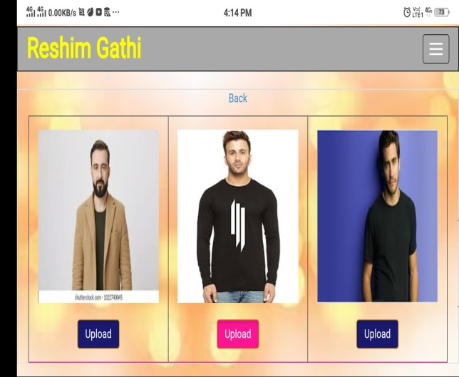

**View Package Quotation**

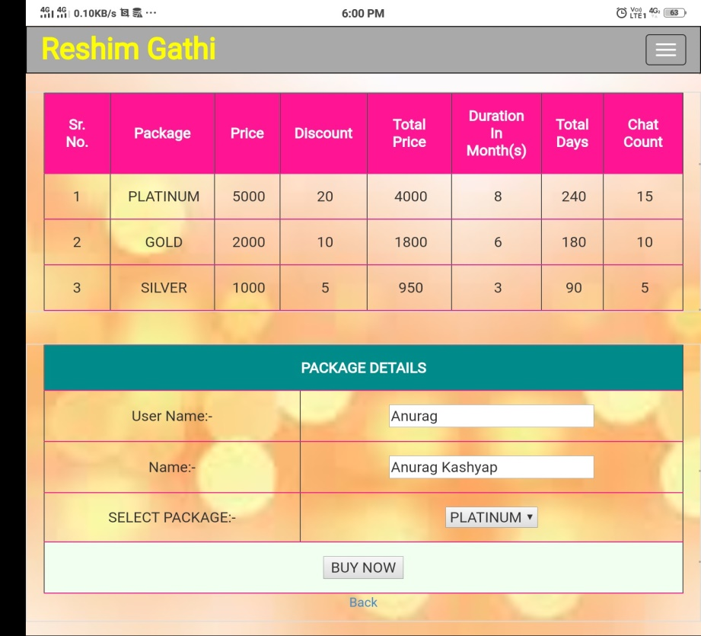

**Buy Package**

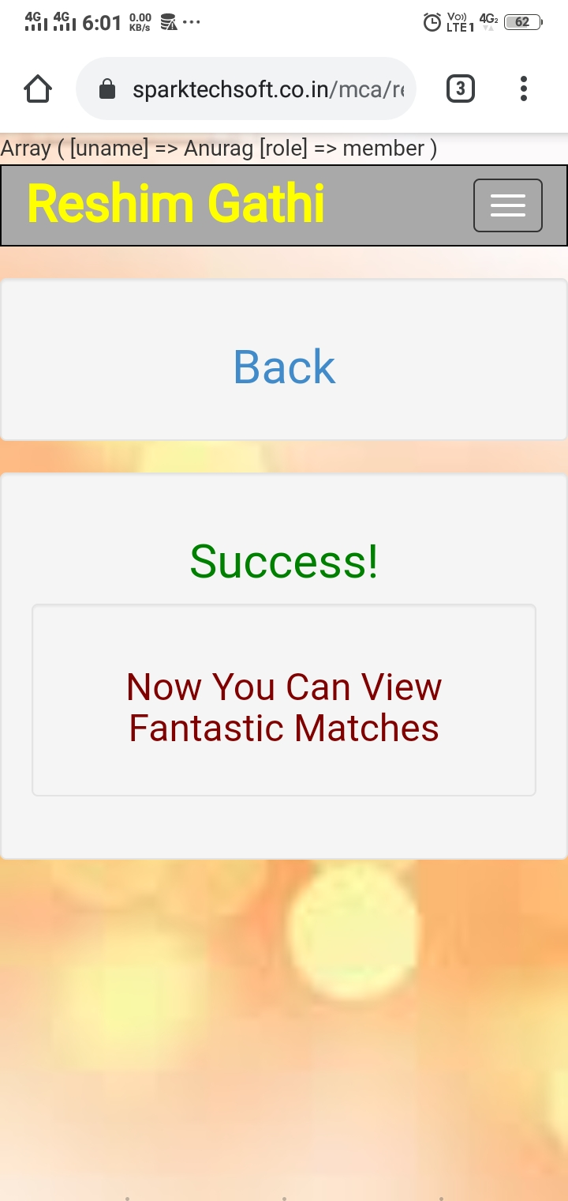

**Send Message to Admin**

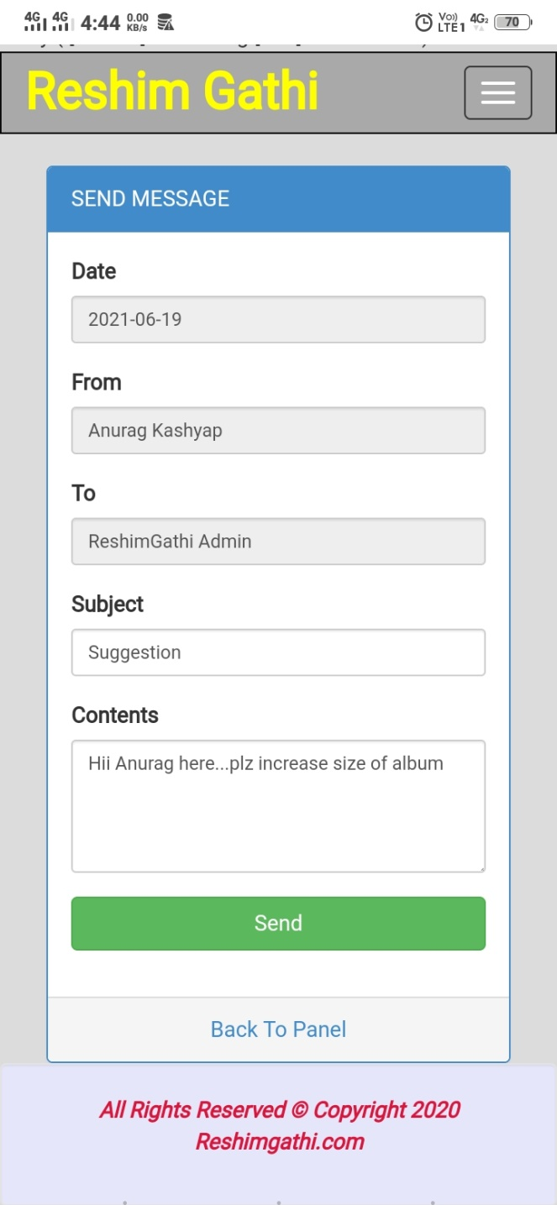

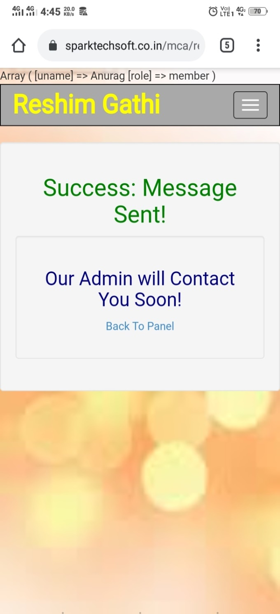

**4.2. Output Screen**

**Matches for You**

**Search Filter**

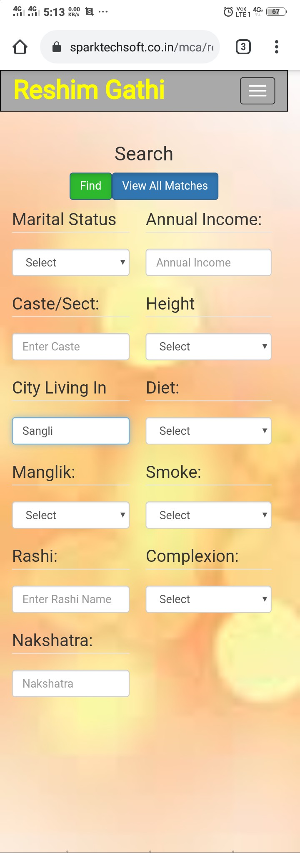

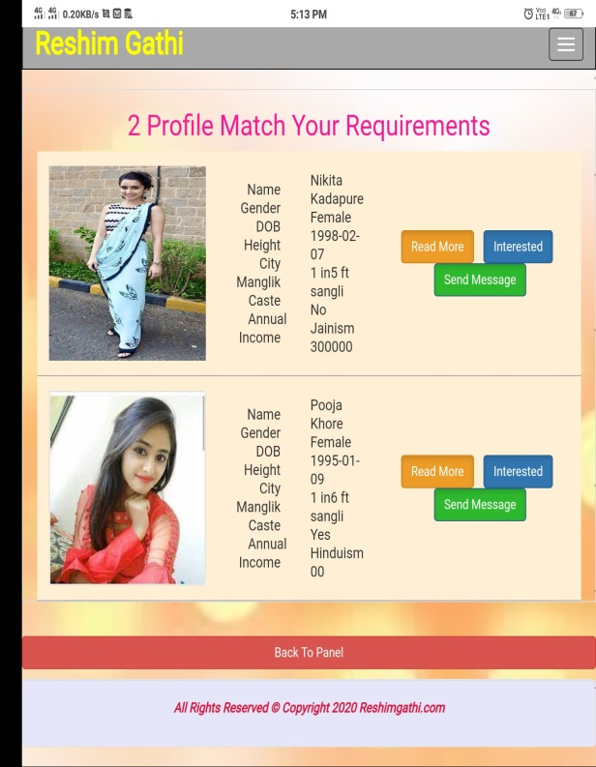

**View All Matches**

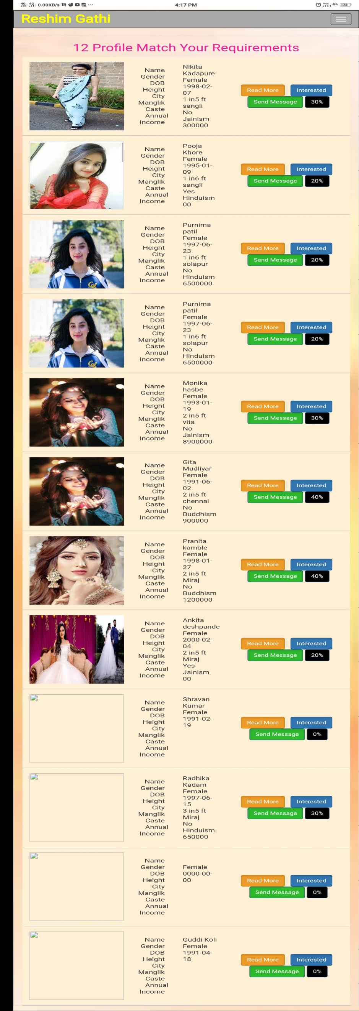

**View Profile**

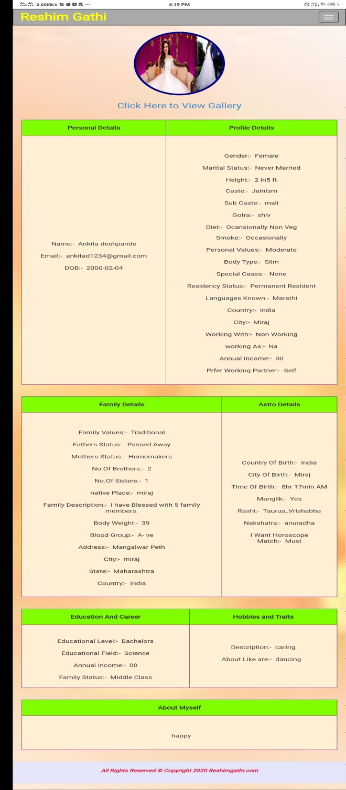

**View Gallery**

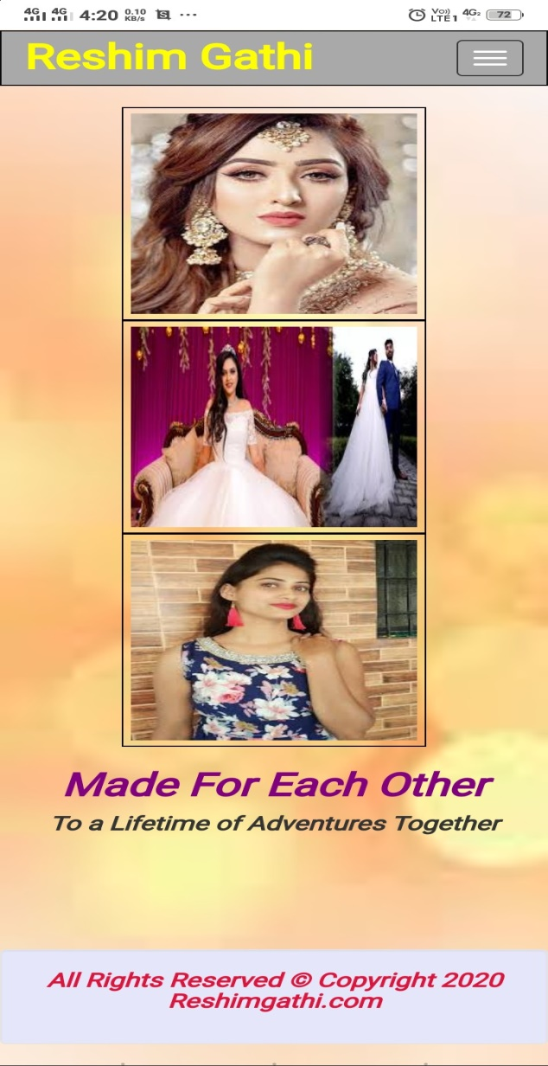

**Send Interest**

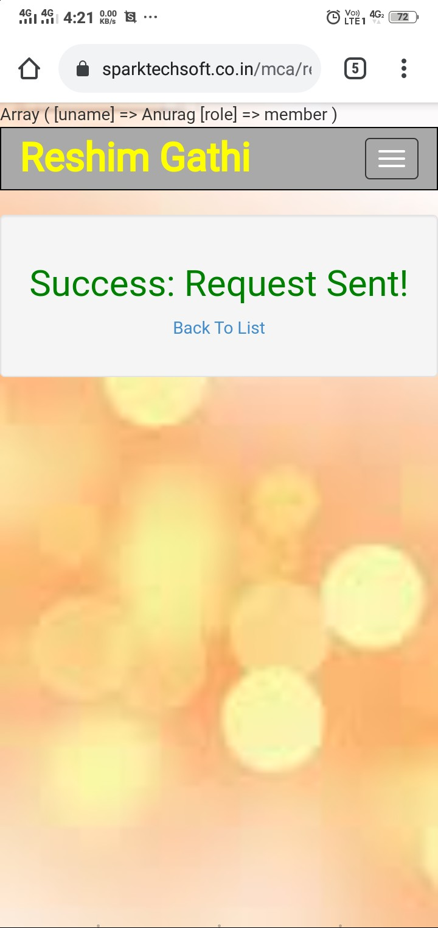

**Send Message**

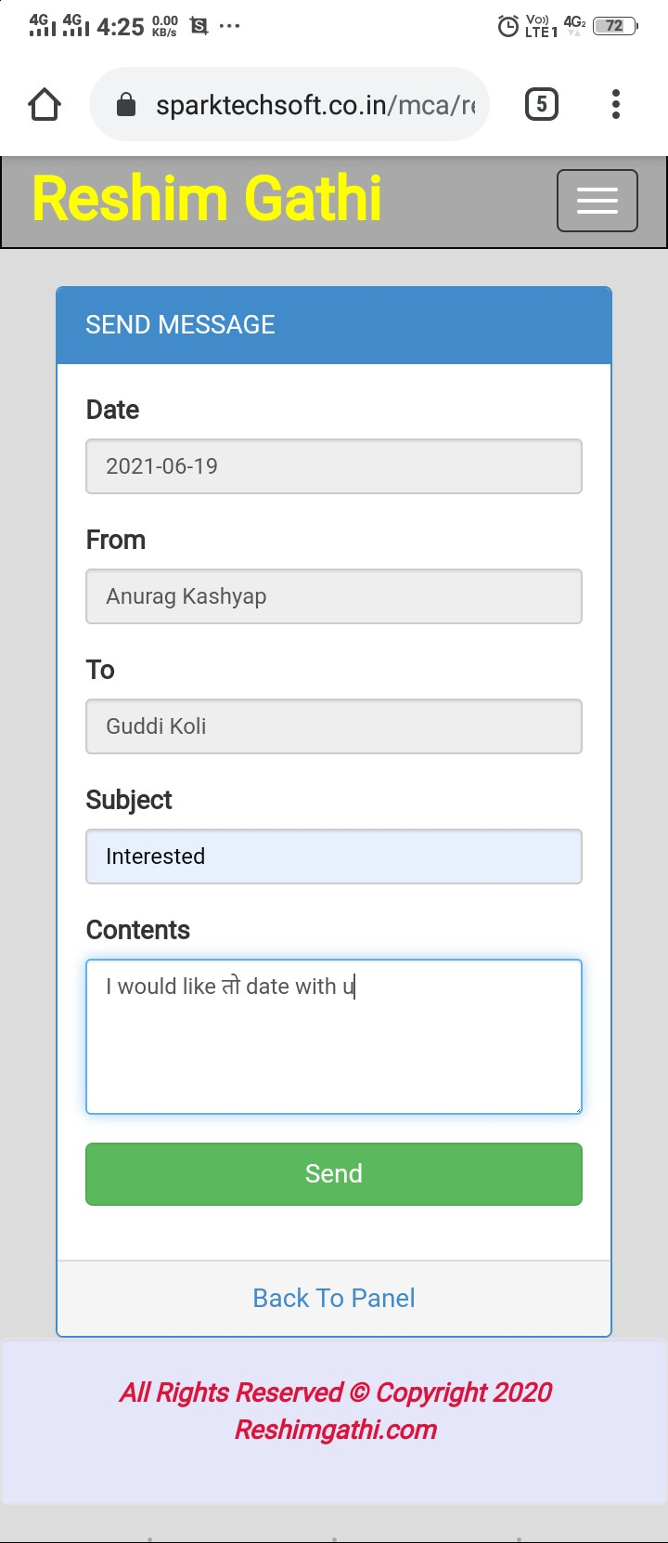

**View Chat Limit**

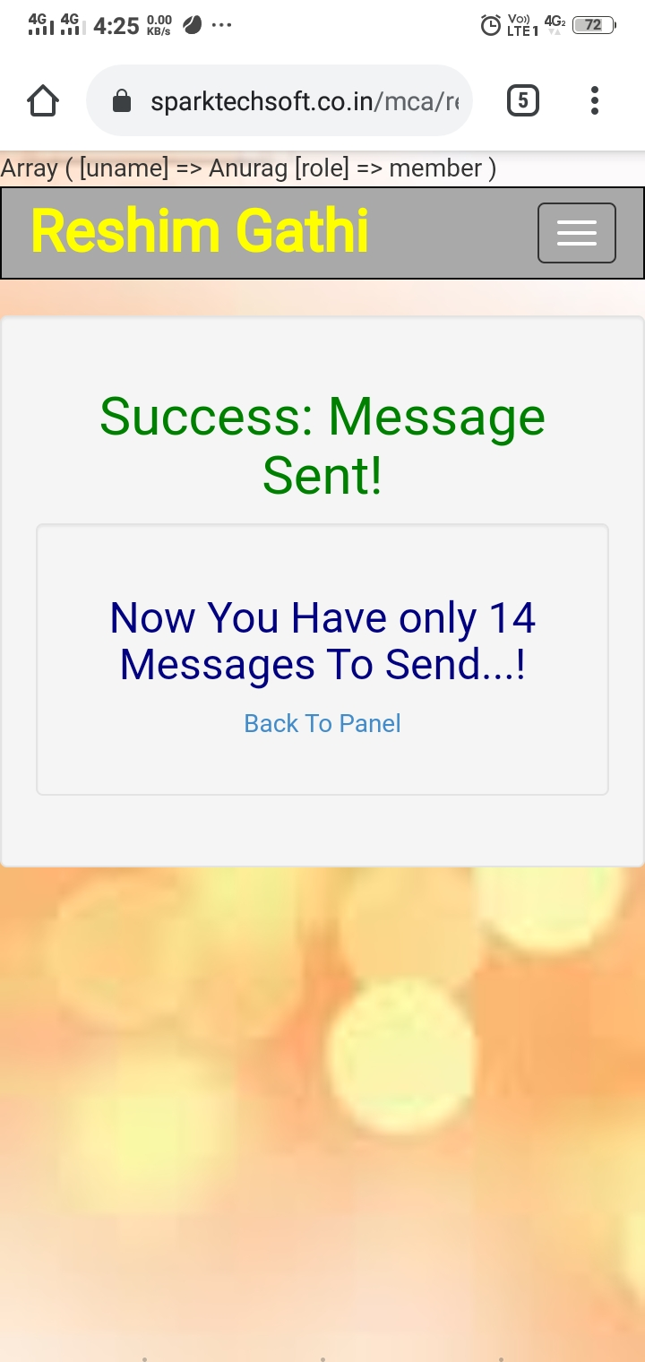

**People Interested in Me**

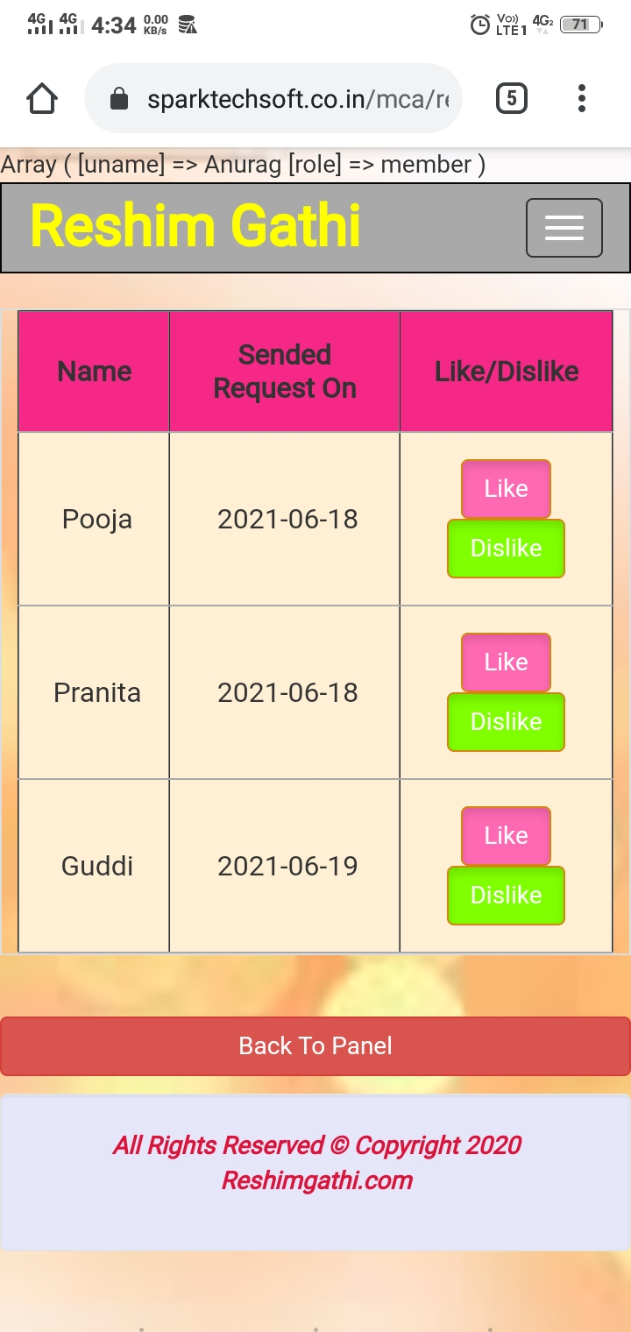

**Send Like**

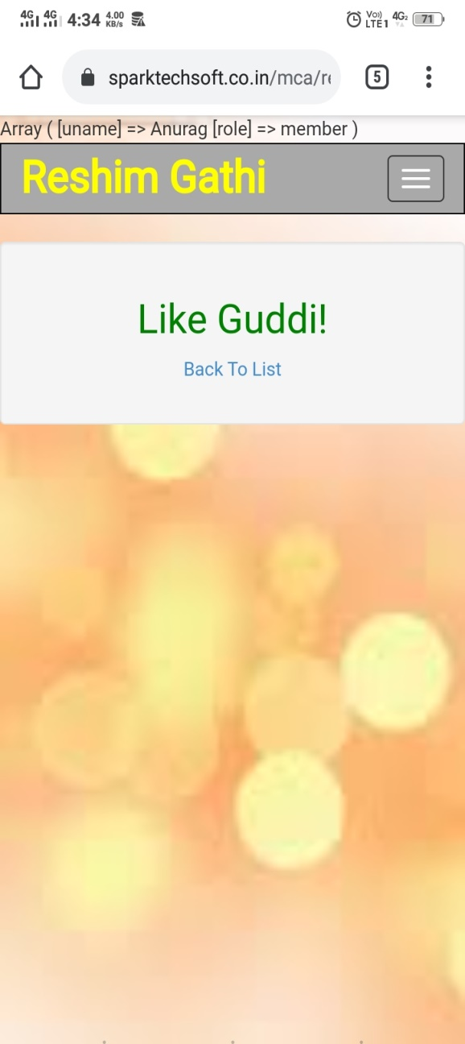

**My Interest(s)**

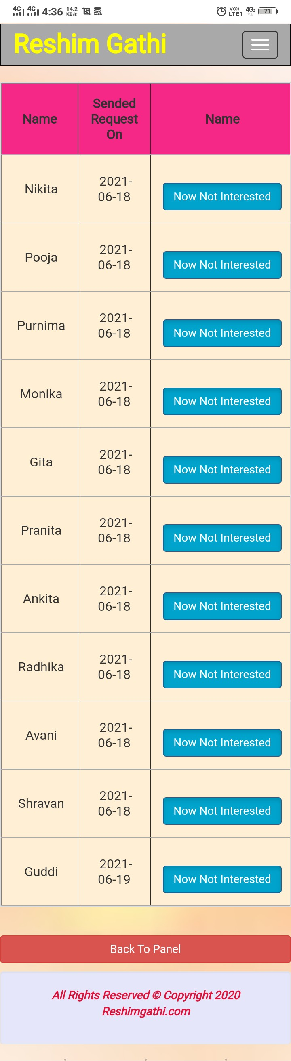

**Send Interest**

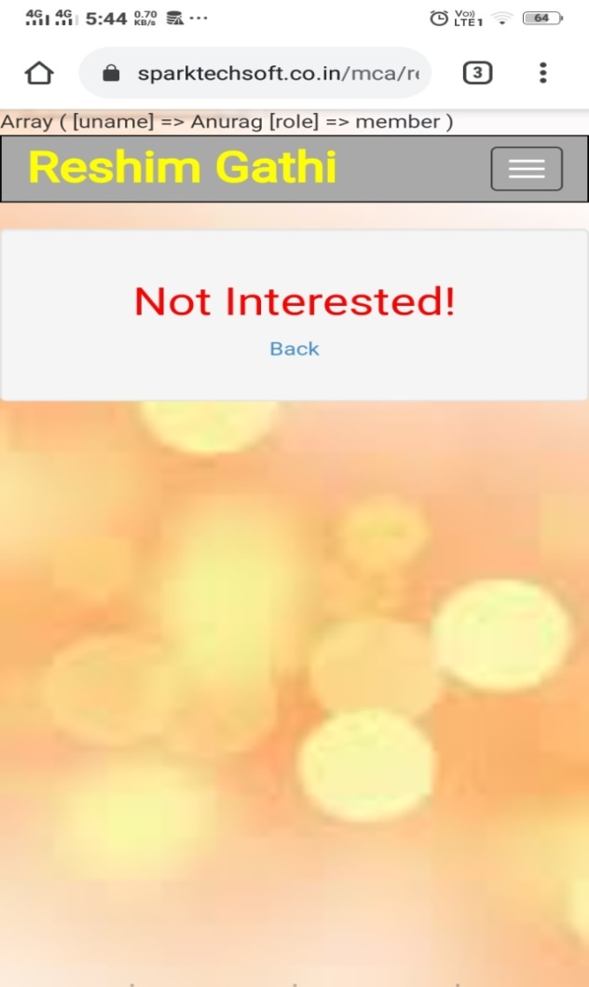

**Inbox**

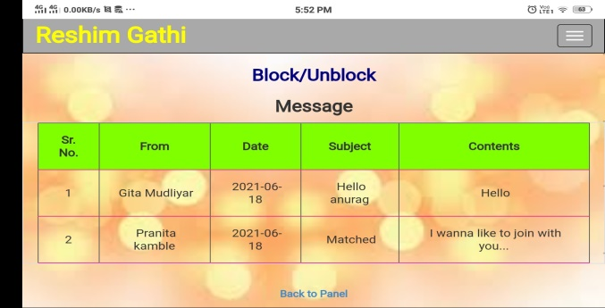

**Outbox**

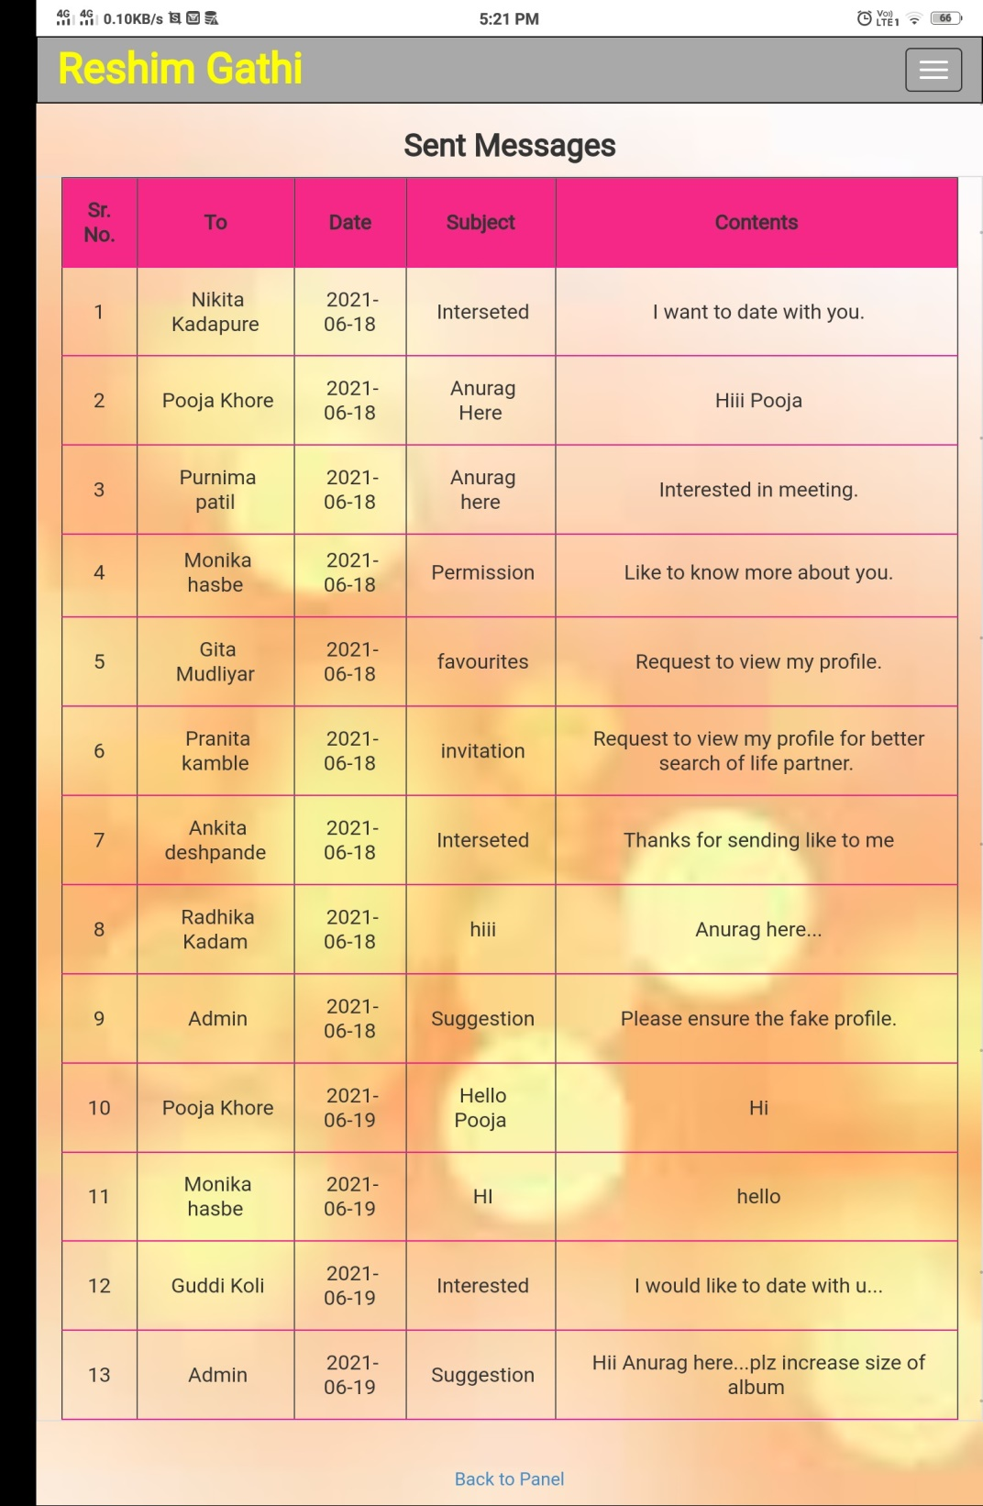

**Block/Unblock User**

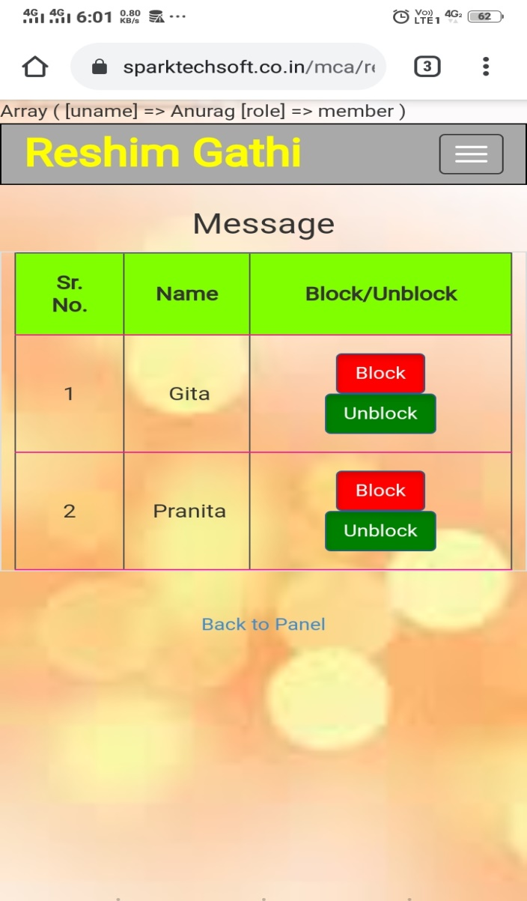

**Block User**

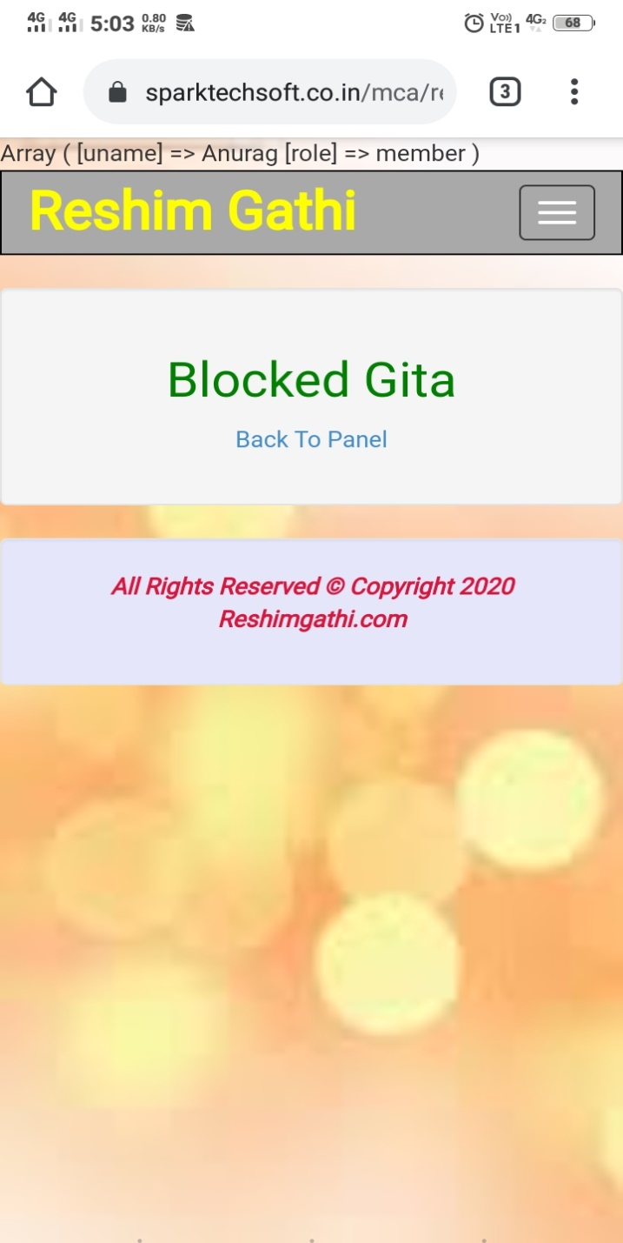

**Unblock User**

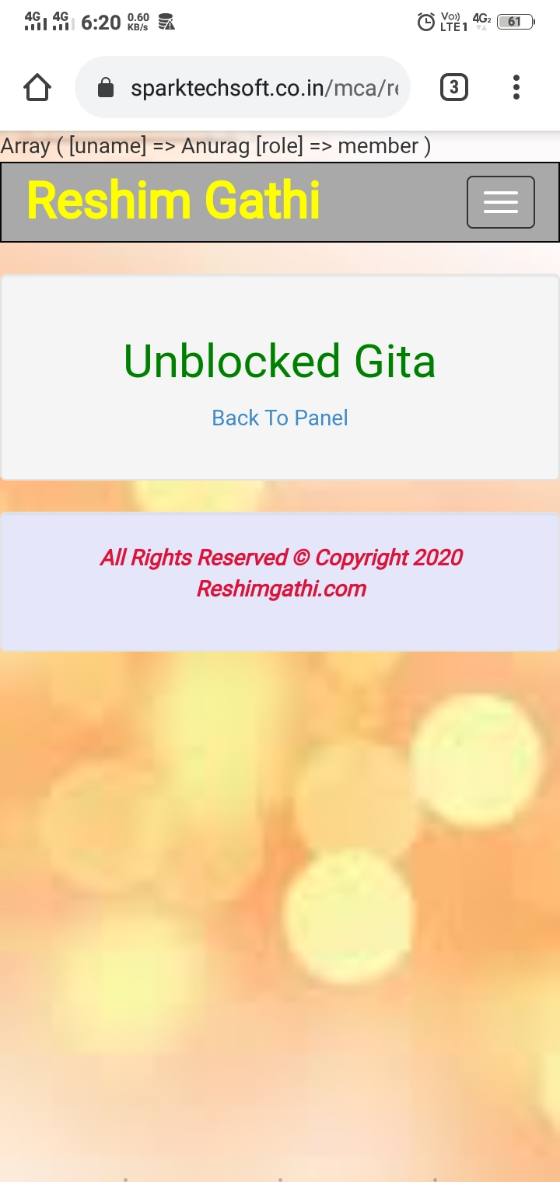

**Blocked List**

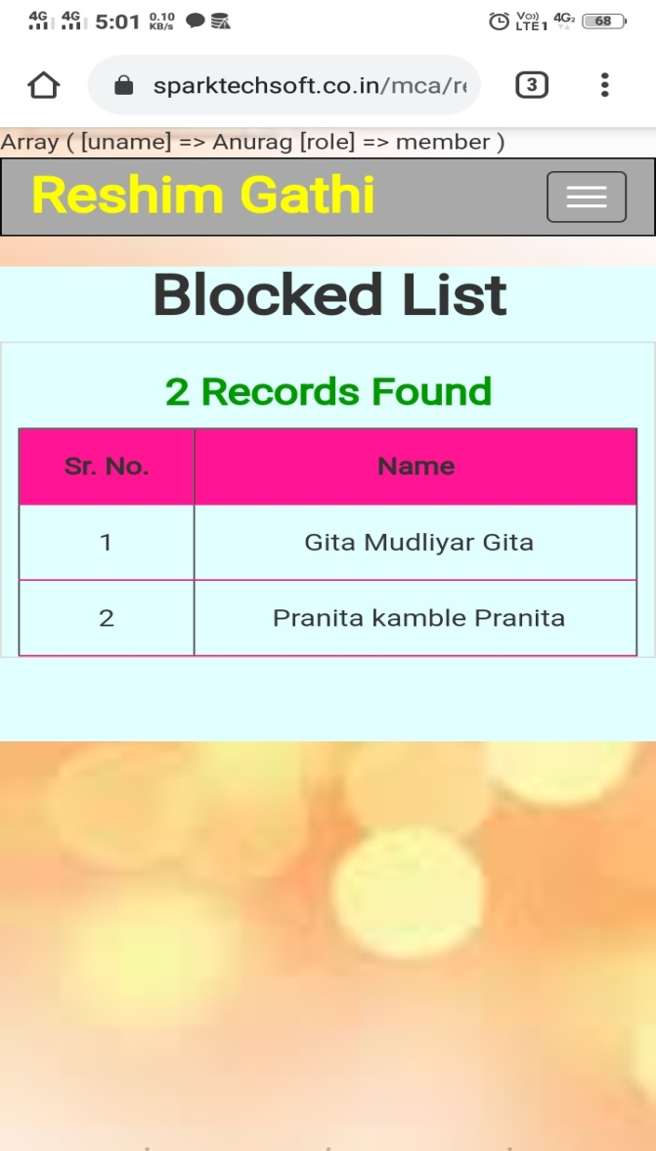

**Favorites**

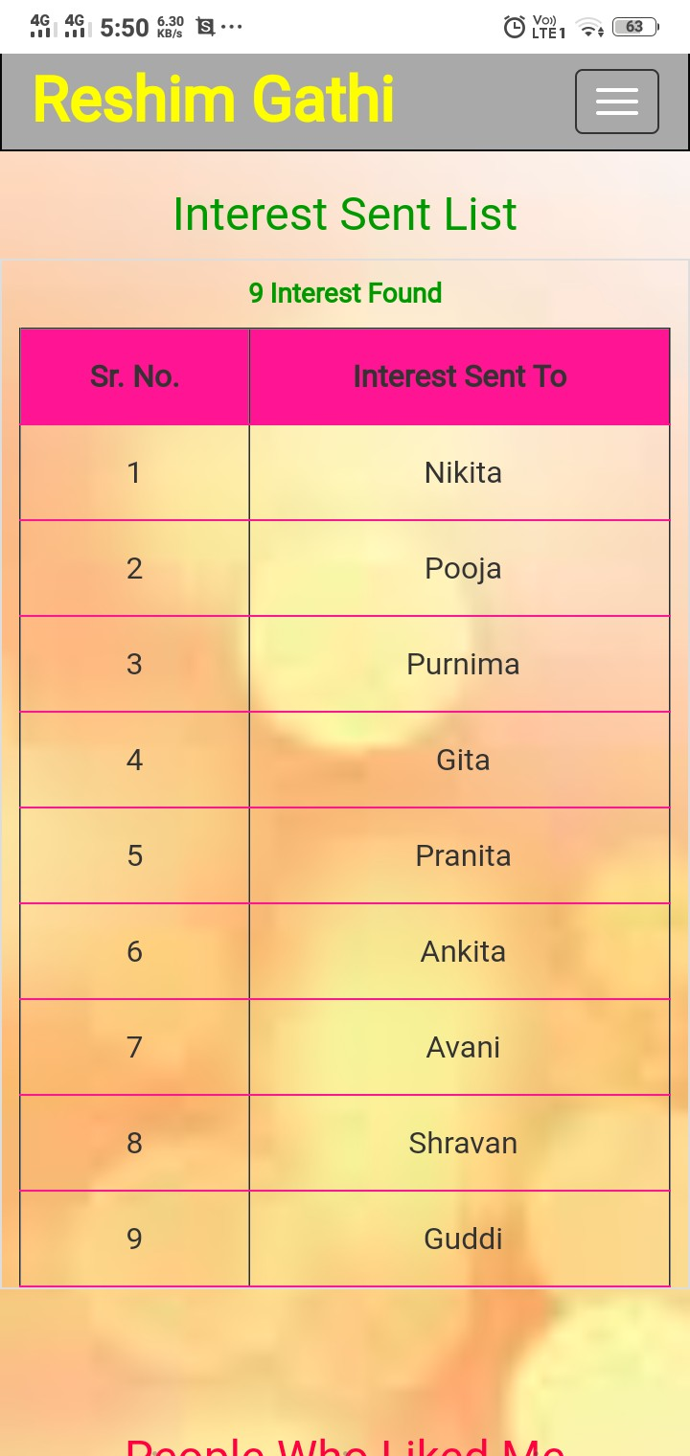

**Delete Profile**

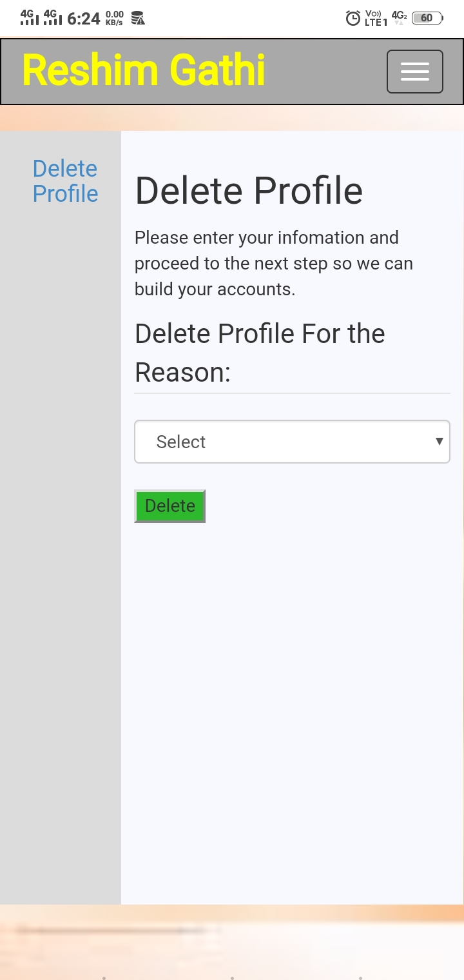

**Share Reason**

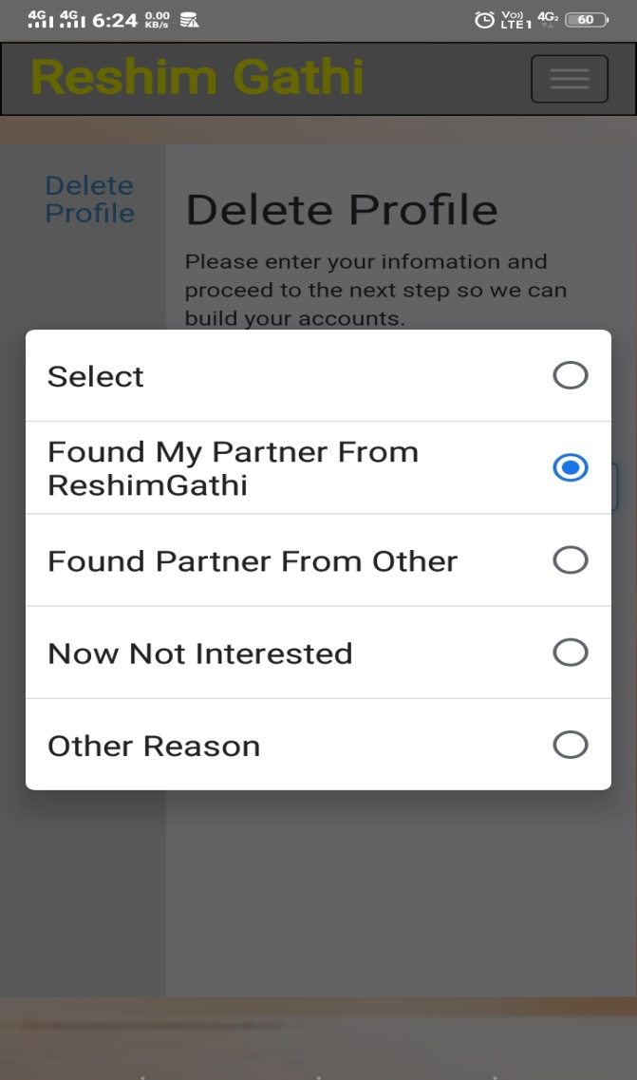

**Share Story**

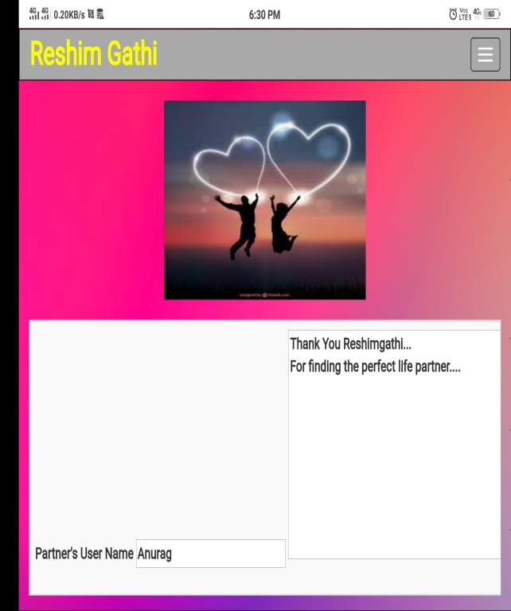

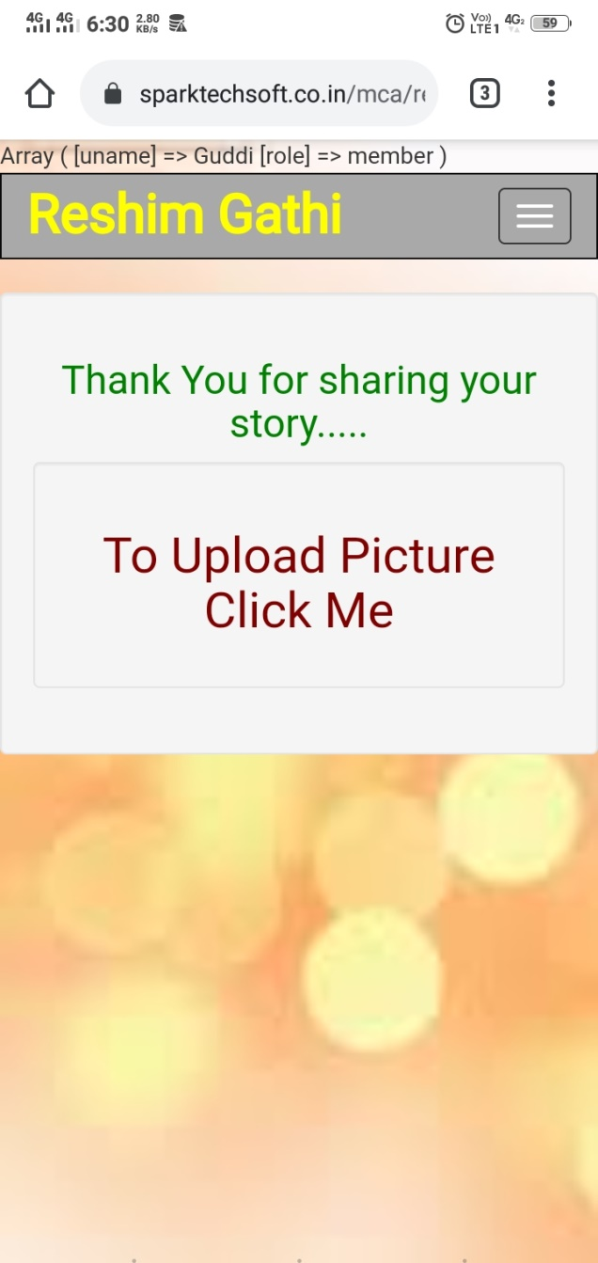

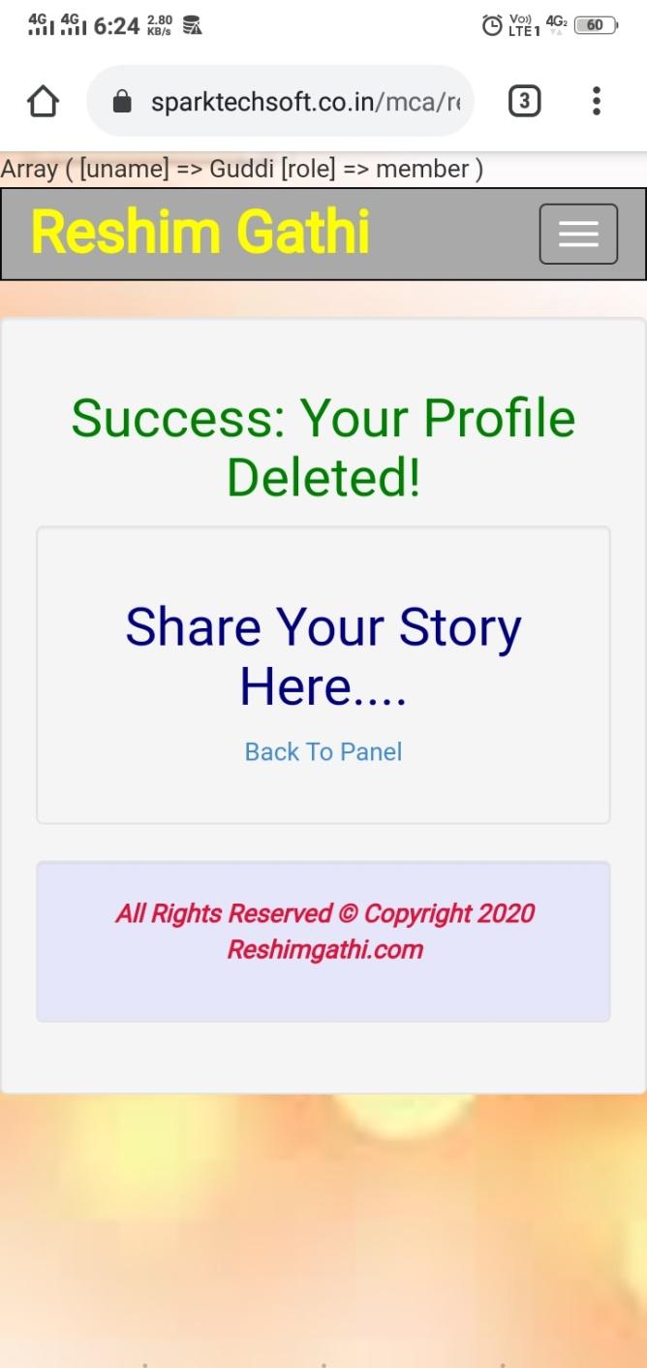

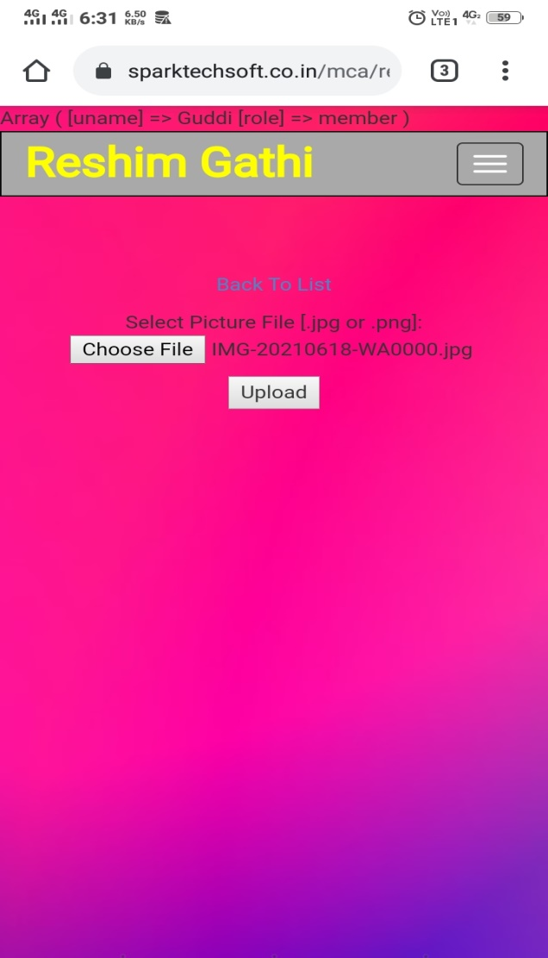

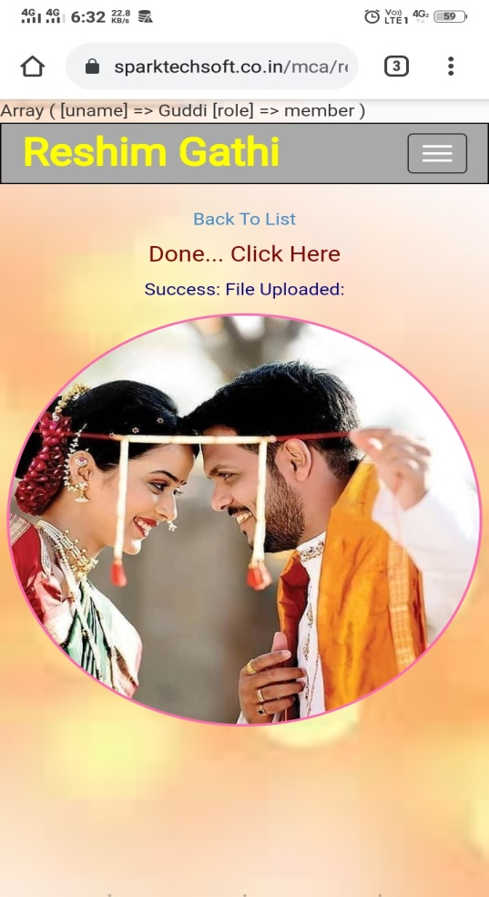

1. **Admin Interface:-**

**Admin Panel:-**

**Description:-** This page displays descriptive terms to admin.

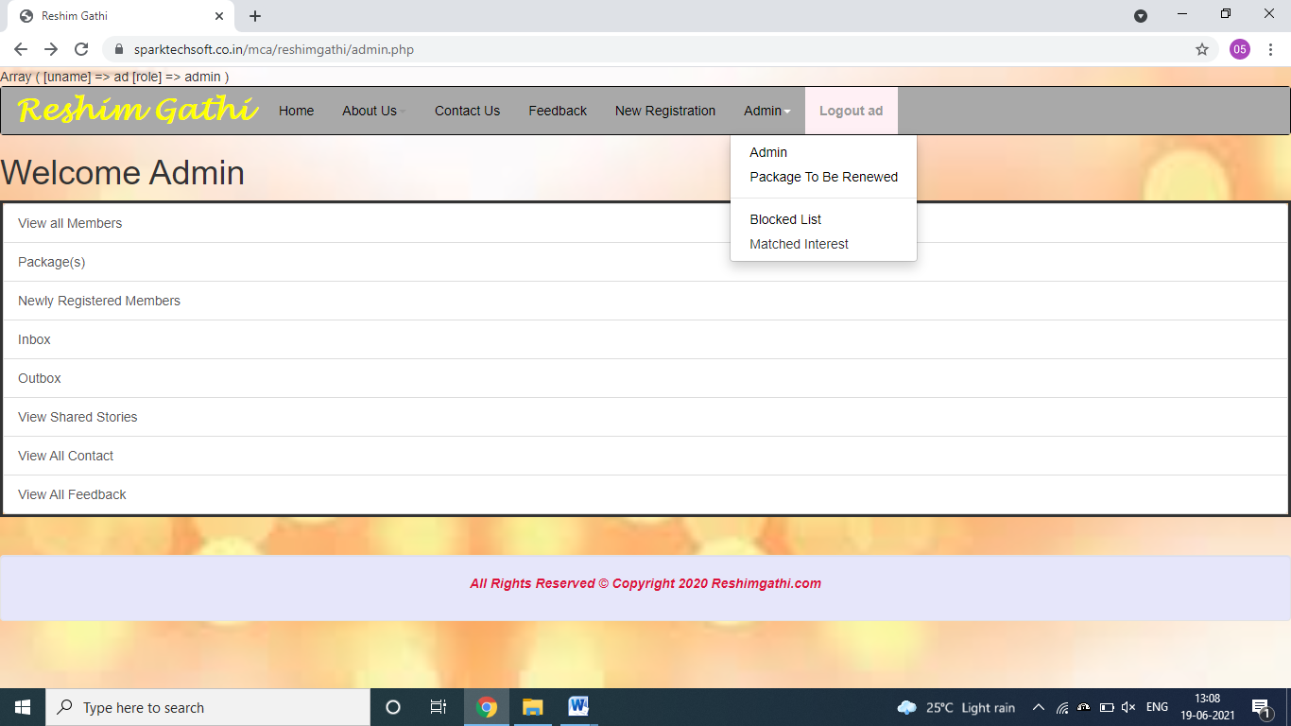

**Blocked Users**

**Description:-** This page displays list of blocked users.

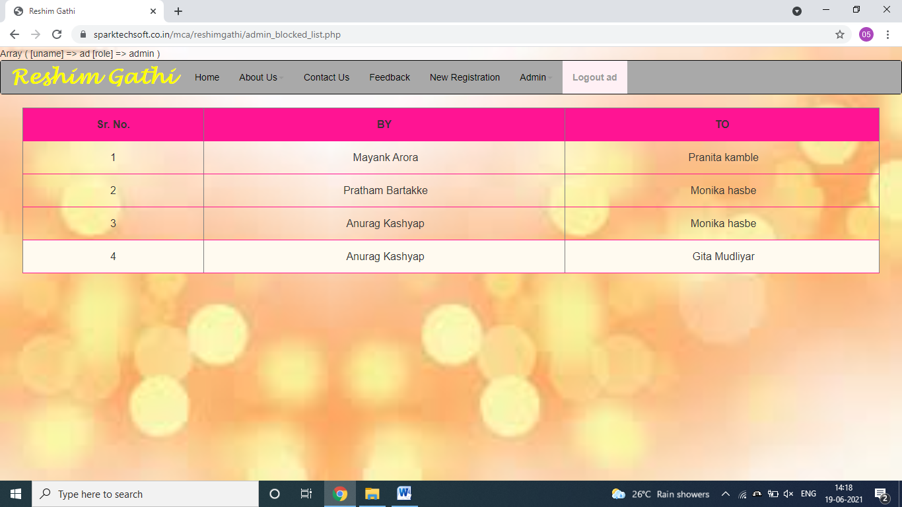

**Matched Interest**

**Description:-**This page displays the list of people who are interested in each other.

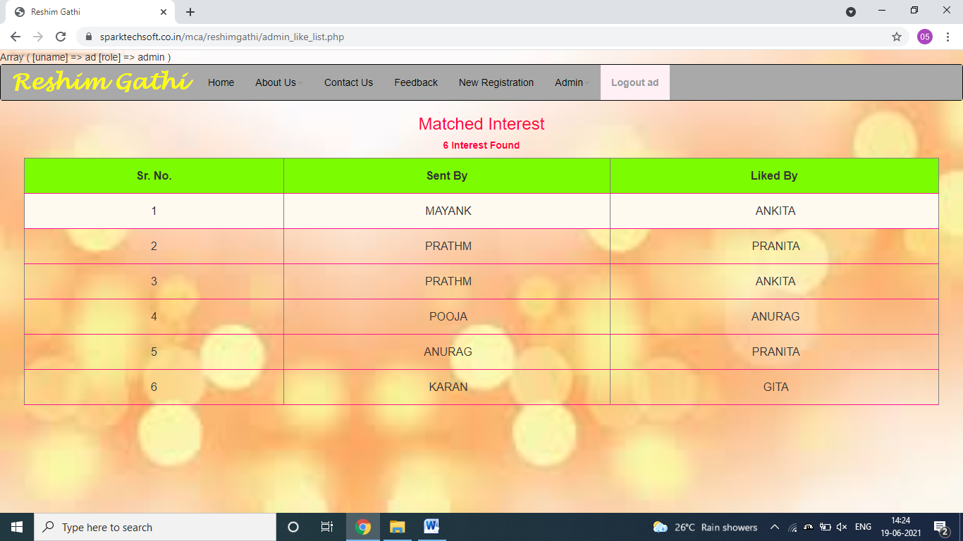

**View All Members**

**Description:-**This page displays the list of members who are using ReshimGathi where admin can read more details about users, send message and also delete user.

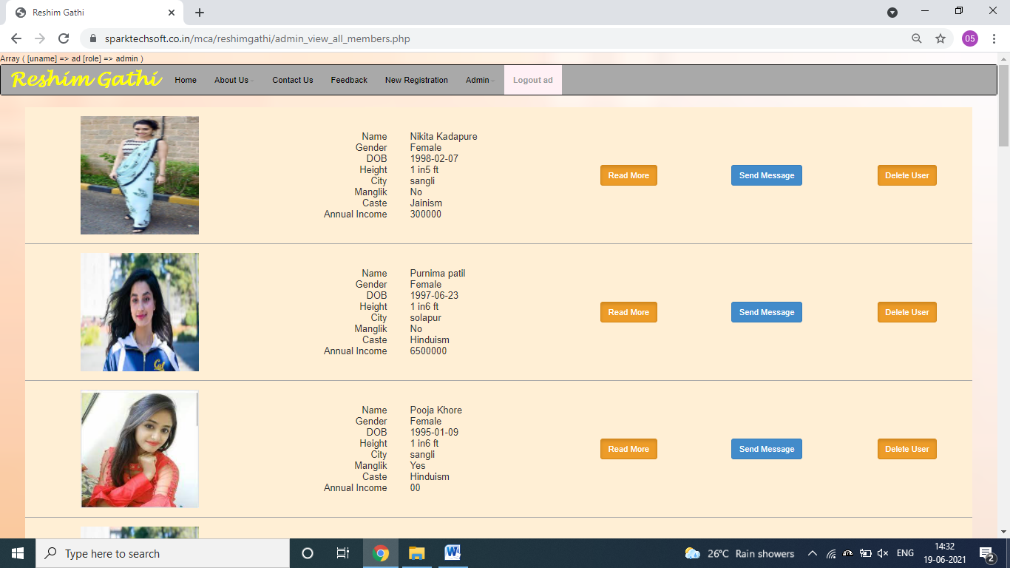

**Packages**

**Description:-**Here admin can view the packages and also create new package, edit it and view list of members who belong to a particular package.

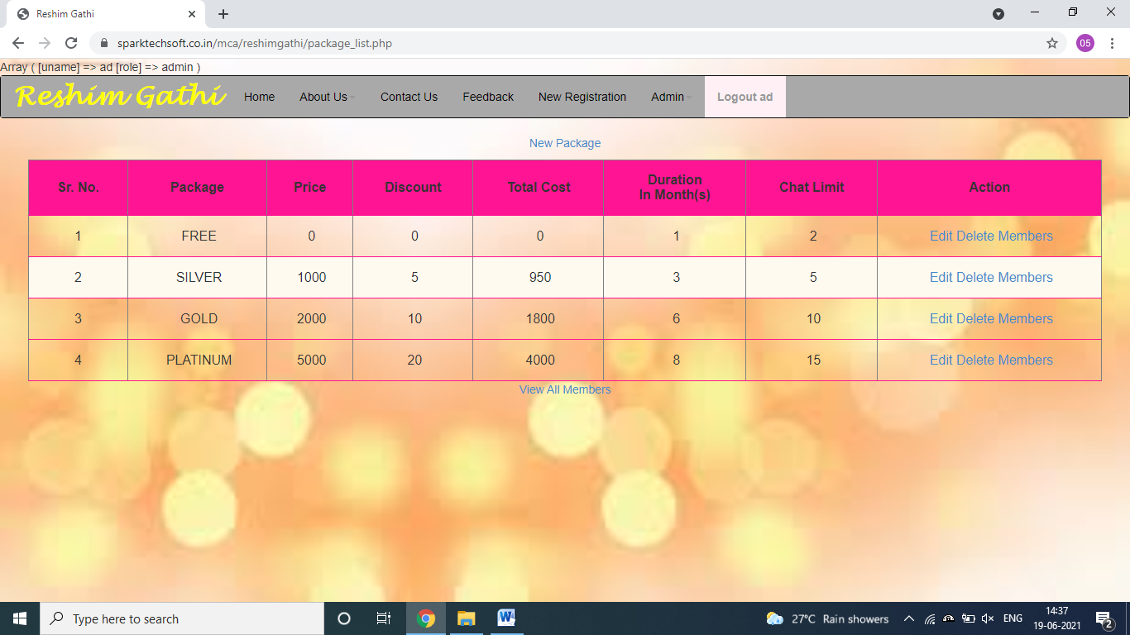

**New Package**

**Description:-**Here admin can create new package.

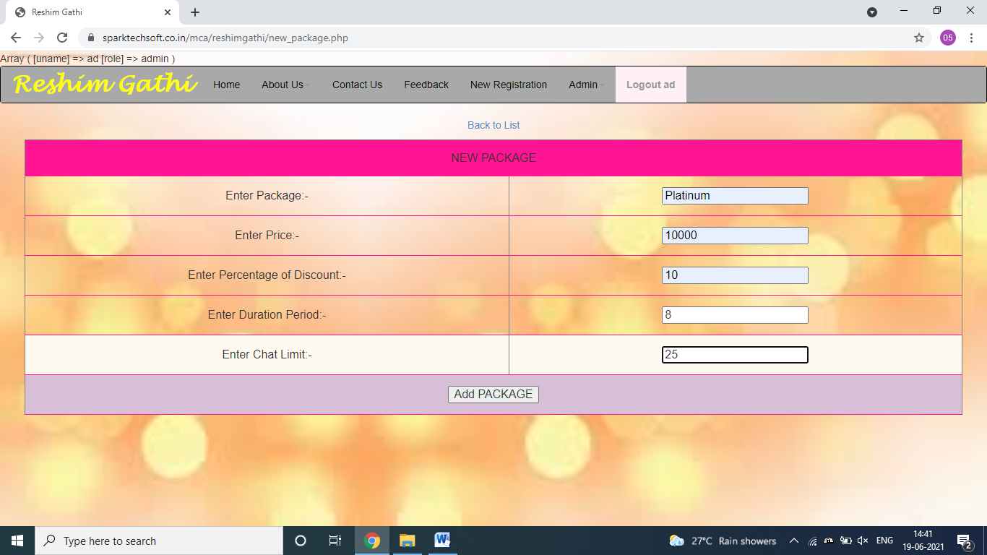

**Newly Registered Members**

**Description:-** This page display a list of members who have newly registered

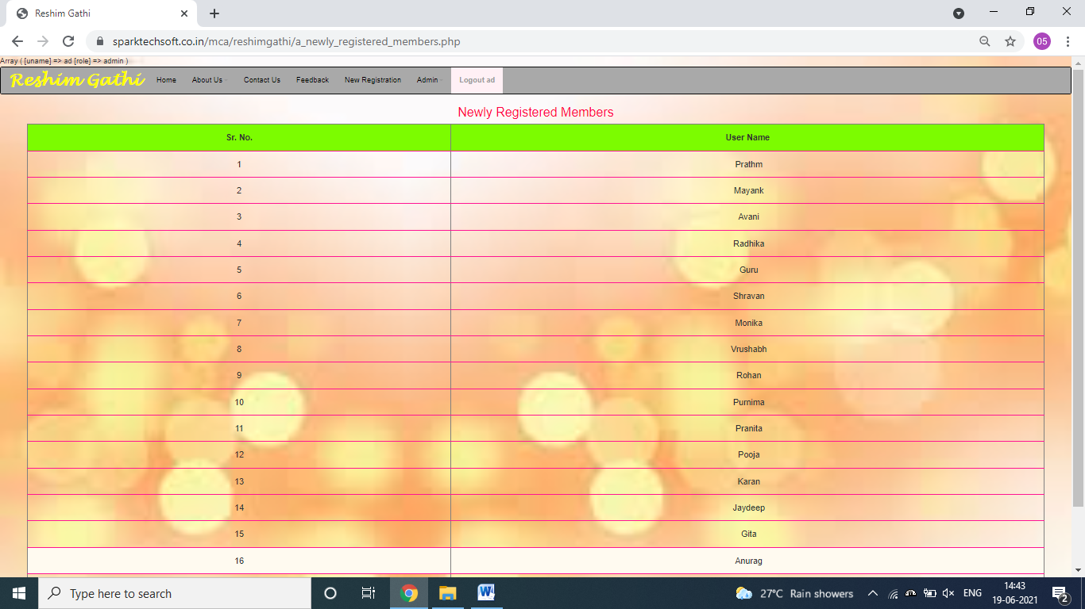

**Inbox**

**Description:-**Here admin can view messages.

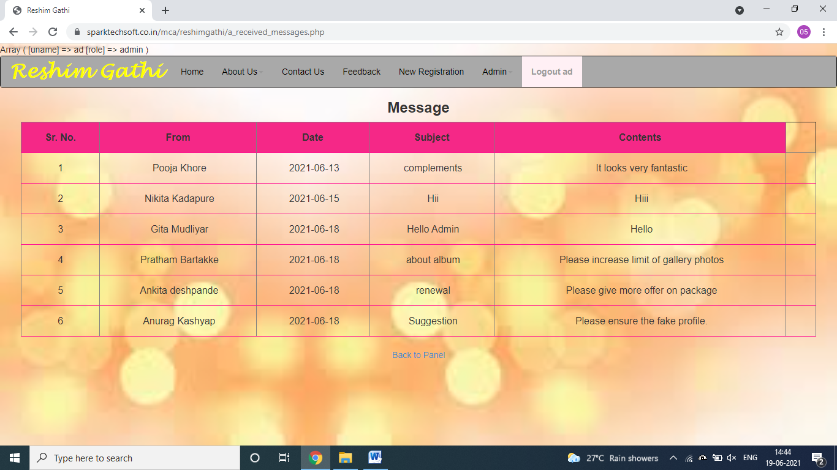

**Outbox**

**Description:-** Here admin can view messages that he sent.

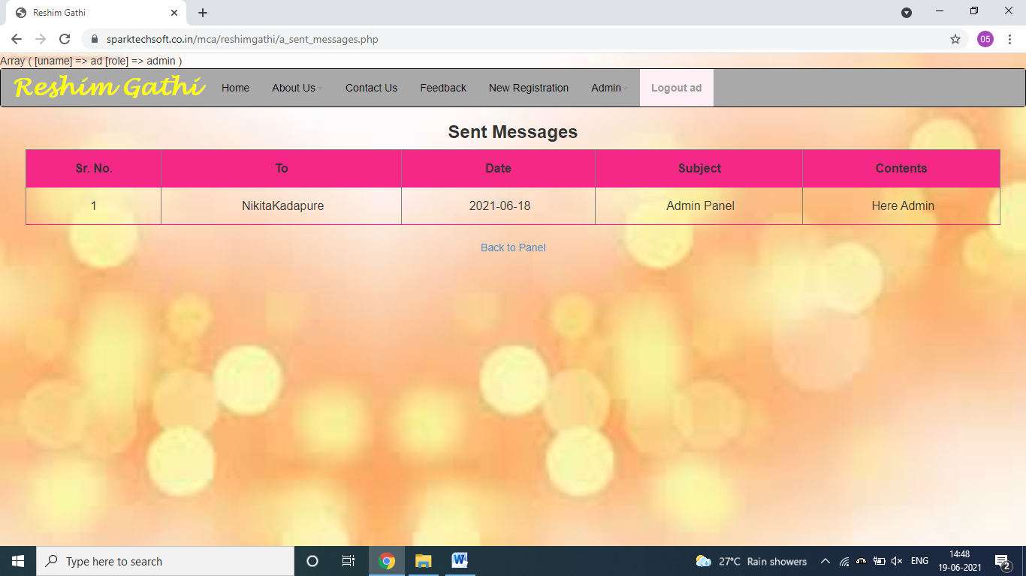

**View Shared Stories**

**Description:-**Here admin can view list of successful stories that its users shared. He can also add/remove stories from stories.

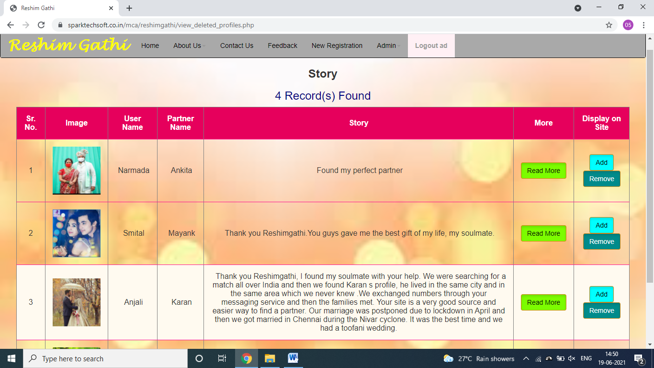

**View all Contact**

**Description:-** This page displays all contacts.

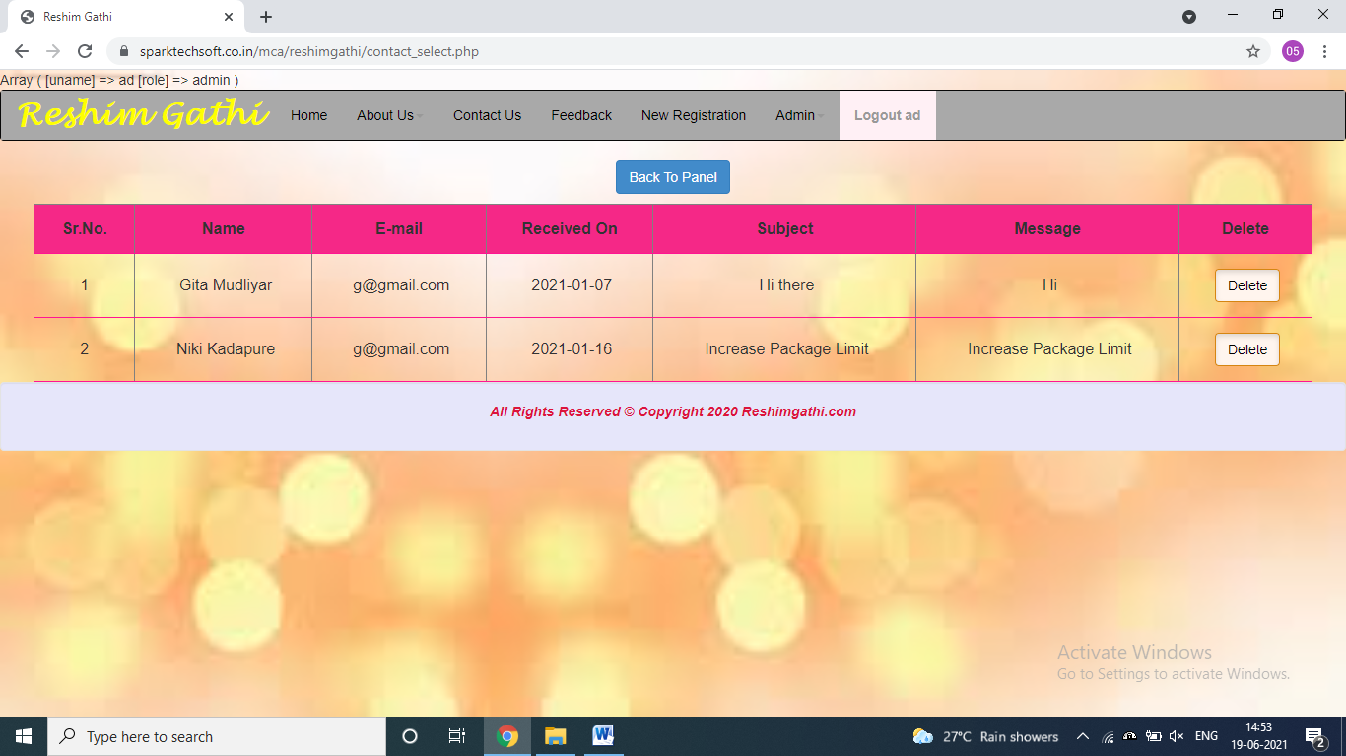

**View all Feedback**

**Description:-** Here admin can view all feedback.

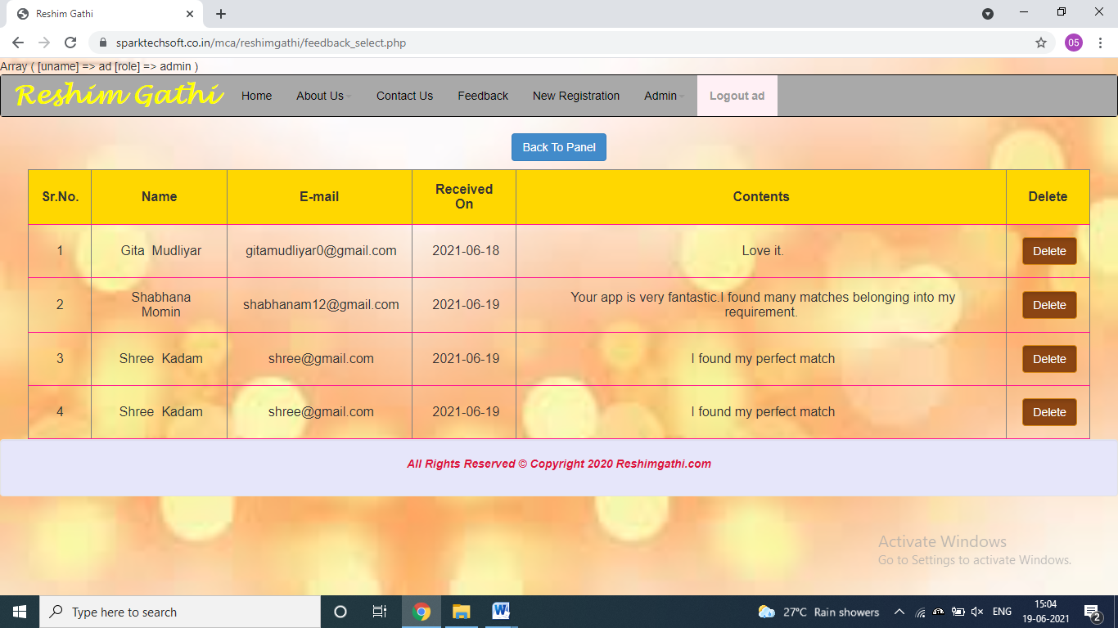

* 1. **H/W and S/W Requirement:**
     1. **For Server (Minimum)Hardware Requirements: -**
        1. Intel 2.5 GHz Processor
        2. 80GB Storage Memory
        3. 1GB RAM
        4. 56 Kbps Internet Connection

##### For Server(Minimum)Software Requirements:-

* + - 1. OS-Windows XP or Higher Versions
      2. Database-MySQL
      3. Internet Browser (e.g. Google Chrome)

##### For Client(Minimum)Hardware Requirements:-

* + - 1. Intel 2.5 GHz Processor
      2. 40GB Storage Memory
      3. 600MB RAM
      4. 56 Kbps Internet Connection

##### For Client (Minimum)Software Requirements:-

* + - 1. OS-Windows XP or Higher Versions
      2. Internet Browser(e.g. Google Chrome)

##### User Manual:-

This project is about “website” and “application” of “ReshimGathi a Matrimonial Site”. This website contains modules as under:

* 1. **Member Module:-**
  + Creates profile by proving various kinds of information like personal, family, educational information, profile details, astrological details, hobbies and expectations.
  + Find matches as per expectations.
  + View compatibility match.
  + Send Interest to the person.
  + Send like or dislike.
  + View personal details (except confidential details).
  + Send messages and check Inbox and Outbox.
  + Block/Unblock user.
  + Report to admin.
  1. **Admin Module:**
  + Admin can browse website.
  + Admin Login.
  + View all members.
  + Check packages that are to be renewed.
  + Create/Manage packages and also check how many users are using a particular package.
  + Find members who have registered recently.
  + Share stories on site/app.
  + Check blocked list (i.e. who blocked whom).
  + Find people who are interested in each other.

#### Menu Explanation:-

### Member

1. **Update My Profile:-**

Member updates his/her profile.

1. **Create Album:-**

Member can add photos and create album.

1. **Matches for you:-**

This is where one can find match and send interest and message if interested.

1. **People Interested In Me:-**

This page displays list of people who are interested in you.

1. **My interest(s):-**

This page displays the name of people whom you are interested in.

1. **Blocked List:-**

This page displays the list of people whom you blocked.

1. **Favorites:-**

This page displays the list of people to whom you sent interest and also who like you.

1. **Message to Admin:-**

Member can send message to admin.

1. **Inbox:-**

Displays all the messages received by member.

1. **Outbox:-**

Displays all the messages sent by member.

1. **Delete Profile:-**

Here member can delete his/her profile and also share his/her story (if found partner through the site).

### Admin

1. **View All Members:-**

Here admin can view profile of all members also can send message to members and also delete user.

1. **Package(s):-**

This page helps admin to create and manage packages in which he can set duration, price and time limit. Also here admin can view number of people who are using a particular package.

1. **Newly Registered Members:-**

Admin can view members who have recently registered.

1. **Package to be Renewed:-**

Here the users’ packages that are to be renewed are displayed.

1. **Blocked List:-**

It displays the list of people who have blocked someone.

1. **Matched Interest:-**

This page displays list of people who are interested in each other.

1. **Inbox:-**

Displays all the messages received by admin.

1. **Outbox:-**

Displays all the messages sent by admin.

1. **View Shared Stories:-**

Here admin can view successful marriage stories and display on site or remove already displayed story from it.

1. **View All Contact:-**

All the suggestions and grievance given by non-registered user are viewed here.

1. **View All Feedback:-**

All the feedbacks given by the user are displayed here.

# CHAPTER FIVE “ANNEXURE”

## ANNEXURE

* + 1. **LIMITATION AND FUTURE SCOPE.**
    2. **CONCLUSION.**
    3. **BIBLIOGRAPHY / REFERENCE.**

##### 5. Annexure

##### 5.1. Limitations and Future Scope:

**Limitations**

* + - This site limits the user to add only a defined number of photos on site to create album.
    - This application does not send message or notification to users’ mobile/e-mail. However this is achieved by the application itself leading to the disadvantage of user to view details only when logged in.

##### Future Scope

* Allow user to add more photos on site.
* Adding SMS gateway for the user to get notification even when he/she is not using the application.
* Online payment gateway should be added.

##### Conclusion:

We made “ReshimGathi” a matrimonial website to find perfect life partner just by sitting home.

* Without login the members cannot view any information about other member.
* Messaging facility is provided to members for having a safe communication without having to share contact details to other users.
* Thus, in this system reliability and accuracy is maintained simultaneously also the security is maintained by keeping personal information secure.
* Administrator has the highest authority where he can track user’s behavior.

##### Bibliography/References:-

* **Books:-**
* **Websites:**
* HTML,DHTML - By Ivan BAyross (BPB Publication) [Javascript And CSS]
* Web Programming Using PHP & MySQL – By K. Meena, R. Sivakumar(Himalaya Publication)
* Mobile App Deelpoment – S. Sydhani Begum.( Notion Press Publisher).
* [www.shaadi.com](http://www.shaadi.com)
* [www.jeevansathi.com](http://www.jeevansathi.com)
* www.Marathimatrimony.com
* [www.php.com](http://www.php.com/)
* [www.w3schools.com](http://www.w3schools.com/)
* [http://www.tutorialspoint.com](http://www.tutorialspoint.com/)
* https://[www.mysql.com](http://www.mysql.com/)